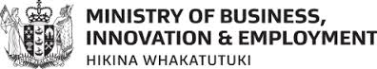
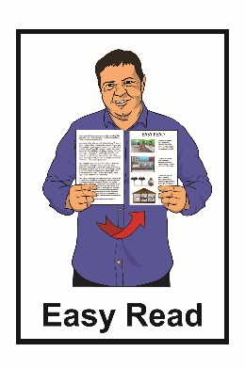

A New Zealand
Income Insurance Scheme

How the Income Insurance Scheme could work in New Zealand

March 2022
Before you start
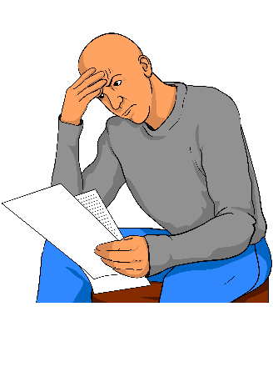

This is a long document.

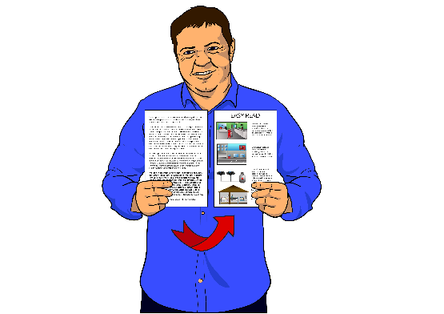
While it is written in Easy Read it can
be hard for some people to read a document this long.

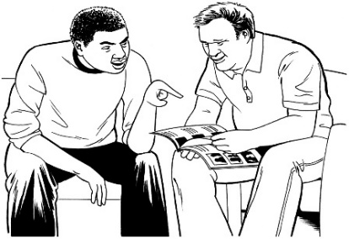
Some things you can do to make it easier are:
- read it a few pages at a time

- have someone help you to understand it.

What you will find in here

Page number:
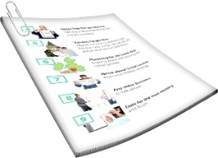

What is this document about?……...…..….3

What is an Income Insurance Scheme?.....6

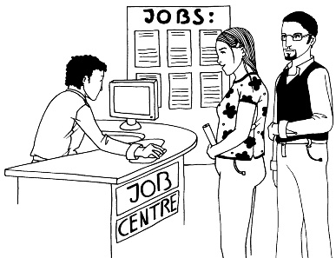
Who will be covered by the New Zealand Income Insurance Scheme?.....................11

Support to get back to work………..…..…19

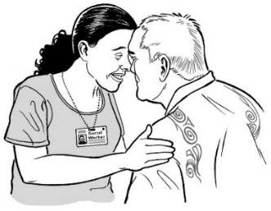
Who will look after the Scheme?..............23

Partnership with Māori……………......…..25

How to have your say……………………. 26

Where to find more information…….…… 28
What is this document about?

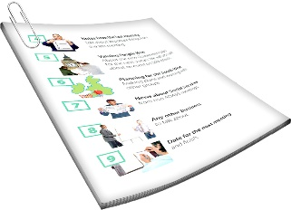
This document is from the Ministry of Business, Innovation and Employment.

The Ministry of Business, Innovation and Employment is also called MBIE.

This document is about a proposal for the New Zealand Income Insurance Scheme.
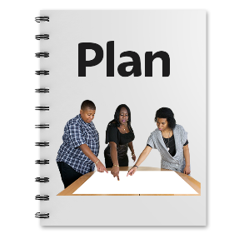
A proposal is a plan that suggests how something could work.

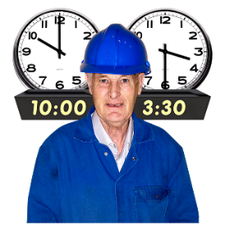
Every year 1 hundred thousand New Zealander workers:

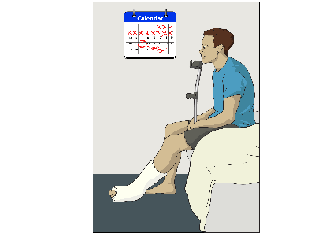
- are made redundant

- are laid off
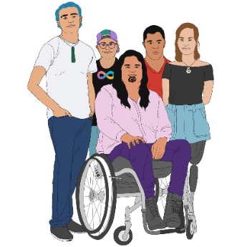
- have to stop work because of a health condition
- have to stop work because a
disability.

Workers are people who have a paid job.

Being made redundant or laid off means losing your job because the person you work for does not have enough work for you.
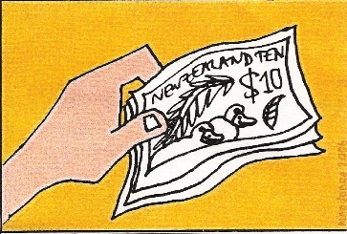
A way of supporting New Zealanders who cannot work for these reasons is the New Zealand Income Insurance Scheme.

In this document we will call the New Zealand Income Insurance Scheme the Scheme.

The ideas in the Scheme have been put together by:
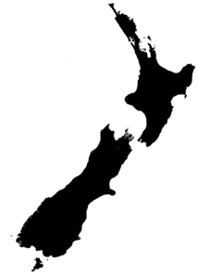
- the New Zealand Government
- Business New Zealand
- the New Zealand Council of Trade Unions.

What is an Income Insurance Scheme?

The Scheme would give some financial support to people who cannot work anymore because they have:
- been made redundant

- been laid off
- had to stop work because of a health condition
- had to stop work because a disability.
Financial support is when the government pays you money so you can pay for things like:

- bills / cost of living

- food.
The Scheme would mean workers:
- who have to stop work would get 8 dollars for every 10 dollars that they would usually get from their paid work up to a maximum amount of money
- could get this support for up to 6 months.
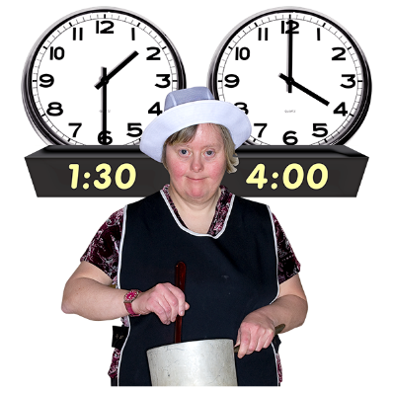
The Scheme would also mean that workers would be supported if they need to work fewer hours because of a health condition or disability.
.
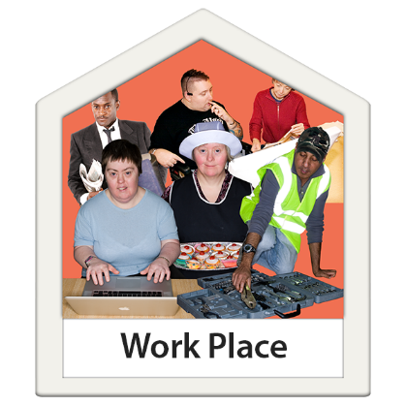
The Scheme would mean workers would have the time and money to:
- find a good job
- take part in training
- go through rehabilitation.
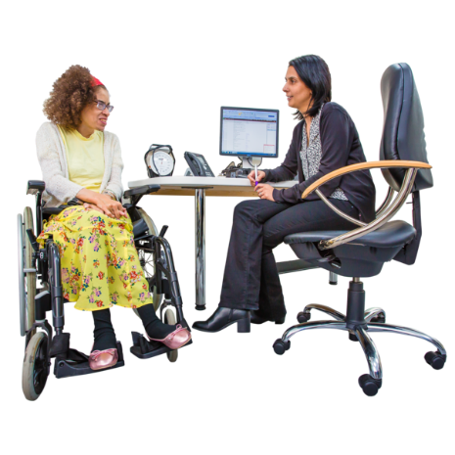

Rehabilitation means doing things that support you to get back to paid work.

This might be things like:

- going to a specialist doctor
- having some treatment
- learning some new work skills.
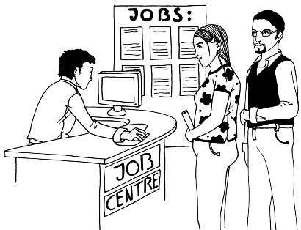
To be part of the Scheme people will need to:
- look for work
or
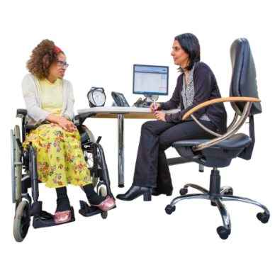
- take part in training
or
- go through rehabilitation.

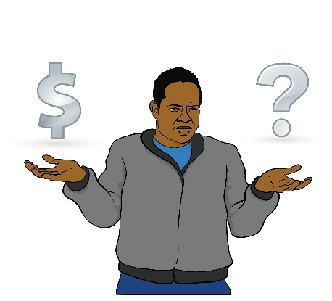
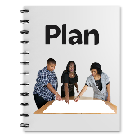
The Scheme will be paid for by:
- levies on wages
- levies on salaries.

Levies are a way of paying for specific government services.

Most workers would pay the new insurance Scheme levy.

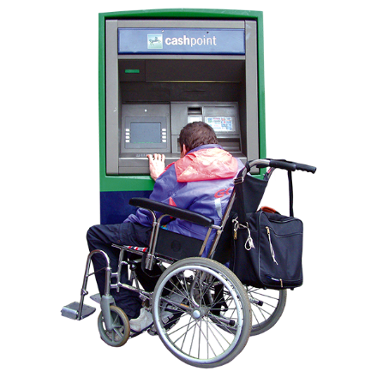
Salaries are the money you are paid for the work you do.

Workers would pay less than 2 dollars in levies for every 100 dollars they earn.

Employers would pay the same amount of levies for each person who works for them.

Who will be covered by
the Income Insurance Scheme?

The proposal is meant to:
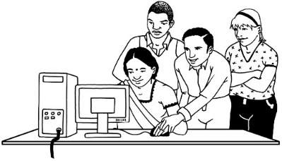
- support as many workers as possible
- support the different ways people work
- keep the cost of the Scheme low.

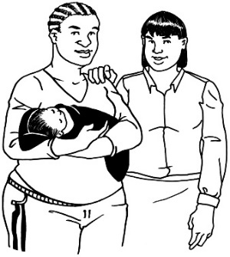
To be able to use the Scheme people will need to have been working or on parental leave for at least 6 months in the past 18 months.

Parental leave is leave that parents can have after the birth or adoption of a child.

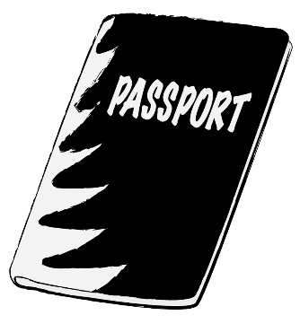
To be able to use the Scheme people also will need to be a:

- New Zealand citizen
or
- New Zealand resident.

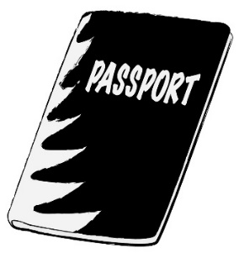
A New Zealand citizen is someone who can get a New Zealand passport.

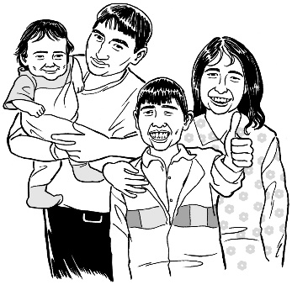
Many New Zealand citizens are born in New Zealand.

Some people who come to live in New Zealand from overseas also become New Zealand citizens.

A New Zealand resident is someone the government says is allowed to live in New Zealand.
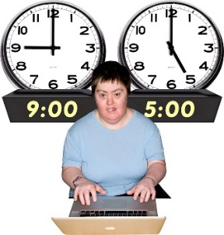
The Scheme includes cover for full time and part time workers who are:
- made redundant or laid off
- who lose work because of a health condition or disability.

It has been difficult to include self-employed people in the Scheme.

Self-employed people:

- own their business

- work for themselves.

MBIE is keen hear your views on how self-employed people can be included in the Scheme.

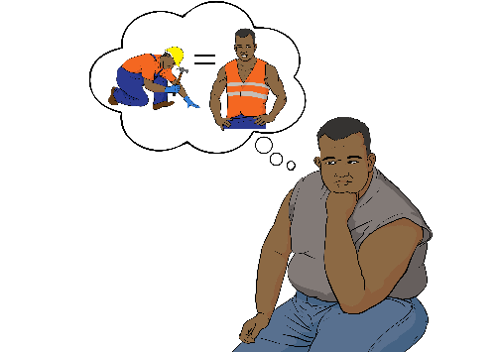
The Scheme will give enough financial support so that workers can:
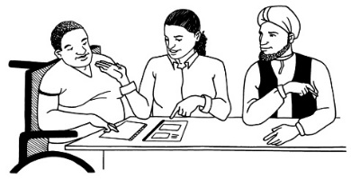
- find a new job
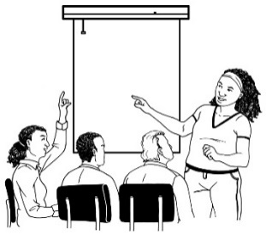
- go through rehabilitation
- train for a different career / type of work.

Workers only pay levies on income up to 130,911 dollars a year.

The highest possible insurance payment is 80 percent of the 130,911 amount or around 105,000 dollars.

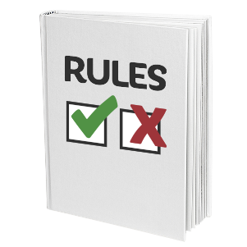
Workers are not covered if they:
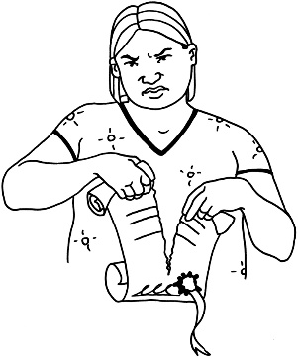
- lose their job because they did not do a good job
- lose their job because they broke the rules
- quit or give up their job.
The payments do not change if people:
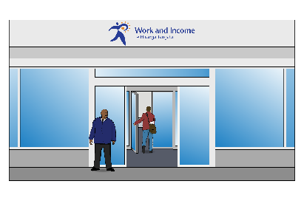
- have assets like a house
- get money from somewhere else like government support
- have other people in their house who are still earning money.

Employers who want to lay off workers or make workers redundant need to:
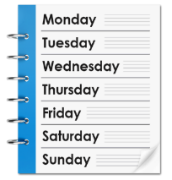
- give you notice that you are being made laid off / made redundant
- provide you with most of your 4 weeks of pay.

Workers who are laid off get up to 6 months of financial support from the Scheme if they are:
- laid off for economic reasons

- made redundant for economic reasons.
Economic reasons are things like:

- the business not making enough money

- there not being enough work for people to do.
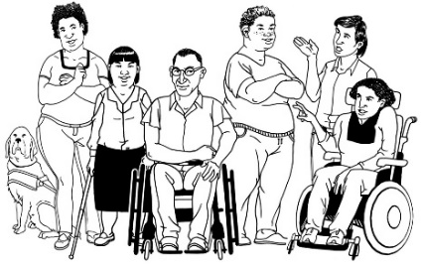
Workers with a health condition or disability will get the same amount of insurance cover.
The eligibility criteria for someone with a health condition or disability are:
- they must have to stop working completely
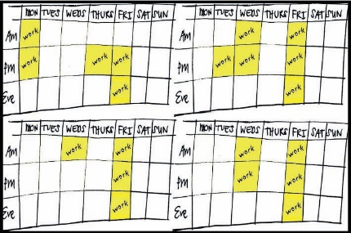
or
- they must only be able to work less than half the time they were working before.
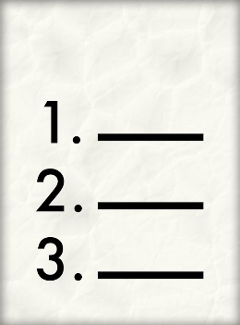
Eligibility criteria are a list of things that need to be met for someone to be part of the Scheme

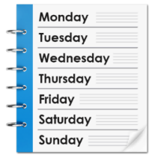
Part of the eligibility criteria is also that the health condition or disability is expected to last for at least 4 weeks.
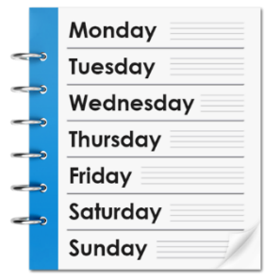
Any health issues shorter than 4 weeks should be covered by other options like sick leave.

Support to get back to work
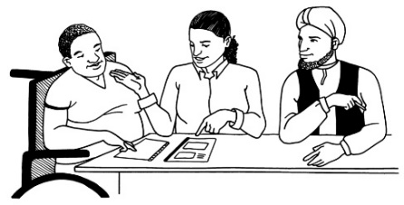
Workers will be offered support to get back to work.
The Scheme will assist people to
find new jobs that match their:
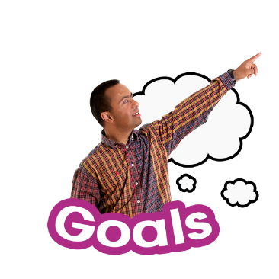
- skills
- goals.
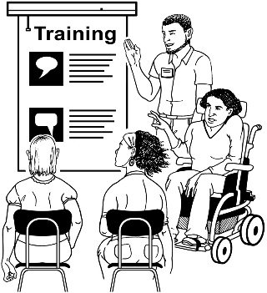
The Scheme will give people time to:
- learn new skills
- go through rehabilitation.

There will be support for people to:
- find work
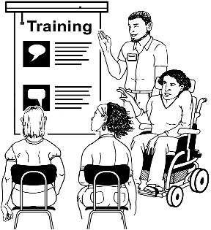
- find training
- find rehabilitation programmes.
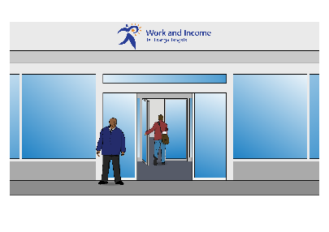
Most other kinds of government support will not be changed by the Scheme.
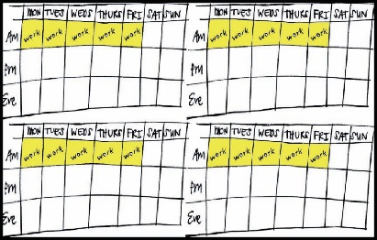
People can work part-time while getting payments from the Scheme.

Payments may be stopped if people do not do what they need to do to use the Scheme.
Payments being stopped will be the last option to get people to do what they need to do to use the Scheme.

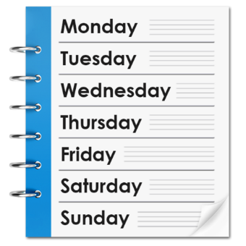
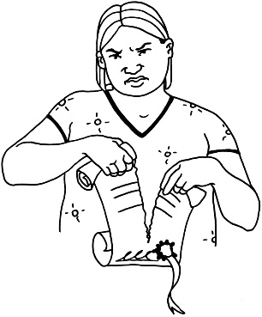
To make sure the Scheme is only used by people who need it employers will provide a 4 week payment for:
- redundancy
- layoffs.

The 4 week payment is to:
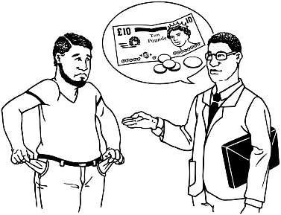
- stop redundancies that do not need to happen
- make sure the Scheme is only used by those who need it
- lower the cost to other employers.

Who will look after the Scheme?
Having an income insurance scheme is a new idea for New Zealand.
The New Zealand Income Insurance Scheme would be looked after by ACC.
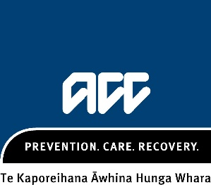
ACC is the Accident Compensation Corporation.

ACC is run by the government.

ACC pays for treatment for people who get hurt in an accident.

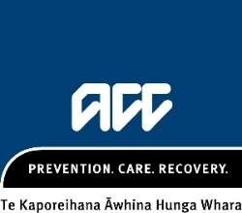
The Scheme would be run like ACC.

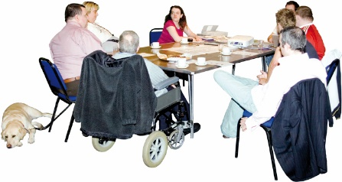
The government will use the experience of ACC to run the New Zealand Income Insurance Scheme.

Partnership with Māori
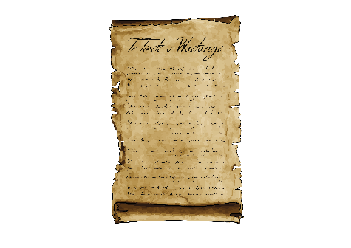

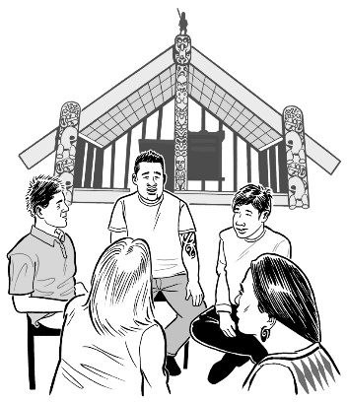
We need to make sure the New Zealand Income Insurance Scheme follows te Tiriti o Waitangi / Treaty of Waitangi by:
- working with Māori to run the Scheme
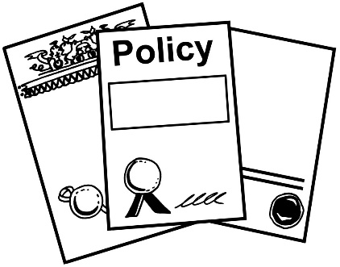
- providing the Scheme in partnership with Māori
- working with Māori to make sure the Scheme is good for everyone

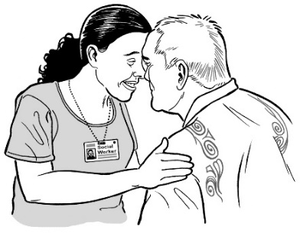
- working with Māori to write the policies / rules of the Scheme
- making sure the Scheme respects te ao Māori / Māori ways of thinking.

How to have your say

MBIE want to hear what you think of this proposal.

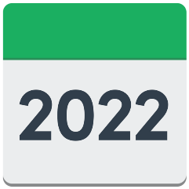
You will need to send in your thoughts by 26 April 2022.

You can find an online survey at this website:

www.research.net/r/NZIISconsultationsurvey

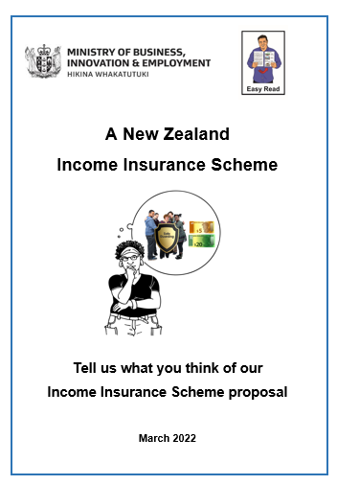
You can also tell MBIE what you think in an Easy Read document called:

A New Zealand Insurance Scheme: Tell us what you think of our Income Insurance Scheme proposal.

You can find this Easy Read document on this website:

www.mbie.govt.nz/have-your-say/income-insurance/

Where to find more information

You can find more information about the New Zealand Income Insurance Scheme on the MBIE website at:

www.mbie.govt.nz/have-your-say/income-insurance/

If you have any questions you can email MBIE at:
incomeinsurance@mbie.govt.nz

This information has been written by the Ministry of Business, Innovation and Employment.
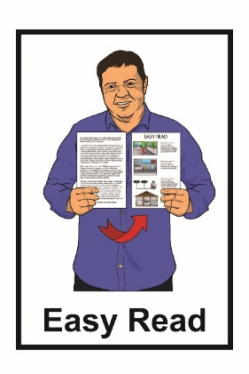
It has been translated into Easy Read by the Make It Easy service of People First New Zealand Inc. Ngā Tāngata Tuatahi.

The ideas in this document are not the ideas of People First New Zealand Inc. Ngā Tāngata Tuatahi.
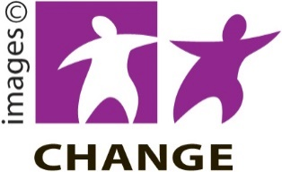
Make It Easy uses images from:

- Changepeople.org
- Photosymbols.com
- Sam Corliss
- Huriana Kopeke-Te Aho

All images used in this Easy Read document are subject to copyright rules and cannot be used without permission.

