MARCH 2024

Enabling digital technologies for New Zealand’s circular and bioeconomy, including the role of digital twins

Report

PREPARED BY:

Table of Contents
Executive Summary 3
Introduction 3
Digital twins and the circular economy 3
Māori and digital technology 5
AI could be key to the circular economy 6
Glossary of terms 7
MAIN REPORT 10
1. Introduction 10
1.1 The circular economy and bioeconomy in New Zealand 10
1.2 Digital twins 11
1.3 Digital twin activity in New Zealand 13
1.3.1 Overview of vendor and solution provider offerings 13
2. Stakeholder views from New Zealand on digital twins 15
2.1 Key conversation topics from stakeholder engagements 17
2.1.1 Barriers and challenges related to technology and data 17
2.1.2 The role of government 18
2.1.3 Collaboration 18
2.1.4 Knowledge sharing and best practice 18
2.1.5 Measuring impact 18
2.1.6 General comments 18
2.2 New Zealand’s digital twin maturity 19
3. Te Ao Māori and digital technologies in the circular economy and bioeconomy 21
3.1 Recent developments 24
3.2 Key initiatives 24
4. Other digital technologies 25
4.1 Other digital technologies 28
4.1.1 Artificial Intelligence (AI) 28
4.1.2 Robotics and automation 29
4.1.3 The Internet of Things (IoT) 30
4.1.4 Software as a Service (SaaS) including mobile apps 30
4.1.5 Online trading platforms and market places 31
4.1.6 Digital passports 31
4.1.7 3D Printing/additive manufacture 32
4.1.8 Digital engineering 32
4.2 Overseas developments 34
5. Conclusion 36
Appendix 1 – Stakeholder engagement 38
Appendix 2 - Digital twin definition and categorisation 47
Appendix 3 – Other technologies and their application 49

This report has been commissioned by the Ministry of Business, Innovation & Employment (MBIE), as part of its Circular Economy and Bioeconomy work programme.
It forms part of MBIE’s “Impacts, Barriers, and Enablers for a Circular Economy” project, which includes identifying:
- Project 1: Impacts of circular approaches on emissions, jobs, and other factors
- Project 2: Barriers, enablers, and approaches for a more circular economy
- Project 3: International developments toward more circular economies and the implications for New Zealand
- Project 4: Enabling digital technologies for New Zealand’s circular and bioeconomy, including the role of digital twins.

This report is a deliverable for Project 4 and its scope includes:
A high-level overview of developments in enabling digital technologies to manage data and information as it relates to the development of a circular economy.
Assessment and demonstration of the strategic potential of digital twins for New Zealand. This includes:
- Technical engagement with 50 stakeholders leading digital twin development.
- Adoption and piloting through interviews and consideration of a Te Ao Māori framework.
- Assessing New Zealand’s capability, applications, benefits, risks and challenges.
- A demonstration of digital twin potential through a use-case workshop designed to enable interaction by a (non-technical) government audience and other stakeholders such as industry and business. (See separate report)

The views, opinions, findings, and conclusions or recommendations expressed in this paper are those of the author(s). They do not necessarily reflect the views of MBIE or the New Zealand Government and are not government policy.

Executive Summary

Introduction
This report presents an overview of the current and potential role of digital technologies in the development of the circular economy and bioeconomy in New Zealand. It has a particular focus on digital twins. Our research included a literature review and engagement with 50 key stakeholders in October and November 2023.
We define the concept of the circular economy as “an economic system that promotes the continual use and reuse of resources, minimizing waste through recycling, refurbishing and sustainable practices.” It also incorporates a systemic transition to renewable energy. It is closely linked with the ‘bioeconomy’: the use of renewable biological resources to produce food, products and energy.
Digital technologies are already playing a variety of roles in New Zealand’s economy. However, the current development of digital twins in New Zealand is not primarily driven by circular economy development. Instead, the focus is on costs, resource management and efficiency.
These drivers significantly overlap, and digital twins have the potential to contribute to the development of the circular economy and bioeconomy in New Zealand in a range of ways.
These include:
- Efficient monitoring, tracking and optimisation of resource flows throughout the entire lifecycle of products and materials.
- The data driven use of artificial intelligence (AI) and Internet of Things (IoT) devices to innovate and achieve cost efficiencies.
- Gaining valuable insights into their supply chains, facilitate collaborations between various stakeholders and enabling the exchange of resources and knowledge.

Digital twins and the circular economy
A digital twin is: “A dynamic and interconnected digital representation of a physical asset or system, enabling comprehensive insights and informed decision making.”
The potential contribution of digital twins to the development of the circular economy includes:
- Supporting the circular economy through optimisation and monitoring of resources, leading to reduced waste and greenhouse gas emissions, as well as efficient lifecycle management.
- Facilitating predictive maintenance, track resources and extend product life. This could further minimise material consumption, improve product reusability and enable better end-of-life recovery and recycling of machinery, infrastructure and consumer goods.
- Resolving key barriers around market inefficiencies that may be blocking the development or scaling of circular practices, including, for example:
- Incomplete information about product composition and conditions preventing reuse or recycling.
- Transaction costs around identifying sources of secondary or excess materials.
- The need to track significant components as they move in the value chain.

In our research, stakeholder interviews highlighted other barriers and limitations to the adoption and development of digital twins and related digital technologies.
These include:
- Interoperability and standards
- Data governance, security and sovereignty
- Skills gaps and usability
- Competition and data sharing
- Ethical considerations
- Collaboration and coordination
- Energy use and environment impact.
The interviews also identified an expressed desire for focus on ‘vison, leadership and approach’ as key elements of digital twins development. Many noted the role of strong government leadership and the promotion of government-industry partnership as essential elements in fostering innovation and driving collaborative solutions.

To see how this is working overseas, we explored how several countries are currently pushing forward with ambitious plans for digital twins and related digital technologies.

Since 2016 The Singaporean Government has promoted the development and adoption of digital technologies to transform the country into a “Smart Nation”. That includes the first ever digital twin city: “Virtual Singapore”. Since 2018, the UK government has led a National Digital Twin Programme (NDTP) focused on developing a functioning market in digital twins. And a recent report from Australia has a vision of a federated ecosystem of connected digital twins and their value to the Australian economy. The Victoria State Government has released the Digital Twin Victoria programme. The New South Wales State Government has also launched a programme to develop a digital twin of the state, the NSW Spatial Digital Twin.

However, despite widespread interest, developments remain at an early stage. There is currently little information available to evaluate their progress.

In New Zealand, progress will require stronger collaboration between industry stakeholders and technology providers, as well as work to strengthen compliance with robust data governance practices and regulatory frameworks to maintain data security and privacy. The value of digital twins for decision making and innovation is yet to be fully recognised here. However, there has been a steady increase in interest in recent years.

This includes such examples as:
- Wellington City Council’s digital twin city.
- Hastings District Council’s digital twin of its Toitoi Arts and Events Centre.
- The New Zealand Institute for Plant and Food Research’s digital twin of an orchard system and supply chain for quality control.
- Ara Institute of Technology’s digital twin of one of its buildings.

Māori and digital technology
The growing connections between Māori and these developments was of particular interest.
Our research found that for Māori the potential of digital twin technology is viewed with a combination of tradition and innovation. In various iwi communities, geospatial technology is readily embraced. It serves as a powerful tool to map sites of significance and forecast economic development outcomes. Digital twins can help to safeguard cultural heritage by enabling Māori to manage, update and use them in alignment with their values and traditions.
It empowers Māori to have authority over how their data is collected, stored and shared. This is pivotal for the privacy and dignity of Māori and ensuring their data is used to benefit their communities, rather than exploited for external interests. Māori data can be viewed as living taonga and understanding ownership protocols around it is crucial with the advancement of digital technologies.
Interestingly, initiatives to support the Māori tech sector in New Zealand have been gaining traction. Efforts have been made to promote and advance Māori participation in the technology industry, fostering innovation, entrepreneurship and digital literacy within the community. These include Te Ao Matihiko, a networking and collaborative collective that supports capability development and coordination for Māori in the technology sector.
To further develop these initiatives, and release the potential this entails, will require a concerted approach to development and adoption. There will be roles for government, for example in setting goals, and supporting coordination, data governance, and data accessibility.
Our engagement process identified a range of barriers to the development and adoption of digital twins for progressing circularity that exist at firm, sector or whole economy levels.
These included enhancements in:
- Communicating case studies
- Data governance frameworks
- Digitisation within government
- Resource sharing
- Energy efficiency in data storage
- Industry collaboration and co-ordination
- AI integration
- Research and development

The development of these technologies must also involve engagement with whānau, hapū and iwi and respect for Te Ao Māori principles. This includes holistic environmental stewardship, social and economic inclusivity as well as shared learning and innovation.

AI could be key to the circular economy
Our research highlighted AI integration as a leadership opportunity for New Zealand.

This could enable digital twins to:
- go beyond ‘mimicking’ their real-world counterparts
- do predictive modelling, anomaly detection and complex data analysis
- operate as dynamic hubs, facilitating comprehensive data-driven insights, predictive maintenance strategies and agile decision support mechanisms.

Properly managed and supported, developments like this have the potential to become fundamental drivers and enablers of the circular economy in New Zealand.

Glossary of terms

3D Printing | Additive manufacturing method to create physical objects from digital designs.
Advanced Analytics | The use of advanced statistical and mathematical techniques to extract insights from data.
Additive Manufacturing | A 3D printing process that builds objects layer by layer.
Artificial Intelligence (AI) | The simulation of human intelligence in machines to perform tasks and solve problems.
Augmented Reality (AR) | Technology that overlays digital information on the real-world environment.
Automation | Using technology to perform tasks with minimal human intervention.
Big Data | Large and complex datasets that require specialised tools and methods for process, analysis, and interpretation.
Blockchain | A decentralised and secure digital ledger for recording transactions.
Data Governance | The framework and policies that ensure data quality, security, and compliance within an organisation.
Data Ownership | The legal and ethical rights of individuals or entities over the data they collect or generate.
Data Sovereignty | The concept that data is subject to the laws and regulations of the country in which it is located or people it belongs to.
Deposit Return Systems (DRS) | Automated systems for returning and storing items securely.
Digital Engineering | Using digital tools for designing and testing products/materials/projects.
Digital Finance | The use of digital technology to provide and manage financial services and transactions.
Digital Passports | Digital record containing comprehensive information about the composition, origin, and lifecycle of a material for resource management and supply chain tracking.
Digital Twin (DT) | A virtual replica of a physical object or system or “a dynamic and interconnected digital representation of a physical asset or system, enabling comprehensive insights and informed decision making”.
Digitalisation | The transformation of analogue or physical processes into digital forms.
Drone | Unmanned aerial vehicle used for various purposes like surveillance and delivery.
E-waste | Discarded electronic devices and equipment, often containing hazardous materials.
Fintech | Financial technology, which encompasses innovations in financial services and products.
High-Performance Computing | Powerful computing systems capable of handling complex and data-intensive tasks.
Internet of Things (IoT) | A network of interconnected devices and objects that can exchange data and communicate with each other.
Interoperability | The ability of different systems or devices to work together and exchange information seamlessly.
Kaitiakitanga | Guardianship, protection, preservation or sheltering. It is a way of managing the environment, based on the traditional Māori world view.
Kotahitanga | Unity (togetherness, solidarity, collective action).
Machine Learning | A subset of artificial intelligence where systems learn from data to improve their performance on a specific task.
Manākitanga | Process of showing respect, generosity and care for the community and others.
Mātauranga Māori. | Body of knowledge originating from Māori ancestors, including the Māori world view and perspectives, creativity and cultural practices.
Nano and Advanced Technologies | Cutting-edge technologies at the nanoscale and beyond, often involving materials and processes on a very small scale.
Non-Fungible Tokens (NFTs) | Unique digital assets representing ownership or proof of authenticity.
Online Trading Platforms | Digital tools for buying and selling assets.
Open Finance | A financial system that allows data sharing and access among different financial service providers.
Papatūānuku | Earth mother, representing the land.
Product Lifecycle Management | The process of managing a product from its initial concept through design, manufacturing, and eventual disposal.
Pūrakau | Stories and legends.
Rangatiratanga | Within a tertiary setting, speaks to the qualities and attributes of leadership forged through relationships, knowledge and practice.
Ranginui | Māori mythology personified the heavens as a sky father.
Robotics | Machines designed to perform tasks autonomously or semi-autonomously.
Smart City | An urban area that uses technology and data to enhance efficiency, sustainability, and the quality of life for its residents.
Software as a Service (SaaS) | Software delivery model where applications are accessed via the internet.
Tāonga | Treasure, anything prized. Applied to anything considered to be of value, including socially or culturally valuable objects, resources, phenomenon, ideas, and techniques.
Te Ao Māori | Denotes the Māori world view that acknowledges the interconnectedness and interrelationship of all living and non-living things.
Te Mana Raraunga | Maori Data Sovereignty Network.
Tikanga | Behavioural guidelines for interacting with others. The customary system of values and practices developed over time and are embedded in the social context
Tupuna/tipuna | Grandparent, or any ancestor more remote than one’s parents.
Virtual Reality (VR) | Immersive technology that creates a computer-generated environment.
Whakapapa | With a literal translation ‘to place in layers’, it involves multiple layers and interpretations that form the basis of Māori values and beliefs. It acts as a basic form of knowing an epistemological template.
Whakataukī | Māori proverbs.
Whakawhanaungatanga | Process of establishing relationships, relating well to others.
Whenua | Land (country, nation, state, territory).

MAIN REPORT

Introduction
This research report focuses on the role that digital technologies can have in supporting the circular economy and bioeconomy in New Zealand. It has a particular focus on the current and emerging status of digital twins and related technologies.
It’s based on a literature review and stakeholder engagement exercise on the barriers and opportunities for digital twin development in this country. It’s also informed by feedback from a stakeholder workshop that took place in November 2023. This set out demonstration cases for digital twins.

The circular economy and bioeconomy in New Zealand
The concepts of a circular economy and bioeconomy have recently come to the fore of international sustainability discourse. They offer strategies for optimal resource use, environmental protection and business innovation. For New Zealand, these concepts have applications in addressing climate change, supporting trade and mitigating the economic challenges of our geographical isolation. They also provide opportunities for collaboration with indigenous communities to preserve and enhance natural habitats and distinctive ecosystems for future generations.
The circular economy
A circular economy model involves designing out waste, keeping products and materials at their highest value (by extending asset/product life and ‘closing the loop’) and regenerating nature.
The circular economy shifts from the dominant, linear 'take, make, dispose' approach to a system where materials and products are kept circulating at the highest value possible. Assets, products, materials and resources are designed for durability and extended lifespans. This conserves their inherent value and minimises waste. Raw materials are used efficiently and effectively. Waste is eliminated by repurposing and recycling used materials and products back into the production cycle. This cuts the cost of waste management, while nurturing innovation and new employment opportunities.
In New Zealand, the circular economy may help mitigate inherent supply risks specific to us. These include our dependency on imported technology materials, products and essential chemicals like phosphates for fertilisers. By fostering a stronger reuse and recycling system, this country could increase its self-sufficiency in materials, increasing resilience against disruptions in international supply chains.
The bioeconomy
The bioeconomy encompasses all economic activities involving the use of biotechnology and biomass in the production of goods, services or energy. It’s centred on converting renewable biological resources into valuable products, like food and energy. It applies life sciences to create sustainable alternatives to currently non-renewable resources.
This presents significant economic opportunities for a country like New Zealand with its relatively abundant natural resources. Global interest and growth in these industries is being driven by the desire to replace non-renewable materials, especially those harmful to health or ecology, with renewable, more benign, alternatives.
Other benefits of a bioeconomy include advancing soil health, water management and biodiversity, and promoting food security.

Digital twins
What is a digital twin?
A digital twin is a digital replica mapped into a computer system from a living or non-living entity. Its value lies in its ability to synchronise information between the physical and digital artefacts. This can provide useful feedback.
Currently, there are a variety of working definitions for this concept (see Table 2 below). Further details about digital twin definitions and categorisations can be found in Appendix 2.
For this report, from the stakeholder engagement, a digital twin was defined as a dynamic and interconnected digital representation of a physical asset or system, enabling comprehensive insights and informed decision making. It’s not just a static digital copy, but encompasses various technologies and capabilities.
The use of digital twin technology has grown significantly. Its global market was valued at US$6.75 billion in 2021 and is projected to grow to US $96.49 billion by 2029. Although current adoption rates are 8-10% on average across some industries, the technology is being rapidly and increasingly adopted in specific sectors. For example, 100% of the world’s top electric vehicle manufacturers and 90% of the top drug and healthcare laboratories use digital twins.
Digital twins play an important role in new businesses and business models. They can enable comprehensive simulation and modelling of scaling scenarios. By virtually prototyping and testing products and processes, digital twins also facilitate streamlined product development without the need for physical experimentation.
Hence, this technology can support circular economy approaches. Applied in this way, it can reduce waste, improve resource efficiency, enable reuse and cut carbon emissions for items like machinery, infrastructure, or consumer goods.
This leverages the capabilities of the technology to:
- Optimise and monitor resources during production and manufacturing.
- Predict maintenance requirements.
- Extend asset and product life through design feedback.
- Track resources through to end-of-life.
The integration of predictive analytics and Artificial Intelligence (AI) to digital twins can also enable businesses to forecast market demands, assess competition and anticipate regulatory challenges. This empowers them to develop robust strategies for successful scaling.
Other digital twin-related technology developments include:
- Sensors and effectors
- Internet of Things
- Artificial intelligence Cloud storage and data structuring
- Augmented Reality/Virtual Reality
- 3D/Additive Manufacturing
- Automation and robots
- Blockchain and Non-Fungible Tokens

Table 1 Definitions of digital twins
Source | Definition
MBIE | Virtual representation of an object or system that spans its lifecycle, is updated from real-time data and uses simulation, machine learning and reasoning to help decision making.
Grieves (2003) | Virtual products are rich representations of products that are virtually indistinguishable from their physical counterparts.
Dassault Systemes | “Virtual Twin” is a virtual representation of what has been produced. We can compare a Virtual Twin to its engineering design to better understand what was produced versus what was designed, tightening the loop between design and execution.
World Economic Forum (2022) | The integration of multidisciplinary and multiscale simulation processes by making full use of physical models, sensors, operational history and other data.
Digital Twin Consortium | A virtual representation of real-world entities and processes, synchronised at a specified frequency and fidelity.
NASA | A digital twin integrates ultra-high-fidelity simulation with the vehicle’s on-board integrated vehicle health management system, maintenance history and all available historical and fleet data to mirror the life of its flying twin and enable unprecedented levels of safety and reliability.
Microsoft | A digital twin is a virtual model of a process, product, production asset or service. Sensor-enabled and IoT connected machines and devices, combined with machine learning and advanced analytics, can be used to view the device’s state in real-time. When combined with both 2D and 3D design information, a digital twin can visualise the physical world and provide a method to simulate electronic, mechanical, and combined system outcomes.
Crespi et al (2023) | A Digital Twin is considered as a contextualised software model of a real-world object.

Digital twin activity in New Zealand
There are wide range of examples of digital twin approaches being progressed in this country.
We have highlighted a few of these below.
Wellington City Council has an award-winning digital twin of the city. This is being used to co-design climate change adaptation solutions and connect mātauranga Māori, city planning data, climate science and community value. It uses real-time data to provide transportation statistics, air traffic visualisations, cycle sensor data and carpark availability. It’s built from a range of data from GIS maps and city-wide sensors. It displays past, present and future characteristics of the city.
Hastings District Council has a digital twin of its Toitoi Arts and Events Centre. Sensors throughout the building measure CO₂ levels, humidity, energy consumption and water use. The digital twin can also indicate the building’s carbon footprint should it have to be replaced - from manufacture to delivery to installation. All the Council’s 140 buildings and major park assets are to be added into the digital twin over time. The project won the IPWEA 2022 Excellence in Asset Management Award. The required an initial investment of $110,000, with each additional building added expected to cost an average $3,000, depending on its complexity.
Hamilton City Council’s digital twin of the city models building envelopes from district plans and proposals using rules-based modelling coupled with growth data. For example, various proposed locations for a walking bridge can be displayed, along with slope analysis and other information about trees, heritage areas and significant natural areas.
The New Zealand Institute for Plant and Food Research is developing a digital twin of an orchard system and supply chain for quality control. Using diverse data sources, and developing incrementally, it’s modelling and enabling predictions about crop quality, variability, loss and wastage.
Ara | Te Pukenga in Christchurch has developed a digital twin of one of its buildings, and plans to extend this to others on the campus. The system covers architecture and structure as well as mechanical and electrical elements. This has enabled a post-occupancy building baseline and life cycle assessment (LCA) of construction materials. There’s also a virtual reality component, which stakeholders can use to access a range of information and insights.
A digital twin has been created at Christchurch City Council in an MBIE-funded Building Innovation Partnership to test the resilience of infrastructure to flood events. The pilot is being developed into a Christchurch digital twin and in work by the NZ Geospatial Research Institute to democratise access to flood assessment modelling.

Overview of vendor and solution provider offerings
Digital twin technology encompasses a range of different features and functions in multiple industries and applications. For example, collaborative development platforms emphasise interoperability. Each addresses specific needs in areas such as infrastructure, urban planning and supply chain management.
The steady increase in digital twin interest in recent years is indicated in the following timeline.

Table 2 Digital twin timeline
2018 | - Building Innovation Partnership delivered a ministerial briefing on a University of Canterbury Qusake Centre, funded by the Ministry of Business, Innovation and Employment, initiative to develop a National Digital Infrastructure Model (NDIM) including leveraging the Nextspace Bruce platform.
2019 | - Digital Twin workshop hosted by Wellington City Council where the concept of a national digital twin of infrastructure is tabled and discussed.
2020 | - Infrastructure NZ webinar on the value of a Digital Twin.  - Digital Twin Hub Australia New Zealand launched by Smart Cities Council ANZ to provide information, resources, access to networks, and host events and forums in support of progressing the adoption of digital twin.
2021 | - Digital Twin Summit hosted by Smart Cities Council ANZ and Aurecon (90-100 attendees) brought together industry, suppliers and vendors, academics with local and central government for the first time in New Zealand to talk about progressing the digital twin agenda for the benefit of people, planet and economy.  - Leaders Lunch with then Minister of Digital Economy David Clark hosted by Infrastructure New Zealand and GHD focused on digital engineering and the application of digital technology to infrastructure and informing a submission on the Towards a Digital Strategy for Aotearoa discussion document.  - Release of the ANZ Digital Twin Strategy Blueprint, Smart Cities Council ANZ.  - Launch of the 2021 Digital Twin Challenge across ANZ by Smart Cities Council ANZ as an 18-month immersive programme for leading councils and government agencies to develop and deliver Digital Twin innovation, for all.  - Building Innovation Partnership submitted an updated version of the National Digital Infrastructure Model (NDIM) as input into the development of the draft Digital Technologies Industry Transformation plan.
2022 | - NZ Digital Twin Summit hosted by Smart Cities Council ANZ and Aurecon (100-120 attendees) including three workshops on digital twins for environment and climate resilience, a roadmap to digital twins, and digital twins in the infrastructure sector.  - Building Nations 2022 included a session covering the Review into the Future for Local Government’s draft report with Sir Peter Gluckman drawing on the work of the Koi Tū: The Centre for Informed Futures and suggesting that cities need a digital twin.  - Te Rautaki Matihiko Aotearoa – the Digital Strategy for Aotearoa released including a case study on Dunedin’s new outpatient building and the potential for the use of digital twin technology.
2023 | - Digital Technologies Industry Transformation Plan released including data driven innovation as a future focus area.  - Volunteer-led industry group Digital Twin Partnership New Zealand launched to accelerate the adoption of digital twin as a tool for growth and prosperity by creating deep and diverse connections between people and across organisations.  - Infrastructure New Zealand released third tranche of policy positions including a paper outlining that New Zealand was not effectively leveraging the value of digital, geospatial and data technologies to address our infrastructure deficit, resilience and decarbonisation priorities, or opportunities that deliver existing infrastructure investment more efficiently.  - NZ Data and Digital Twin Summit hosted by Smart Cities Council ANZ and BECA (150 – 175 attendees)  - Te Waihanga/the New Zealand Infrastructure Commission recommended that investigations into city, region and nation-wide digital twins be accelerated so the technology could be embedded as a tool of choice for spatial planning development.  - Construction Sector Accord released “Digital Mapping for the Construction Sector” report, cross-government review of the current state and development of a pan-sector digital North Star including with respect to digital twin.

Stakeholder views from New Zealand on digital twins
Stakeholder engagement for this project took the form of a series of interviews with 50 stakeholders regarding digital technologies and digital twins in New Zealand. Figure 1 summarises the types of stakeholders engaged, with further information on the process in Appendix 1.
Our findings were relatively diverse. The conversation topics ranged in accordance with the stakeholder category, as seen in Figure 2. Nevertheless, key topics and conclusions can be drawn.
As virtual replicas of physical systems, digital twins may be important for resource management and system optimisation. They can resolve key barriers related to market inefficiencies that may be blocking the development or scaling of circular practices.
These include:
- Incomplete information about product composition and conditions preventing reuse or recycling.
- The need to track significant components as they move in the value chain.
- Transaction costs around identifying sources of secondary or excess materials.
- The need for a testing ground for strategies to reduce environmental impact without the risk of real-world consequences.
From our stakeholder analysis, it’s clear that the adoption of digital twins in this country is not currently being driven primarily by circularity objectives. Instead, costs, resource management and efficiency appear to be much more important.
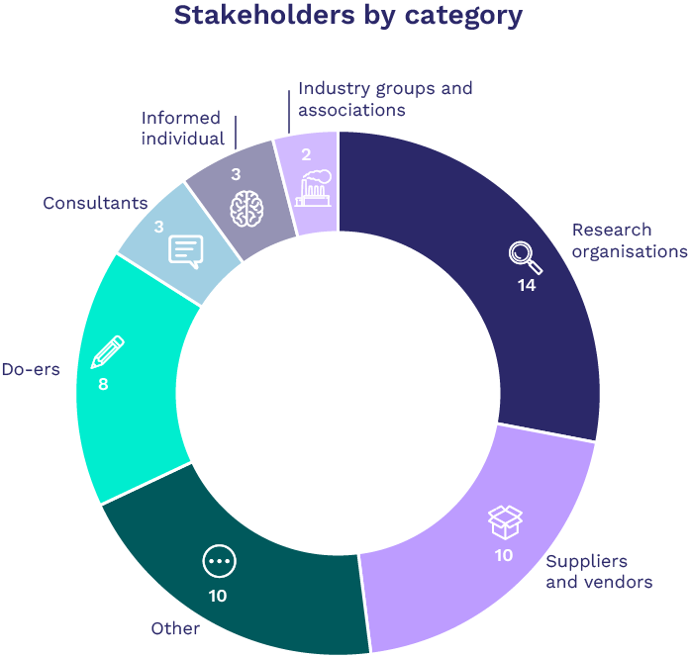
Figure 1 Overview of stakeholder engagement by category
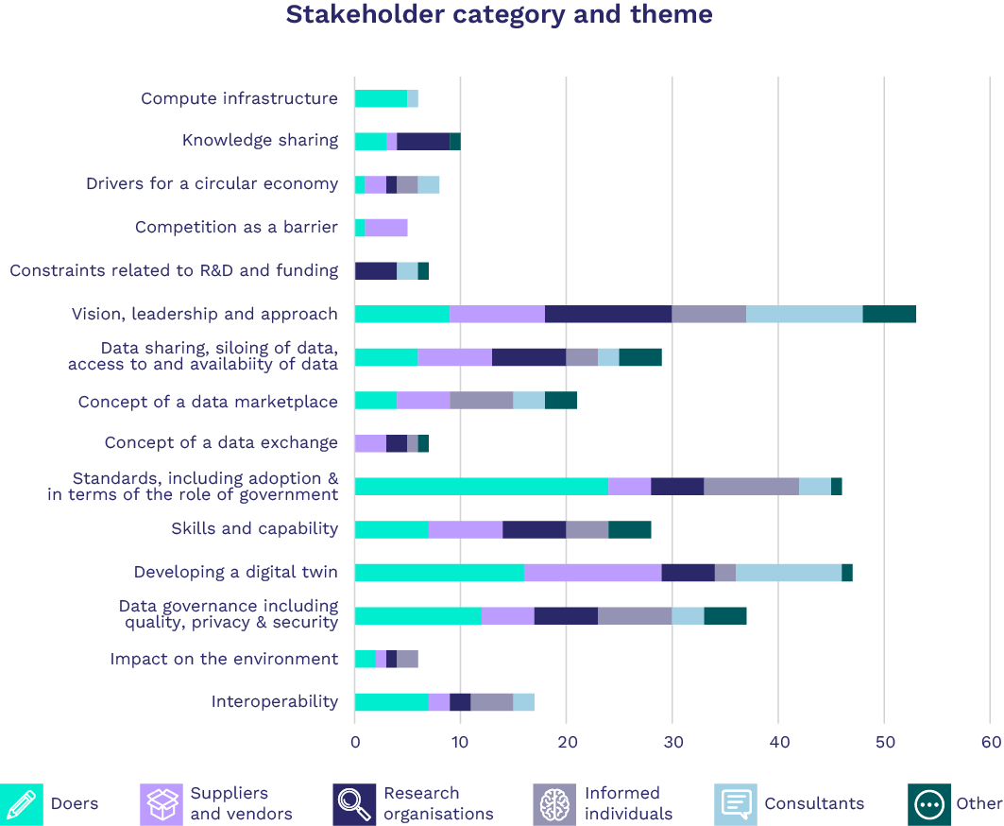
Figure 2 Topics of conversation based on stakeholder category
From the engagement process we identified primary barriers to digital twin adoption:
- Interoperability limitations on data management and storage. There are no consistent standards or conventions being applied in nomenclature, quality, and format. This limits the ability to connect data from different sources and control access to it.
- High energy use and the attendant financial and environmental costs of data crunching computer power.
- Data security, sovereignty, ownership, sharing and recognition of value, especially from a Māori perspective. As we push the boundaries of digital technology, data privacy and the safety of sensitive data is becoming more of a concern.
- Skills gaps. This technology is evolving rapidly, but adoption does not come naturally to all professions. Skills and capability development are a slow process and the learning curve can be steep.
- Lack of collaboration can mean siloed data and similar projects with no communication between them. Competitiveness is hindering even foundational data set sharing, leading to inefficiencies.
- Difficulty getting high quality unbiased data. For example, digital designs from engineering companies include a disclaimer on their accuracy, creating the perception of increased risk and uncertainty.

Key conversation topics from stakeholder engagements
Figure 3 (below) sets out the key themes and the breadth of interest from stakeholder interviews about digital twins.
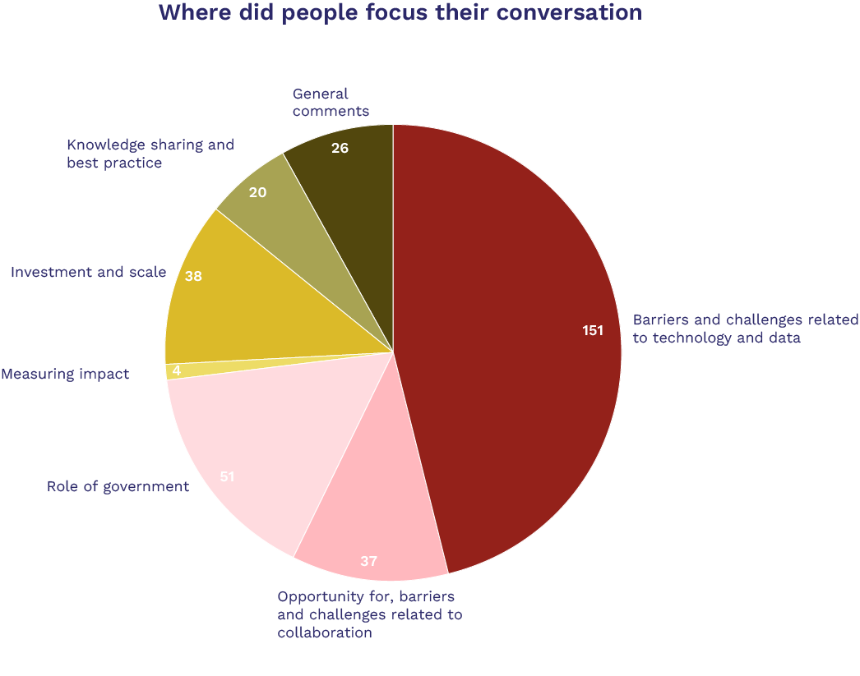
Figure 3 Overview of where the conversation in stakeholder interviews about digital twins was focused

Barriers and challenges related to technology and data
Stakeholder comments highlighted that digital twin technologies in New Zealand face formidable obstacles.
First and foremost, the lack of data literacy and maturity significantly limits the effective exchange and use of data, hindering the overall potential of digital twin technologies.
Another critical impediment lies in the absence of the common data standards necessary to integrate information from diverse sources. Stakeholders interviewed did, however, acknowledge the challenges in terms of adoption of standards and suggested a “we will build it and they will come” approach may be worth considering.
As digital technologies continue to push boundaries, ensuring robust data ethics and privacy measures becomes increasingly paramount. Upholding ethical practices, not only within the projects but also for the benefit of the communities involved, is vital. This is particularly true when considering the principle needs of Māori communities.
A focus on enhancing data accessibility, breaking down data silos, and maintaining data quality is crucial. This should emphasise rigorous data governance and strategic efforts toward promoting interoperability.

The role of government
Participants considered that it would be essential for the government set a clear vision and leadership on effective tracking of critical product lifecycle information. By implementing policies that encourage data sharing and collaboration, it was considered that the government can foster a conducive environment for the development of new and innovative products and solutions. A first step may be valuing data for the future, by requiring digital information be provided in public procurement processes.
Furthermore, the government can drive progress by the adoption of standardised frameworks and promoting the integration of digital models across various sectors. By taking the lead in establishing clear governance arrangements and promoting data compatibility, the government can create a more sustainable and scalable platform for technological advancements and data management.

Collaboration
The current approach of building digital twins in isolation without standardisation or interoperability is leading to fragmentation and restricting the technology's potential. By emphasising collaborative initiatives and promoting standardised practices, New Zealand can foster a more unified and efficient approach to digital twin development. This would help unlock the technology's full capabilities.

Knowledge sharing and best practice
Collaborative initiatives, such as bringing together stakeholders and forming communities of practice, could significantly contribute to knowledge sharing and capacity building. Facilitating networks that promote the exchange of ideas and expertise can assist learning and growth. This is particularly true for smaller organisations.

Measuring impact
Participants talked about the need to differentiate between theoretical ideals and actual, tangible progress. Recognition of data value should be part of a more holistic approach to impact assessment.

General comments
The discussions reflected the diverse perspectives and general observations of the individuals interviewed. They focused largely on the critical importance of data, technology and effective decision making. There was also an emphasis on the potential for digital twins to revolutionise businesses, stimulate market innovation and ensure data continuity across product lifecycles.

New Zealand’s digital twin maturity
Our engagement process also enabled us to develop a high level of assessment of New Zealand’s digital twin maturity, shown in Figure 6.
It indicates that New Zealand's digital twin maturity is at an early stage, primarily denoted by a ‘red’ (low level of maturity) and ‘yellow’ rating (implying the need for increased investment and focused efforts).
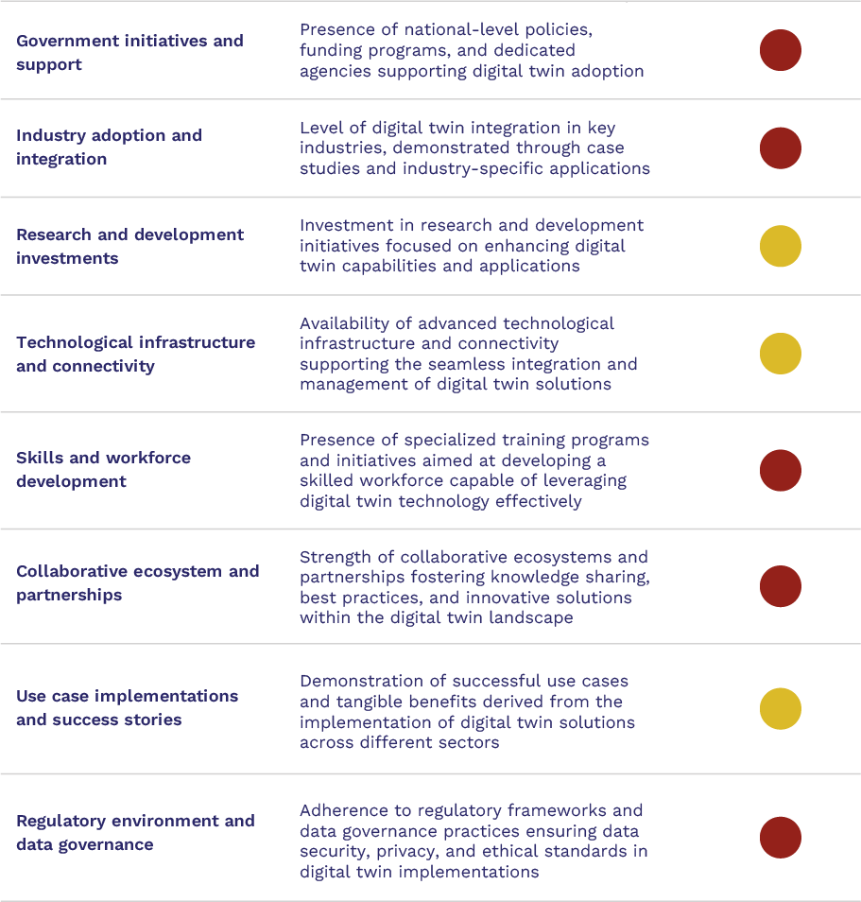
Figure 4 Digital Twin Maturity Assessment
Key: Red = Low level of maturity. Yellow = Implies the need for increased investment and focused efforts.

Current and upcoming developments discovered through the stakeholder engagement exercise include the following projects and collaborations:
- The New Zealand Digital Twin Partnership (DTP-NZ) body announced its launch in June 2023 with a sole focus on leadership and advocacy for the digital twin market. Like its Australian counterpart, DTP-NZ will focus on advocacy, building capability through collaboration, innovation and standardisation, and bringing together a community of stakeholders to share and learn, as well as a commitment to engaging with iwi.
- The Digital Built Aotearoa Foundation was created in 2023. Initially established to provide a national, neutral home for the NZ Forward Works Viewer, it will expand to become a repository of knowledge across the infrastructure sector, with a specific focus on collaboration and disaster recovery to improve infrastructure resilience. The Foundation’s goal is to encourage collaboration and knowledge sharing from lessons learned to enable and improve infrastructure resilience throughout New Zealand, offering digital tools, maintaining and making available data processes and standards, and promoting coordination and collaboration amongst stakeholders.
- At the University of Auckland, the Digital Twin Computer Science Collaboratory is developing a computer science collaboration for digital twins. Meanwhile, the New Zealand Centre of Research Excellence (Te Pūnaha Matatini) is developing a project inspired by Te Ao Māori that advocates for the development of digital ecosystems rooted in specific communities.
- The Scion led Forest Flows research programme includes a digital twin component with innovative use of Internet of Things networks, big data and remote sensing. This work has attracted interest from NASA and the European Space Agency (ESA).
- Māori economic development agency Reureu Kotahitanga Ltd received funding of $250,000 + GST from Hoe ki angitū - the Waka Kotahi Innovation Fund to develop a digital twin of the 6.1 km rail corridor between Halcombe and Kakariki in Manawatū. Data and insights from this initial project are now being used to refine operating practices, develop risk and safety plans and assess the ongoing benefits for the community, consumers, and operators. The agency is proposing to deploy a test rail shuttle in 2024. This is intended to improve model accuracy and generate the data necessary to help train an Artificial Intelligence to safely operate an autonomous shuttle service. The aim is to launch a pilot commuter service by 2027.
- Through the Construction 4.0 Endeavour programme the University of Auckland will be developing a digital twin. The Institute of Environmental Science and Research (ESR) is developing an Endeavour programme proposal focused on AI as an enabler for digital twin in a number of areas including the circular economy.
- Massey University researchers are looking at developing an Endeavour research programme proposal focused on digital twin related to the built environment.
- The Geospatial Research Institute, at the University of Canterbury, is developing a Smart Ideas proposal for Digital Twin as a Service for flood risk assessment across the country.

Te Ao Māori and digital technologies in the circular economy and bioeconomy
Our stakeholder engagement provided us with insights regarding the circular economy within the Māori context. Specifically, we encountered a shared emphasis on sustainable community development and intergenerational continuity.
However, it should be stressed that the circular economy does not directly align with mātauranga Māori. Economy, in the sense of production and consumption, is not a concept in Te Ao Māori. Māori are inherently connected to whenua through whakapapa lineage. Papatūānuku and Ranginui are tupuna, denoting a responsibility to take care of them, and Kaitiakitanga is to be responsible for guardianship of the whenua. This plays a vital role in enriching biodiversity and countering the adverse effects of land-use change and pollution, highlighted as significant challenges in the Biodiversity in Aotearoa report.
Amidst discussions about technological integration, the central focus remained on bridging the gap between theoretical knowledge and practical application - ensuring technology aligns with the community's needs. It emphasises the significance of nurturing and reinvesting in the community's assets.
In speaking with a representative from Te Ao Matihiko, a digital learning collective, we understood that for Māori the potential of digital twin technology could be viewed through a combination of tradition and innovation.
In various iwi communities, geospatial technology is readily embraced. It serves as a powerful tool to map sites of significance and forecast economic development outcomes. This integration of traditional knowledge and modern technologies facilitates informed decision making for sustainable economic growth and land use. For example, digital twin capabilities in the agritech sector enable the testing and modelling of crop yields, optimising the supply chain and enhancing productivity. Additionally, within the marae settings, the use of digital twin technology holds the promise of comprehensive mapping, providing valuable insights to prioritise ongoing work programmes and support community development.
Māori are, and have been, data designers, collectors and disseminators for generations. In recent times, Māori data has been defined as digital or digitisable information, or any kind of knowledge, that is about or from Māori people, language, culture, resources or environments. The importance of data for the advancement of indigenous development has been emphasised by indigenous NGOs, communities and tribes globally. At UN Permanent Forum on Indigenous Issues (UNPFII) events over the last years, representatives have expressed concerns regarding the suitability of existing statistical frameworks for capturing their perspectives. They’ve highlighted the limited indigenous involvement in data collection, management, storage and governance.
The digital revolution and the rapid pace of technological advancements have significantly changed how data is created, replicated, transmitted, stored, accessed and used. This is amplifying both potential advantages and risks. Māori data can be viewed as living taonga and understanding ownership protocols around it is crucial.,
These issues and opportunities gave rise to the Māori sovereignty movement. It arises from the fundamental right of Māori to govern, manage, and control their own data. It acknowledges the significance of data in preserving cultural heritage, fostering self-determination and advancing socio-economic wellbeing.

The key principles of data sovereignty are:
- Rangatiratanga | Authority
- Whakapapa | Relationships
- Whakawhanaungatanga | Obligations
- Kotahitanga | Collective benefit
- Manaakitanga | Reciprocity
- Kaitiakitanga | Guardianship

The application of digital technologies in respect of these principles might include secure data storage systems, encryption and authentication mechanisms that protect the integrity of Māori data.
As virtual replicas of physical entities or systems, digital twins can play a role in safeguarding cultural heritage. They can enable Māori to manage, update and use them in ways that align with their values and traditions. It may empower Māori to have authority over how their data is collected, stored, and shared. This control is pivotal in safeguarding the privacy and dignity of Māori people and ensuring that their data is used to benefit their communities rather than exploited for external interests.,,
“As a Māori woman deeply engaged with my community, I am passionate about the circular economy. My interactions with rangatahi, kaumatua, and our wider community have shown me the depth of mātauranga Māori in this area, surpassing that taught in universities.
For us, the circular economy is not just theoretical; it is deeply practical. It revolves around the concept of 'home fires,' ensuring that no matter where we go or what we do, we bring our skills and resources back to benefit our people and our land. It embodies the essence of giving and returning, fostering a continuous cycle of reciprocity and sustainability.
Reflecting on the legacies of our ancestors and the work they have passed on, I realise that I am part of a much larger and enduring legacy. This realisation aligns with the idea of a circular legacy, where our culture continues to thrive and evolve, ensuring that future generations carry forward the work and values that define us.”
Elle Archer, Executive Board Chair – Te Ao Matihiko
An example project is the Microsoft Lighthouse collaboration with Ngāti Toa in Porirua and the Ministry for the Environment (MfE). This is the first time stories from mana whenua have been combined with Western science to build a virtual city.
It shows how landscapes are affected by human decisions, including environmental hazards like sea level rise and pollution. It incorporates video interviews with rangatira and kuia. It’s intended to be used for environmental restoration planning or issuing building consents.
In our research a representative of the Ngai Tahu Centre at the University of Canterbury described how in serving as educational tools, motivational platforms and decision-making guides, digital twins can effectively represent and communicate the intricate relationships and interconnections at the core of Te Ao Māori. These technologies enable the visualisation of decision impacts along a chain, modelling different scenarios for risk-averse Māori authorities exploring new ventures. Incorporating the principles of kaitiakitanga, digital twins can actively engage with the world, highlighting and displaying relationships crucial for monitoring, measuring and motivating actions. The flexibility of these tools allows users to tailor views based on their priorities, aligning with diverse Māori perspectives.
Māori values, particularly kaitiakitanga, can be harmonised with modern technologies like digital twins. The alignment emphasises a holistic approach common to digital twins and Māori cultural values, focusing on understanding systems and their interconnected components. Data, from a Te Ao Māori perspective, is likened to the DNA of whakapapa, underpinning interconnectedness and reflecting Mātauranga Māori. Emphasising tikanga in technology, adherence to Te Mana Raraunga/Māori Data Sovereignty principles ensures respectful, secure and culturally sensitive data management practices. This aligns with ethical considerations and honouring the significance of data within the Māori worldview.
However, this discussion goes beyond data sovereignty, towards a cultural philosophy for navigating the digital world. Steering traditional protocols in the digital realm involves a holistic approach, integrating cultural wisdom and technological advancements. Through the exploration of te reo, tikanga and indigenous knowledge, the journey of understanding technology in relation to indigeneity and Mātauranga Māori has been transformative for Māori. This has led to a deeper appreciation and comprehension of collective consciousness and holistic thinking. The emphasis lies in fostering true collectivism, transcending individual ego and emphasising the foundational aspects of Māori philosophy.
Finally, the significance of infrastructure within Māori communities resonates deeply. As a Te Ao Matihiko representative explained, this is especially true in the context of preserving traditional knowledge and integrating it with contemporary advancements. The integration of this ancient wisdom with modern technology through the digital twin concept symbolises the cherished connection between the past and the future, ensuring the preservation and perpetuation of Māori heritage and wisdom for generations to come.
As such, applying a Te Ao Māori lens to digital technologies can take many different forms and approaches. The following key themes help unpack the “how” and the “why”.
Cultural preservation and recognition
Recognising and preserving Māori cultural values, knowledge systems and practices promotes the integration of traditional wisdom and cultural practices into the design and implementation of digital technology and data solutions. This helps to ensure these solutions are culturally sensitive and aligned with Māori values.
Cultural sovereignty and empowerment
Allowing Māori to have sovereignty over their cultural and intellectual property empowers the Māori community. It provides opportunities for Māori to participate in decisions related to digital technologies and data that directly impact their community. This fosters empowerment and self-determination.
Cultural inclusivity and equity
Promoting cultural inclusivity and equity in the development and use of digital technologies and data ensures the benefits of digital technological advancements are accessible and equitable for all communities, including the Māori population. This reduces the risk of widening the existing digital divide and disparities.
Sustainable development and environmental stewardship
Aligning with Māori principles of kaitiakitanga and incorporating traditional ecological knowledge and practices, a Te Ao Māori perspective emphasises the importance of environmental sustainability and stewardship. It encourages the development of solutions and the leveraging of data that prioritises environmental protection, sustainability and the preservation of natural resources.
Interconnectedness and whanau wellbeing
It’s important to acknowledge the interconnectedness of individuals, communities and the environment in the development of technologies. Doing so embeds Te Ao Māori priorities of community wellbeing, social cohesion and the enhancement of whanau structures. This promotes holistic social development beyond economic growth.

Innovation
Inclusivity fosters diverse thinking. It stimulates unique problem-solving. It weaves in traditional knowledge that ensures we’re catering for the needs and aspirations of the Māori community. It also contributes to the overall technological advancement and sustainability of New Zealand.

Recent developments
Initiatives to support the Māori tech sector in New Zealand have been gaining traction. Efforts have been made to promote and advance Māori participation in the technology industry, fostering innovation, entrepreneurship and digital literacy within the community. The following examples demonstrate this.
Te Matarau | Māori Tech Association
Founded in 2021, Te Matarau provides advocacy, networking and collaborative opportunities, as well as coordinating the efforts of Māori in the technology sector.
It aims to:
- Promote diversity within the technology sector.
- Increase opportunities for Māori working in the tech sector.
- Improve digital outcomes for all Māori.

Te Hapori Matihiko is a community for Māori working (or aspiring to work) in digital and tech roles. The community facilitates regular mātauranga sessions with leaders and hosts the Matihiko Awards. These recognise excellence in Māori contribution across a range of digital and tech kaupapa.
In October 2023 Te Matarau and Te Hapori Matihiko announced they would come together as Te Ao Matihiko.
Digital Technologies Industry Transformation Plan
The Digital Technologies Industry Transformation Plan (ITP) was developed by industry and government agencies.
It has four immediate focus areas, one of which is enriching Māori inclusion and enterprise, focused on promoting and supporting activity that enhances Māori leadership and participation in the digital technologies sector and appropriately builds on mātauranga Māori.

Key initiatives
In February 2023, MBIE was a part-funder of the inaugural Māori Tech Annual Report. This highlighted the success and economic contribution of Māori technology companies, their founders, and their workforces.
In July 2023, Making Everything Achievable, in collaboration with MBIE, Te Whare Wānanga o Awanuiārangi and NZTech, produced Mapping the Māori Tech Sector 2023 Report. This sheds light on the profound impact this integration has on their learning experiences and professional journeys.
Also, the Tikanga in Technology research by Te Kotahi Research Institute helps to describe and operationalise the rights and interests of Māori to data under the values of Te Tiriti o Waitangi. This enables Māori to be empowered and skilled to participate in and lead data collection, utilisation within data science, and governance of data resources so that the innovation potential of data can be realised by Māori.
Funded by the MBIE Endeavour Fund, Tikanga in Technology advances indigenous approaches to transforming data ecosystems. The research aims include indigenous data:
- in Governance - Collective privacy, collective benefit.
- in Systems - Data classification, provenance, and valuation.
- in Artificial Intelligence - Decolonising algorithms, indigenising AI, natural language processing and generation.

Te Mana Raraunga - Māori Data Sovereignty Network
Te Mana Raraunga was established to advocate for Māori rights and interests in data to be protected. Its purpose is to enable Māori data sovereignty and advance Māori aspirations for collective and individual wellbeing.

Other digital technologies
There are many ways in which digital technologies can enable a circular economy and bioeconomy in New Zealand.
To illustrate, below is a table with some of the currently available or imminently emergent technologies. Figure 6 provides a visual representation of some of these digital technologies and an indicative market penetration assessment. Please note this graphic is a subjective analysis based on a broad, high level assessment from published literature and commentaries received from those working in the field.
Relative relevance of emerging digital technologies to the circular economy
 | High relevance | Medium relevance
Enabling technologies | - The Internet of Things (IoT)  - Robotics and Automation | - High Speed Internet  - Interoperability Standards  - Machine learning  - Image recognition  - Bioinformatics | - Cloud Computing  - 5G  - Unmanned Aerial Vehicles  - Financial Technology  - Advanced Materials
Advanced manufacturing | - 3D Printing/additive manufacture  - Digital Engineering | - Nanotechnology
Digital transactions & Data management | - Artificial Intelligence (AI)  - Big Data  - Online trading platforms/marketplaces  - Digital Passports | - Data Integration Tools  - Blockchain  - Distributed Ledger Technologies  - Circular platform marketplaces  - Open Finance  - Memory Driven Computing | - High performance computing  - Quantum Computing  - Surveying and Mapping Technologies  - Collaborative Computing  - Cloud Computing
Virtualisation | - Software as a Service (SaaS) including mobile apps | - Digital Twin  - Simulation & Visualisation software  - AR/VR/XR Technology | - Building Information Modelling  - Mobile Applications  - PaaS

It should also be noted that widespread deployment, even in areas that might be considered beneficial to a circular economy, comes with significant risks and concerns.
These include:
- The energy, material use and waste associated with big data processing – the International Energy Agency (IEA) suggest energy use for data centres and transmission networks is each around 1-1.5% of global electricity use.
- Widespread deployment of digital technologies can also be used to facilitate aggressive, even predatory competition, coercion/extortion, control and various forms of commercial and/or geopolitical espionage as well as warfare.
- The use of new digital technologies to control personal and commercial data and to control the movement and behaviour of individuals through technology such as facial recognition, digital ID and Central Bank Digital Currencies (CBDCs).
- Involvement of digital technologies like blockchain in high profile, high value global fraud cases, most notably the US$32 billion collapse of leading crypto-currency exchange FTX.
- Bias, privacy concerns, security risks and ethical challenges related to the rapid development and deployment of AI, possibly with an unprecedented scale and pace.

There’s evidence internationally of efforts to address some of the concerns and risks, many of which are not well defined.
In addition, current assessments of the relative importance of technologies and applications, including for the circular and bioeconomy in New Zealand, remain subjective. This is due partly to the myriad of possible technologies, applications and interactions between them.

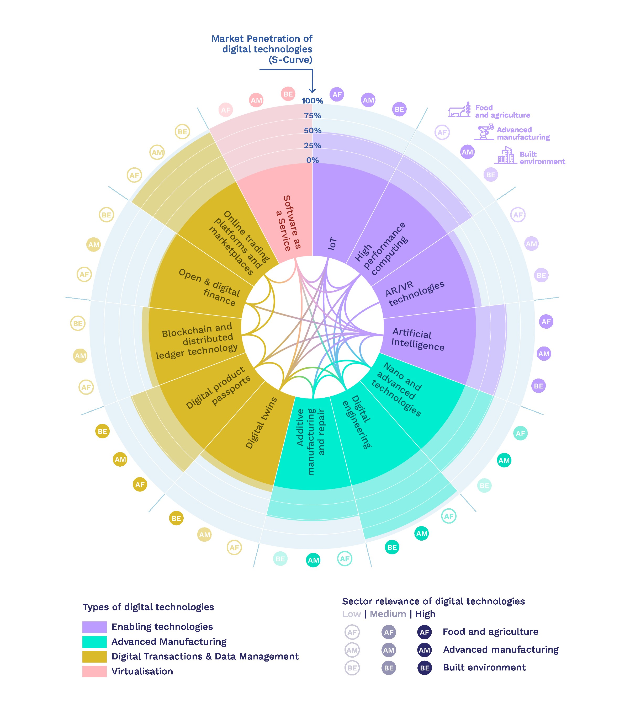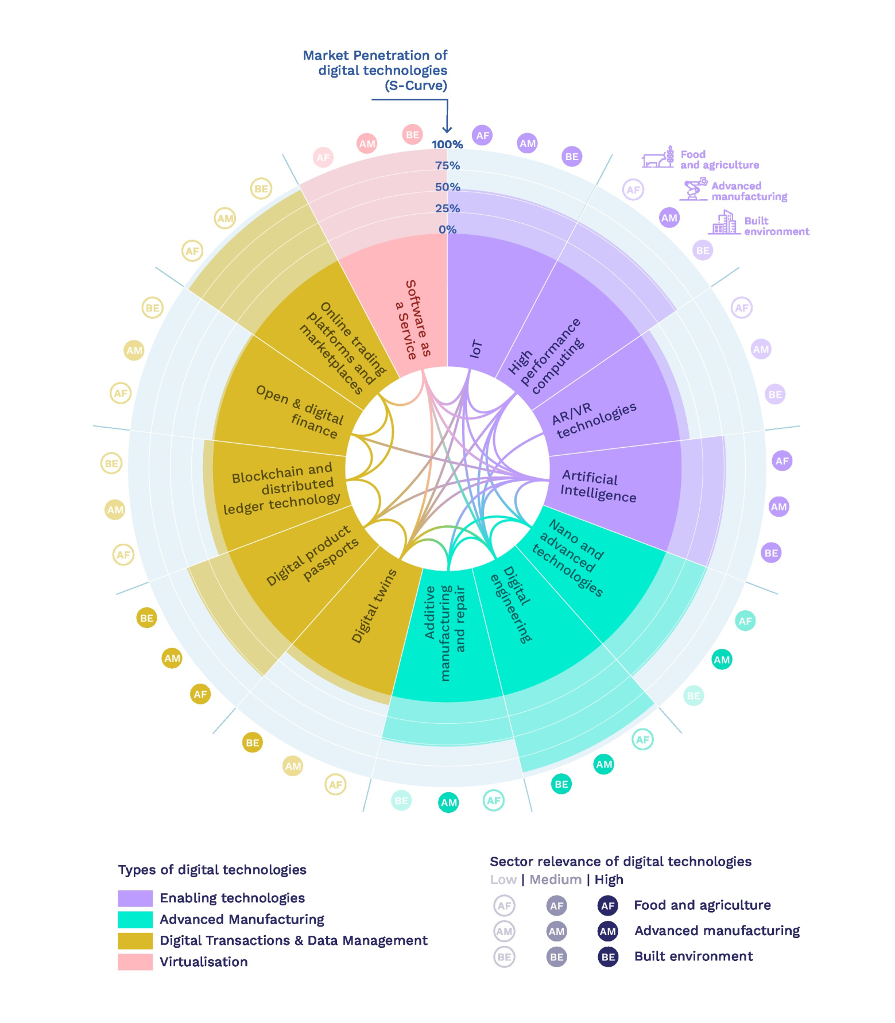
Figure 5 Emerging digital technology market penetration chart (using subjective analysis)

In many cases the dividing lines between these technologies and combinations of technologies, blur and/or overlap, so even their definitions are not definitive. The Organisation for Economic Co-operation and Development (OECD) has attempted a visual representation of the possible interactions and overlaps between different kinds of digital technologies and their applications within the emerging circular economy.
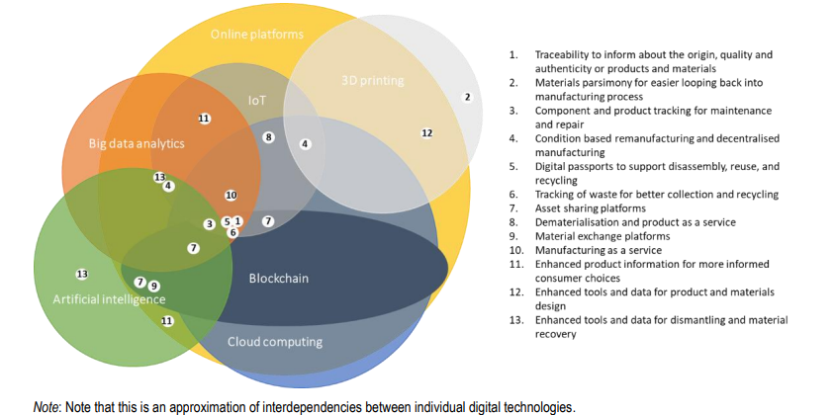
Figure 6 Examples of circular economy activities enabled by the combinatorial power of digital technologies. Bartekova, E & Borkey, P. 2022. Digitalisation for the transition to a resource efficient and circular economy, OECD Environment Working Papers N. 192.
For our purposes, we explored the ‘high relevance’ technologies and their potential role in supporting the circular economy and bioeconomy, as well as digital twins. Further information can be found in Appendix 3.

Other digital technologies

Artificial Intelligence (AI)
The management of material stocks and flows has been identified as a key potential area for big data analytics and AI in fostering the circular economy., Big data analytics and AI can process vast quantities of data in current material stocks. They can pinpoint and map the potential end-of-life uses of these materials. AI can identify recoverable materials through developments like image recognition. This works well in material recovery facilities and automated Deposit Return Systems. A higher quality of sorting of recyclates can determine the financially viability of a process.
AI can be used in optimising circular product design and circular business models. This includes material selection, recycled content, designing for disassembly and more. AI can be used to rapidly process the interactions and relative merits of these criteria.
Big data and AI may be what makes reverse logistics and remanufacturing commercially feasible. Secondary materials markets frequently experience instability in demand, supply and the quality of materials or products., AI-based analytics can help businesses retrieve and process these large quantities of product, consumer and market data for decision making.
There is also potential to enhance the policy implementation process. For example, AI can be used to identify fraudulent behaviours and non-compliance in the marketplace, such as in Deposit Return Systems. AI is increasingly used as a powerful tool for market surveillance by automating the detection of outliers. This can be useful, for example, to identify potential non-compliances for sustainability and circularity credentials and certifications. AI can also be used to inform future policy development by identifying upcoming market trends.
The bioeconomy can also benefit from ‘big data’. Sensors, drones and other IoT devices can collect data about soil quality, weather conditions and crop health. AI can then process this data to optimise resource usage, increase crop yields and reduce waste. With this variety of data sources in the bioeconomy, methods for integrating and analysing them are crucial. Bioinformatics is a field that relies heavily on big data and AI to analyse biological data. This can also include DNA sequences, protein structures and metabolic pathways.
Some examples include:
- AI-based image recognition: Researchers have developed a machine learning algorithm to detect windows suitable for reuse from Google Street View images. CattleEye uses overhead cameras and computer vision algorithms to monitor cattle health and behaviour.
- AI circular material design: Project ‘Accelerated Metallurgy’ was a pilot demonstrating the use of AI to rapidly develop and test many thousands of metal alloy formulations designed with circular economy principles.
- AI-based software: Winnow’s software analyses food waste data and generates targeted waste reports in large commercial kitchens to reduce food waste. Similarly, ReFED is an interactive online platform that uses big data and AI to analyse food waste in the United States by sector, cause, impact, location, and more.
- Machine learning: AI is used to improve electronic waste sorting by Reconext and for materials from plastics to wood chip by Tomra. Deep learning is a subset of machine learning. It uses mathematical functions to map the input to the output. Deep learning is being used to diagnose plant disease, with an AI model trained on apple black rot images. It’s able to identify and diagnose with an accuracy of 90.4%. This indicates the proposed deep learning model may have great potential in disease control for modern agriculture.
- AI and robotics: Ecocycle provides high quality sorting of e-waste to improve recycling and recovery rates.

Robotics and automation
In 2021, more than 500,000 new industrial robots were installed in factories around the world.
With their ability to carry out precise movements repeatedly and consistently, robots can play a major role in reducing wasted materials. Robotics and automation have the potential to optimise resource use, reduce waste, streamline processes and improve the overall efficiency of circular and land management practices.
Examples include:
- High-speed robotic sorting systems, produced by companies like AMP Robotics, can perform physical tasks of sorting, picking and placing material. They can achieve up to 99% accuracy and capture more high value material with minimal contamination.
- Robotics can provide lower risk, lower cost options for recycling toxic materials. For example, the KUKA KR QUANTEC device extracts poisonous gases and removes harmful elements such as fluorescent tubes and screens.
- Bosch has been developing Bonirob, an agricultural robot to automatically detect and physically destroy weed plants.
Robotics manufacturers also need to consider the lifecycle of their own products from a circular economy point of view.

The Internet of Things (IoT)
The Internet of Things (IoT) is where individual products or parts of products can communicate. For example, a connected washing machine that advises when a wash is finished, or a fridge that can provide up to date stock and shopping information.
IoT offers convenience, data creation, collation and collection as well as greater visibility across users, uses and networks. This can facilitate take-back schemes, servicing, upgrading and repair of products. This is especially true of ‘product as a service’ approaches, such as hire, lease and group ownership. These lend themselves to enhanced producer responsibility and circularity for device manufacturers.
In the circular economy IoT has the potential to facilitate reverse logistics. The network of IoT devices can be used to monitor and track complex information about products vital for their reusability and recoverability such as condition and availability. In conjunction with robotics and AI applications, IoT can be used to automate processes, such as returning reusable products to a well-defined and accessible stock inventory.
IoT can be useful for extending product life and maximising resource efficiency. The information collecting and transmitting capabilities of IoT can enhance the reusability of goods at scale by providing real-time information on asset availability, location, and functionality. IoT also helps extend product lifespans by communicating defects for maintenance and enhancing technical maintenance provisions and services. It can increase product efficiency by shutting devices down when they are not in use. IoT combined with 3D printing could theoretically remove the need to stock large spare part inventories.
Major cities, like Hong Kong, are using IoT monitoring for preventative maintenance of key infrastructure and built form. This prolongs the effective life of these facilities, conserving resources.
The IoT has also been used to improve remanufacturing and repair processes. For example, General Electric uses industrial IoT and cloud computing to assess the condition of the motor engine to be remanufactured before ascertaining the remanufacturing or repair procedure.

Software as a Service (SaaS) including mobile apps
SaaS is particularly of interest in the role it can play in supporting alternative business models and assisting with warranties, repair and guarantee information.
‘Access over ownership’ is a key concept in the circular economy. It’s expressed in models like Product-as-a-Service (PaaS). It provides access to products via services (rental and leases) rather than ownership, which can result in less production of goods in the long run and reduced material use. This can also increase customer engagement and attract a wider range of customers than a simple sales model. Some studies suggest that PaaS can achieve up to a 50% reduction in environmental footprint from a standard sales and ownership model.
Software-as-a-Service (SaaS) is a digital application of this. While material use is limited in software sales, SaaS models can be key enablers for the circular economy. For example, software can manage product rentals or help customers repair, reuse and recycle. Consolidation of software can also reduce resource use and create efficiencies.
Some examples include:
- The Circulars Accelerator collaborative project provides innovative circular start-ups access to cloud supercomputers via a SaaS platform.
- SAP offers software to help design out waste and pollution, optimise resource use, and apply innovative circular business models. Its range of circular economy software solutions includes packages for responsible design and management, circular packaging, product lifecycle management, and supplier transparency.
- Lizee’s Rental Management System promotes the reuse of consumer products.

Online trading platforms and market places
Online trading platforms such as Trade Me, Ebay and others, organise data streams, economic interactions and social exchanges between users.
To date, platform marketplaces have largely supported traditional linear consumption models. They prioritise convenience, with products and packaging largely becoming waste after use. However, there are several platforms emerging that facilitate sharing, leasing, repairing, refurbishing and recycling.
They can:
- Close information gaps in existing waste and recycling material markets.
- Help establish networks that create value among the manufacturing, waste and digital sector.
- Reach large audiences and create positive feedback loops.

Digital passports
Digital passports can hold and transfer in-depth information about products, such as material composition, manufacture and usage history.
These can be linked to digital twins to provide a seamless flow of information throughout an asset or a product's life cycle. Information stability and access can help facilitate more efficient repair, reuse, recycling and waste management.
Digital passports can interact with other technologies, such as blockchain, to provide a secure and decentralised framework for storing and managing data, IoT to enable real-time connection between physical products and sensors or trackers, and big data to manage and analyse large amounts of data.
Some examples of digital passports include:
- Madaster. An online material and products registry for the built environment. Within the platform, data from a specific project is recorded with insights around disassembly, embodied carbon and toxicity of materials. Madaster creates comprehensive material passports for assets, providing transparent and standardised documentation of the materials used to facilitate future reuse, recycling, and responsible end-of-life management.​
- Circularise is a blockchain platform. It provides digital product passports to enhance traceability and secure data exchange for industrial supply chains. It provides a detailed record of a product’s origin, material composition, LCA data and additional environmental data.
- The concept of a Digital Wallet is currently being explored by the Trust Alliance in New Zealand. It will allow farmers and growers, to improve the efficiency of sharing their verified farm information with regulators, auditors, financial services, processors and/or retailers.
The adoption rate of digital passports is growing slowly, but remains relatively limited due to technological constraints, costs and concerns about data integrity. That may be about to change. The recent EU Digital Product Passport (DPP) requirement will add regulatory momentum. This system is intended to become an integral part of the EU market, affecting most products sold within the union by 2030 – including goods from New Zealand.
This presents both challenges and opportunities for businesses. Companies that act early may be able to shape the regulation, improve compliance and benefit from opportunities from early adoption. However, companies need to prepare for uncertainties in the initiative’s scope, technical setup and data requirements.

3D Printing/additive manufacture
Additive manufacturing (AM) could play a significant role in the circular economy and bioeconomy. It provides advantages in resource efficiency and design flexibility. Provided items are properly designed and executed, it has the potential to reduce waste by using only the material required.
AM is favoured in various applications for its additional design freedom. It can produce a single component that replaces multiple parts in traditionally manufactured products, reducing material requirements. This design freedom also offers the potential for considerable weight and material savings. It allows engineers to focus materials only where structural integrity is needed. This feature is particularly beneficial for industries like aerospace, where weight is a critical factor. It’s also used in medical devices, where the customisation of implants to individual patients represents a significant benefit.
AM is not without its challenges. It can create less waste at the production stage, but the post-manufacturing phases still generate waste, albeit at reduced volumes. Health concerns, such as the release of fine particles, also need to be considered and managed.
Quality control, especially for items with low fault tolerance, is also an issue. Organisations like SAE International are developing specific guidelines and standards for this, which could include the use of digital twins.
Some examples include:
- Companies like AMFG are offering digital warehousing solutions for more distributed production, aligning with the principles of a circular economy.
- The 2020 Tokyo Olympics medal ceremony podiums were 3D printed using recycled plastic.
- Companies like Krill Design have capitalised on AM using waste materials like recycled orange peels.
- In New Zealand 3D printing of concrete structures is provided by Qorox and its “Don’t build it. Print it” service.

Digital engineering
Digital engineering is the development of virtual models to represent complex products and systems prior to their construction or assembly. This modelling process creates digital data and connectivity to aid integration between design, development, delivery and support across the whole lifecycle of an asset. It leverages technologies like computer-aided design (CAD), simulation, data analytics and collaboration platforms. This creates a comprehensive and interconnected digital representation of a system or product. It can support collaboration among stakeholders, enhance productivity, minimise costs, improve decision making and management of operational life.
This has gained momentum in New Zealand in recent years. It’s been driven by the government's commitment to advancing digitalisation and innovation within the construction and infrastructure sectors. For example, initiatives like the Construction Sector Accord have actively promoted digital engineering to improve project delivery and asset management. Collaborative efforts between government agencies, industry stakeholders and academic institutions have resulted in the development of advanced digital engineering frameworks and standards. This is fostering a culture of innovation and technological advancement. It’s also demonstrated the tangible benefits of enhanced efficiency, sustainability and resilience in the construction and maintenance of critical assets.
The Construction Sector Accord, the New Zealand Institute of Building’s work on the BIM Handbook, and the Asset Management Data Standard, led by the NZ Transport Agency Waka Kotahi, are examples of this.
Infrastructure New Zealand’s recently published Infrastructure New Zealand Position Paper: Digital challenges those operating within and with the sector to accept that the infrastructure sector must change fast. It acknowledges that work cannot continue the way it has always done – to continue to accept the systemic inefficiencies that exist in project delivery across the sector is not an option.
“Digital engineering, as a holistic approach that spans the entire lifecycle of an asset, complements the systems approach of digital twin technology. It enables the seamless integration of design, construction, and operational data, ensuring a comprehensive representation of the asset’s history. This integration facilitates real-time monitoring, predictive maintenance, and lifecycle management, aligning with the circularity principles of sustainable resource management and minimising waste. By harmonising these methodologies, organisations can achieve a more efficient and sustainable approach to asset development and management, ultimately contributing to the advancement of circular economy practices.”
Project 13 is an industry-led innovative delivery model for infrastructure. It brings together owners, partners, advisers and suppliers working in more integrated and collaborative arrangements, underpinned by long-term relationships. It’s a response to infrastructure delivery models that fail not just clients and their suppliers, but also the operators and users of our infrastructure systems and networks. November 1, 2023 saw the release of its data and digital principles for project success. These are designed as propositions to guide decision making and behaviour in project delivery, regarding digital technology and data collection, management and analysis.
The principles are divided into:
- Purpose, for the creation of outcomes focused on end users’ needs and the use of technology as an enabler of that.
- Culture, to make data more accessible, with the creation of common languages and approaches for better inclusivity, and to develop data and digital skills and capabilities.
- Collaboration, to increase collaboration across shared data, through greater interoperability, standards, information requirements and good practices.
- Process, to use data and digital approaches to define clear common processes for project delivery.
- Value, to unlock and recognise the value of data for decision making and asset information management.
- Data, to establish clear data governance and stewardship.
- Security, using data and digital approaches to improve physical and personal security, not just cybersecurity, and ensure that information flows across organisational boundaries are trusted and resilient.
- Change, to create clear roadmaps, undertake regular benchmarks and understand that the journey is a change process.

Overseas developments
Several countries are pushing forward with ambitious digital plans. Some are listed below. However, at the time of writing this report there was little evaluation evidence we could find on the impact of these plans.
Singapore
Since 2016, the Singaporean Government has been actively promoting the development and adoption of digital technologies to transform the country into a “Smart Nation”. It established the Government Technology Agency of Singapore (GovTech), emphasising and enhancing its internal technical and digital capabilities.
Five ‘capabilities centres’ have been established to strengthen public sector engineering expertise and build the government’s capabilities in digital technologies.
- Application Design, Development and Deployment: Focused on delivering citizen-centric government digital services to support the public sector transformation.
- Cybersecurity: This centre provides a comprehensive range of technical and operational capabilities to cyber threats and implements strategies and programmes that enhance the cybersecurity resilience of government agencies in a sustainable, practical, and efficient way.
- Data Science and Artificial Intelligence: This centre is focused on formulating effective policies and delivering services through data-driven insights, by working with other governmental agencies in using data science and artificial intelligence to improve existing policies, outcomes, service delivery and operational efficiency.
- Government ICT Infrastructure: This centre’s expertise lies in the design and construction of flexible, secure, resilient, and cost-efficient ICT infrastructure tailored for the public sector. The scope ranges from data centres/hosting, networks, digital workplace applications, end-user devices, IT support, secure ICT Infra, and ICT Infra applications.
- Smart City Technology: Focused on designing, building, and implementing a government-wide IoT infrastructure to support a range of Smart City applications. The work ranges from hardware design on embedded platforms and robotics, to infrastructure development and deployment on cloud management platforms.
The government also developed the Digital Government Blueprint. This is a strategic roadmap and framework that outlines its vision and initiatives for leveraging digital technologies.
In addition, to drive co-creation and learning from both the public and private sector, GovTech developed the ‘Digital Academy’ and ‘STACK’. These offer programmes for the public service workforce and tech community. It also provided standards and guides to ensure a complete and consistent user experience.
Specifically on digital twins, Singapore developed the first ever digital twin city, entitled ‘Virtual Singapore’. This is co-led by the National Research Foundation, the Singapore Land Authority and the Government Technology Agency. It integrates a wide range of data sources, including geospatial data, environmental data, traffic data and more. Virtual Singapore is intended as a tool to test and refine ideas and policies before implementing them in the physical city. It has been upgraded with additional datasets, functions and scenarios. It is currently one the biggest examples of digital twin in application.

Estonia and Finland
The cities of Tallin and Helsinki, together with Tallin University of Technology and Aalto University, are part of the GreenTwins project. This aims to model the urban environment and develop models to provide information on the effects of urban planning.
GreenTwins is developing a green model for the digital twin cities (HEL-TAL) to test and analyse landscape changes as well as assist co-design of sustainable and liveable urban spaces.
Tallinn became the European Green Capital for 2023. This award recognises local action towards a transition to a greener, more sustainable future.
Dubai
Dubai Municipality’s GIS Centre contains maps and geospatial data for Dubai. It is currently developing the Digital Twin of the city.
The GIS Centre has also recently introduced “GeoDubai”, a platform offering mapping services.
Luxembourg
As part of a governmental approach to better understand the country and help manage crises that can range from pandemics and earthquakes to energy transformation, the Luxembourg Institute of Science and Technology (LIST) is currently working on a digital twin of the whole country.
Tuvalu
The Pacific nation of Tuvalu started a programme to create a digital twin of the country and perhaps become the world’s first digital-only nation, as climate change and rising sea levels threaten the future of the islands.
Since the programme launch at COP27, nine nations have agreed to officially recognise Tuvalu’s digital statehood, creating a pathway to sovereignty that can secure the country’s maritime boundaries and international voting rights.
Europe
The European Commission launched a major initiative that aims to develop a highly accurate digital model of Earth: Destination Earth (DestinE). This is intended to monitor and predict environmental changes and impacts and support sustainable action developments.
The initial phase of the programme is to develop extreme natural disaster digital twins. These will combine data with simulations to help anticipate events and responses. Beyond this, DestinE will support additional digital twins, ranging from urban for smart cities to biodiversity and migration.
UK
The government-led National Digital Twin Programme (NDTP) is developing the standards, processes and tools necessary for the foundation of a functioning market in digital twins. Launched in 2018, it aims to enable a national digital twin, deliver an information management framework and align a digital framework task group.
The UK has also developed a first-of-its-kind collaboration between academia, utility networks and government to create a climate change adaptation digital twin. This aims to improve climate adaptation and resilience across a system, by enabling data sharing across sectorial and organisational boundaries in a safe and efficient way.
The Gemini Principles outline a national digital twin framework in the UK. It is focused on aligning information management across the built environment and establishing agreed definitions and principles.
Australia
A recent report from Australia outlined the principles for spatially enabled digital twins of the built and natural environment. Drawn from The Gemini Principles, it outlines the vision of a federated ecosystem of connected digital twins and their value to the Australian economy.
States and cities
Australia’s Victoria State Government has the Digital Twin Victoria programme. This combines more than 4,000 datasets, including 2D, 3D and live data visualisations. It works across six other streams, around advanced earth observations, digital twin utilities, automated approvals, faster subdivisions registration, enhanced disaster response and digital twins for asset management.
The New South Wales State Government also launched a programme to develop a digital twin of the state, the NSW Spatial Digital Twin. This aims to deliver spatial data on quality and performance levels, support infrastructure planning, and provide opportunities for better environmental management decision making.
Municipalities worldwide are embracing the ‘Smart city’ concept. The operational mechanisms should include a precise mapping of the physical and digital city, analysis and insights from it, virtual-real interaction between the models and intellectual intervention when necessary.
Although some concerns have been raised due to the type and amount of public data being collected, several cities globally have been recognised for innovation in their technology around smart cities and its use to increase sustainability and circularity (e.g. Amsterdam, Singapore, New York).

Conclusion
Digital technologies, and specifically digital twins, have enormous potential to accelerate the shift to a circular economy and bioeconomy in New Zealand. Many businesses are already using these technologies to enable these new business models or improve existing ones. The drivers behind this adoption are varied in nature.
However, we are in the early stages of these technologies in this country, and somewhat behind developments overseas. There is still work to be done on defining and coordinating these technologies and their adoption.
Our engagement process identified a range of barriers to the development and adoption of digital twins for progressing circularity that exist at firm, sector or whole economy levels. Below we present a number of promising approaches for overcoming them:
- Case studies of digital twin applications (including the circular and bioeconomy aspects) could be communicated to small businesses, through channels like the Digital Boost platform. In particular, this could include showcasing successful use cases to serve as effective models for others. This would increase awareness and preparedness for greater adoption of these technologies.
- A robust data governance framework that addresses data ownership, data synchronisation, and decision-making processes would also hasten adoption. This was highlighted by stakeholders as a way of ensuring effective data management and fostering data-driven decision making. Government-led promotion of a standardised and easily comprehensible data governance framework may help drive these changes. This could set out the approaches to key issues such as data ownership and governance, how to avoid lock-in of proprietary systems, and the way forward on data sovereignty. These issues will need to be resolved if government wants to take a leadership role in a national or federated digital twin.
- In addition, the government could lead the transition from manual to digitised internal processes, as a precursor to digital twin developments, and recognising the value of digital data for future use.
- The facilitation of access to High-Performance Computing (HPC) resources is acknowledged as a vital component in supporting complex computational tasks and data-intensive processes. Facilitation of access to Digital Twin as a Service could also provide easier and less expensive options for small business to adopt digital twins.
- Support for energy efficient data storage systems and renewable energy use, in combination with efficient data management practices, is needed to address stakeholder concerns on environmental impact.
- There is also a requirement for enhanced collaboration to promote knowledge sharing and the adoption of best practices within the industry. At the moment, multiple stakeholders are working on similar initiatives without coordination. A community of practice group would help to reduce fragmentation and build consensus around standards and definitions.
- Government support of national and regional industry-led collaborations supporting digital twin adoption is another way that government leadership can be demonstrated.
- Accelerated adoption of the most promising technology that can enhance the capability and efficiency of digital twins could place New Zealand in a leading position internationally; for example predicative analytics and AI integrated into digital twin platforms which is being pioneered by Nextspace.
- And it would be advisable to investigate solutions for current funding constraints as well as ways to streamline research and development processes. This would enable more seamless knowledge transfer and the successful development of innovative solutions.
- MBIE, or a representative, should actively engage with whanau, hapū and iwi during the next phase of this research. This engagement is vital to demonstrate respect for Te Ao Māori principles, ensure holistic environmental stewardship, foster social and economic inclusivity, promote shared learning and innovation and establish long-term sustainability and partnerships.
- By further incorporating indigenous perspectives and knowledge into emerging digital technologies, MBIE can develop more comprehensive and culturally sensitive strategies that benefit both the environment and the economy, fostering a collaborative and sustainable framework for circular and bioeconomic initiatives in New Zealand.

Appendix 1 – Stakeholder engagement
The engagement exercise highlighted a range of factors that need to be considered.
Interoperability
Participants highlighted the critical issue of interoperability in the context of digital technologies and data management including the challenges arising from varying data formats, structures, and semantics across different organisations and systems, which hinder effective communication and data integration. Emphasis was placed on the importance of ensuring data is collected and stored to the appropriate standards and formats, enabling seamless data sharing and use.
Furthermore, the need for platforms that can communicate with each another and tools that facilitate interoperability was emphasised. The lack of a standardised approach to data interoperability is recognised as a significant barrier to efficient data exchange and collaboration. While the digital transformation of data is crucial, the importance of retaining accessibility in both digital and non-digital formats was also acknowledged, particularly for certain user groups and as wider digital transformation across the organisation or sector is still progressing.
Impact on the environment
On more than one occasion, participants talked about the significant environmental implications associated with the implementation and maintenance of digital twin technologies. They highlighted the substantial energy consumption required for data processing, storage, and management within digital twin systems. Concerns were raised about the environmental footprint resulting from the energy-intensive computing processes and the potential for increased demand for renewable energy, impacting local operators.
Furthermore, the data-intensive nature of circular economy initiatives was considered potentially counterproductive due to the substantial energy requirements for data containment. Although the expected benefits of digital twins include an overall reduction in energy use and emissions, there is a recognition that the technology itself can contribute to environmental impact. This leads to questions about the sustainability of developing and sustaining digital twin systems over the long term.
Data governance including quality, privacy and security
Various discussions highlighted the importance of key aspects of data governance, including data quality, privacy, and security. More than one participant emphasised the need to ensure the security and sovereignty of sensitive data, especially in the context of commercial sensitivities. Individuals also stressed the ethical dimension of data governance, highlighting the importance of considering the impact of data practices on the communities involved.
A key concern was the challenge of maintaining data quality and ensuring data reliability. Participants also talked about the difficulty in accessing high quality and updated data relevant to the circular economy. Issues such as poor data quality, data inaccuracy, and the resulting risk aversion were highlighted, suggesting the need for stringent data validation and quality assurance protocols.
Furthermore, comments emphasised the necessity of a robust data governance framework that addressed data ownership, data synchronisation, and decision-making processes. The establishment of clear governance arrangements within government institutions was highlighted as crucial for ensuring effective data management and fostering data-driven decision making more widely with the government taking a leadership role in this regard. It will be important to promote the need for a standardised and easily comprehensible data governance framework that encourages leadership buy-in and defines data responsibilities.
Several participants highlighted the challenge of maintaining updated data and addressing data gaps. They stressed the importance of understanding the value proposition of data governance and the critical role of stakeholders in driving the supply and demand for accurate and timely data. Overall, the comments conveyed the intricate relationship between data governance, data quality, and the effectiveness of initiatives related to the circular economy.
Developing a digital twin
The comments pertaining to the development of a digital twin shed light on various critical aspects and challenges. One of the core requirements emphasised is the need for robust, comprehensive platforms capable of integrating diverse data sources and formats. Standardising and normalising these data sets is highlighted as a time-consuming but essential task. Additionally, the transition from manual to digitised processes within organisations is considered a fundamental precursor to creating a digital twin.
The importance of intuitive technology design and user-friendly interfaces is stressed, underscoring the significance of investing in the user experience and considering the skill levels of end-users. However, a cautious approach is advised to understand and address the limitations of technology adequately. Also discussed was the need to balance reliance on technology with the role of human expertise and judgment in decision-making processes.
Expertise, technical support, and access to foundational data are considered crucial elements in the development and maintenance of digital twins. The need for domain experts is highlighted, emphasising the multidisciplinary nature of this undertaking. The significance of data federation for retaining data sovereignty and ensuring a high level of trust was also discussed.
Several challenges and complexities associated with implementing digital twin technology were acknowledged, including concerns about cost, the complexity of the process, and the need to balance investments with tangible outcomes. The dynamic and evolving nature of technology, people, and problems were also highlighted alongside the need to ensure adaptability and a modular, scalable approach from the outset.
The role of visualisations in enhancing communication and engagement were highlighted, emphasising the potential of visual representations in conveying complex data and concepts to diverse stakeholders. Additionally, the growing importance of customer-driven solutions and the increasing sophistication of end-user demands were emphasised. However, the tensions between data-driven growth and policy implementation was recognised, underlining the delicate balance required to leverage data effectively for both objectives.
Skills and capability
There was a consistent mention of a lack of skills and necessary capabilities within the workforce. The comments covered the learning curve and slow development process in adapting to new technologies, as well as the hindrances posed by a lack of data literacy and maturity, particularly in regard to the sharing and exchange of data.
The slow digital transformation in local and central government and the variation in capability across organisations in other sectors, especially smaller players, was also emphasised. A notable gap between the available technology and the awareness or understanding of its capabilities was discussed, indicating a need for more comprehensive training opportunities and knowledge dissemination. Furthermore, it is noted that capability development often faces challenges in demonstrating the return on investment and overall value, making it a prolonged and challenging process. The comments collectively highlighted the importance of investing in both technological infrastructure and human capabilities to effectively harness the potential of digital twin technology.

Standards including adoption and in terms of the role of government
Much discussion focused on the importance of establishing common data standards and interoperability across various sectors, as well as the necessity for comprehensive and widely accepted data models to facilitate effective data integration and exchange between different stakeholders. Data standardisation's role in defining the parameters for what is considered acceptable and useful data was highlighted, including enabling the effective use of data in various applications.
The need for open standards was discussed as a means to enable seamless data interoperability and foster collaborative data sharing among different entities. The need for strategic standards that define the contours of the circular economy was emphasised to ensure that initiatives in this domain align with a common vision and goal. However, challenges related to the execution and adoption of standards were also acknowledged, alongside expressing concerns about the inhibitive nature of standards on the market.
In the context of the role of the government, there was an emphasis on the need for a clear vision and standards. This approach was seen as essential to facilitate industry-led initiatives and encourage sustainable practices. The discussions also emphasised the importance of funding and resource allocation for the development and promotion of standards, underlining their pivotal role in promoting consistent, scalable, and sustainable practices across various sectors.
Overall, the conversations highlighted the significance of standardised frameworks and their role in ensuring data compatibility, promoting collaborative data management, and driving transformative changes across diverse sectors, particularly in the context of digital twin technology.
Concept of a data exchange
The importance of strong relationships and agreements in enabling effective data exchanges within extensive and large-scale supply chains was discussed. The need for mechanisms within the data exchange to promote and ensure data sharing while maintaining control over data access was also highlighted. Additionally, the significance of building trust through secure and cost-effective data connectivity was acknowledged, as any compromise could lead to a loss of confidence in the system. Encouraging the development of a comprehensive data inventory, understanding data ownership, stewardship, and the wider ecosystem was recommended to facilitate effective data exchange. Accessibility and standardisation of data were emphasised again in order to foster an environment conducive to successful data sharing and exchange.
Concept of a data marketplace
The comments regarding the concept of a data marketplace were centred on the recognition of the evolving nature of data and the need for mechanisms that encourage continuous updates and maintenance of data. While acknowledging that the idea of a data marketplace is still in its early stages of development, there were a number of comments talking about its potential significance. The importance of assigning value to data and establishing a framework for its commodification was discussed, indicating a potential shift towards recognising data as a valuable asset.
Participants in the discussions expressed the need for a tiered data marketplace infrastructure that allowed data providers to control accessibility, openness, and potential charges for data usage. This tiered approach was seen as a practical means of ensuring participation and engagement from various entities. The suggestion to create an ecosystem and community around data underscored the importance of fostering collaboration and knowledge sharing in the data marketplace.
The idea of leveraging a two-sided platform was floated, where the digital twin served as an enabler for various services and was highlighted as a potential avenue for enhancing the data marketplace. The importance of identifying areas where data could bring tangible value and leveraging this knowledge to secure funding for initiatives related to the circular economy was also discussed.
Within the context of the government's role, there was a call for the establishment of regulations, market-based mechanisms, and policies to support the establishment and growth of a data marketplace. Additionally, the need to measure the value of data effectively, including in comparison to the depreciating value of physical assets, was also discussed.
The focus on multiple use cases and stakeholder requirements underlines the complexity of the data marketplace, calling for a comprehensive approach that accommodates diverse needs. Participants highlighted the significance of robust data discovery processes and stressed the importance of raising awareness about the potential uses of data beyond individual requirements. Overall, the discussions reflected a growing recognition of the significance of data and its potential to drive innovation and economic growth within the context of a thriving data marketplace.
Context for this feedback
Data Strategy and Roadmap for New Zealand:
“New Zealand is uniquely positioned to maximise the value of data given New Zealand’s unique characteristics, namely, a connected and innovative culture, growing data economy, commitment to Crown-Maori Treaty partnership, and a safe, open data environment that can be built on. Unlocking the multi-billion dollar opportunity that data driven innovation represents for the New Zealand economy we need to value and consider data as an essential part of New Zealand’s infrastructure.”
At the Data and Digital Twin Summit hosted in Auckland in August 2023 the concept of a data marketplace was mentioned as something that could be explored in relation to the federated data-sharing platform being developed through the Wellington Underground Asset Map programme, with a goal of that programme being to scale the system across the whole of New Zealand alongside enabling compliance policies and procedures. Establishing clear economic worth for data assets ensures fair compensation and incentivises high-quality data provision, essential for accurate and reliable digital twin representations, as well as in fostering trust and transparency and stimulating data driven innovation at scale by attracting diverse participants. The Digital Technologies Industry Transformation Plan identified data driven innovation as a future focus.
Data sharing, siloing of data, access to and availability of data
One significant barrier identified was the reluctance to share data, often attributed to perceived competition or concerns about data control. This has led to a lack of open data and challenges in locating and accessing relevant data sets, particularly when they are held by third parties. The issue of data siloing was also raised, with participants referring to the various systems storing data separately impeding efforts to achieve interoperability and data quality.
The need to prioritise principles that promote data sharing and interoperability was emphasised, advocating for a shift away from closed and proprietary systems. The ethical considerations associated with data access and usage were also highlighted, including the importance of responsible data collection and handling. Concerns were raised about the prevalence of closed platforms, hindering the unlocking and opening up of data, thereby limiting capabilities and transparency across supply chains.
Furthermore, there was a call to incentivise transparency and data sharing among commercial entities, with a suggestion to incorporate data return policies into procurement processes. Encouraging data sharing instead of prioritising commercialisation was seen as a way to foster collaboration and knowledge exchange. Concerns about government data becoming inaccessible due to its placement in proprietary cloud platforms was highlighted, emphasising the need for more accessible and transparent data management practices. Overall, the discussions emphasised the importance of fostering an open and collaborative data-sharing environment to drive progress.
Vision, leadership and approach
Several comments highlighted the critical need for a comprehensive vision and strong leadership. One prevalent observation was the existing compartmentalisation across different sectors, emphasising the importance of converging these sectors and establishing a unified approach with shared reference data to facilitate smoother coordination and data integration. To address this, a proposal has been made for the establishment of neutral and trusted entities that could facilitate data sharing among different stakeholders, encouraging collaborative efforts and enabling the efficient exchange of valuable information. It was also stressed that the solution lies not merely in digital twin technology but in adopting a holistic, systemic approach, involving a range of tools from the 4th industrial revolution.
The role of strong government leadership and the promotion of public-private partnerships were emphasised as essential elements in fostering innovation and driving collaborative solutions. Specific recommendations included advocating for open market solutions, steering away from vendor lock-in, and embracing more agile and collaborative approaches to achieve desired outcomes. The need to incentivise innovation and create an enabling environment for partnerships was highlighted to encourage greater participation and investment in sustainable practices.
There was an emphasis on the importance of setting clear objectives and scalable indicators with an acknowledgment that effective leadership will be critical in initiating and steering the transition towards more sustainable business models. It was suggested that a starting point in terms of leveraging the potential of digital twin technology could be in driving supply chain innovation, which was seen as pivotal for realising the goals of the circular economy and bioeconomy in New Zealand.
Constraints related to research and development and funding
There was a recognition of the need for research and development incentives to foster the development of innovative products. However, it was noted that the current funding landscape may not be adequately supportive of ambitious projects that aimed to generate transformative knowledge from existing data using emerging techniques and tools.
Issues with the research and development tax credit system were highlighted, indicating the complexity associated with navigating its intricacies. Moreover, the comments shed light on the struggles faced by some in academia, where ground-breaking research often encounters barriers when attempting to transition from the laboratory to practical applications. The potential of academia's research tools is acknowledged, but there is a need to address challenges related to the protection of intellectual property and the bespoke nature of their research.
Overall, the comments emphasised the importance of addressing funding constraints and streamlining research and development processes to enable more seamless knowledge transfer and the successful development of innovative solutions.
Competition as a barrier
Commercial organisations were noted to exhibit an aversion to collaborating with other entities, potentially hindering partnerships that could be beneficial. Furthermore, competition among research institutions such as Crown Research Institutes and universities was seen as creating divisions, preventing effective collaboration and communication. The presence of multiple stakeholders working on similar initiatives without coordination was highlighted, leading to fragmentation and decreased overall effectiveness.

Drivers for a circular economy
The discussion has unpacked the multifaceted drivers within businesses and sectors that contribute to the movement towards a circular economy. The challenges associated with acquiring resources were highlighted as an example for the impetus for adopting circular practices. Moreover, the emphasis on productivity and efficiency outcomes suggests that practical benefits are key motivators for many stakeholders.
An intriguing perspective was presented regarding the use of timber in construction, suggesting that cost savings over sustainability concerns may be a key driver behind the industry's interest in this material. The significance of economic incentives in steering industry decisions should be considered as an effective lever for the move to a circular economy.
Another crucial point raised was the necessity of shifting the focus from design-to-build to designing for the entire lifecycle of an asset. Although this shift is seen as an essential strategy, the comments suggested that the current industry focus may not be aligned with this principle.
Additionally, the role of customer demand and demand-side management was perceived as crucial leverage in promoting and encouraging investment in technology and data to support the move toward circular products and services. Recognising these aspects as potential catalysts for change, the comments underscores the importance of aligning customer expectations and market demands as vital for encouraging businesses and sectors.
Knowledge sharing
The comments emphasise the importance of robust knowledge sharing and the promotion of best practice to advance the adoption of sustainable initiatives. Some concerns were raised regarding the need for more detailed and practical insights during conferences, particularly in showcasing successful use cases that can serve as effective models for others.
The value of access to information regarding available grants and funding opportunities was highlighted, underlining the significance of financial support in driving sustainable projects forward. Moreover, the need for unbiased organisations or groups to facilitate knowledge-sharing initiatives was emphasised, indicating the importance of impartial guidance and support in the dissemination of information.
The suggestion to establish communities of practice for effective knowledge sharing was seen as a valuable step towards fostering collaboration and mutual learning among diverse stakeholders. Despite acknowledging the benefits of knowledge sharing, time constraints were identified as a limiting factor, particularly in the context of bringing together various stakeholders for shared learning experiences. Overall, the comments underscored the need for coordinated efforts and enhanced collaboration to promote knowledge sharing and the adoption of best practices within the industry.
Compute infrastructure
The comments highlighted the critical role of robust computing infrastructure and its influence on operational efficiency and scalability. There was a strong emphasis on the need for access to cost-effective computing resources, underlining the significance of affordable solutions for businesses to effectively manage their computational requirements. The concept of hosted infrastructure is underscored as a means to mitigate business continuity risks and avoid potential single points of failure, thereby enabling businesses to scale their operations securely and reliably.
Additionally, the facilitation of access to High-Performance Computing (HPC) resources is acknowledged as a vital component in supporting complex computational tasks and data-intensive processes. The scalability feature of cloud services was highlighted as a key advantage, allowing businesses to expand or contract their computing resources based on their current operational demands and budgets.
The engagement process
Stakeholder engagement was important for enabling an evidence base and base-line assessment to be developed on the potential of digital twin-enabling technologies for supporting the transition to a circular economy and bioeconomy in New Zealand. To ensure a comprehensive understanding of the landscape and requirements, the following strategy was implemented:
Scope definition:
Scope encompassed potential technological interventions such as digital twin and data management technologies that could facilitate the transition as well as key stakeholders likely to play a role in enabling the transition, including key sectors.
Stakeholder selection:
A diverse range of stakeholders was considered, including representatives from government agencies, industry, research institutions, technology providers, and informed individuals. Stakeholders were identified through existing relationships, networks, and relevant projects and experience.
Stakeholders were categorised as follows:
- Industry bodies and associations
- ‘Doers’ (organisations implementing digital twins)
- Research organisations (influencing design, development, and application including policy)
- Suppliers and vendors (of digital twin and data management as well as related technologies)
- Consultants (influence design, development and application as well as related capability)
- Other organisations and Individuals with an informed view (for whatever reason) including policy makers
Breaking down stakeholders into specific categories played a crucial role in ensuring a comprehensive exploration of the potential for enabling technologies in supporting New Zealand's transition to a circular economy and bioeconomy.
Developing, adopting, and piloting digital twin and data management technologies:
Stakeholders provided essential insights into the practical applications and challenges of integrating digital twin and data management solutions within their respective industries. Understanding their experiences and concerns offered valuable real-world perspectives on the feasibility, implementation challenges, and potential benefits of these technologies.
Suppliers and vendors:
Engaging with suppliers and vendors facilitated an understanding of the market dynamics, technological capabilities, and limitations. Insights from this group shed light on the existing solutions, emerging trends, and potential areas for innovation within the supply chain of enabling technologies, thus contributing to a comprehensive view of the market landscape.
Research organisations:
Collaborating with research organisations helped uncover the latest developments as well as ongoing research initiatives, including planned activities. Insights from this group were instrumental in understanding the technological advancements from a uniquely New Zealand context and identifying potential areas for further exploration and collaboration.
Policy makers, consultants and other informed individuals:
Involving consultants and informed individuals enriched the stakeholder engagement process by providing expert opinions, industry trends, and critical insights into the challenges and opportunities within the circular and bioeconomy framework. Leveraging their expertise helped gain a more nuanced understanding of the policy landscape, market trends, and the implications of integrating enabling technologies within the broader context of sustainability and circularity.
The engagement aimed to gather diverse perspectives, foster interdisciplinary collaboration, and build a comprehensive understanding of the current landscape and future opportunities.
Engagement:
In the initial phase, the primary focus was on informing the literature review and developing a baseline in terms of maturity of digital twin technology in New Zealand through targeted interviews and discussions with select stakeholders. The goal was to gather preliminary insights into the challenges, barriers, and existing initiatives related to the integration of enabling technologies, including digital twin solutions, within the circular and bioeconomy framework. As these initial interviews progressed, it was clear that the focus needed to be broadened to encompass a wider array of enabling technologies beyond digital twin, to enable the uncovering of the various technology design, development, and adoption initiatives taking place across different sectors that would translate to contributing to a circular economy and bioeconomy.
As the challenges, barriers, and opportunities were being unpacked, the need to engage with stakeholders that would provide more depth and perspective in areas deemed crucial for the project's comprehensive understanding became evident.
This ensured a holistic view and enabled the synthesis of a more nuanced and robust stakeholder engagement strategy that accounted for the multifaceted aspects of the circular and bioeconomy transition.
Interviews:
One-on-one interviews and focus group discussions were conducted with stakeholders to gather insights and perspectives.
The sessions started with some context and an overview of the project. This was followed by an opportunity for the participant(s) to ask any questions to clarify the context, approach, and next steps. A list of interviewees is provided below.
Each session was very much a discussion and guided by the role of the participant, their organisation, and/or industry/sector, and their exposure to and/or work with digital twin and data management technologies.
Synthesising perspectives and insights:
Qualitative data from interviews and discussions were systematically analysed to identify common themes across different stakeholder groups.
Continuous engagement and feedback loop:
A continuous engagement approach has been adopted, where stakeholder participants will be provided with an update as the project progresses and, where appropriate, an invitation to join the demonstration workshop.
Participants:
List of participating organisations (in order of timing of engagement from late September to early November and pending):
- Ara Institute of Canterbury
- Building Innovation Partnership
- Sean Audain (Wellington City Council)
- Digital Twinning Australia
- FrontierSi
- Urban Kind
- Melissa Zanocco (Leads the Infrastructure Client Group UK)
- Nextspace
- Reveal
- Y5
- Institute of Environmental Science and Research (ESR)
- Standards Australia
- Massey University
- Cucumber
- Digital Built
- String Fellows
- Jacobs
- Transpower
- National Institute of Water and Atmospheric (NIWA)
- Terra Nova Foundation
- Australia's Spatial Intelligence Network (AURIN)
- HERA
- NVIDIA
- Smart Cities Council ANZ
- Stephen Clarke (involved in developing the AMDS)
- Artificial Intelligence Institute (University of Waikato)
- Commonwealth Scientific Industrial Research Organisation (CSIRO)
- Data 4 D
- Infrastructure NZ
- Spark
- Sustainable is Attainable
- Environment Canterbury
- Hamilton City Council
- The Urban Institute
- University of Waikato
- Hastings Digital Council
- Plant and Food Research
- Kiwi Science (University of Canterbury)
- Catalyst
- Rezare
- One NZ
- Agresearch
- Land Information New Zealand
- Orbica
- ClimSystems
- ESRI
- Circularise
- University of Canterbury
- Digital Twin Computer Science Collaboratory (University of Auckland)
- Mark Enzer (former head of the National Digital Twin Programme at the Centre for Digital Built Britain)

We also communicated with the following stakeholders who have helped informed this report:
- BECA
- Digital Twin Partnership
- Mott MacDonald
- NZ Geospatial Research Institute
- Bentley
- Reureu Kotahitanga Ltd
- Callaghan Innovation
- Reekoh
- Te Pūnaha Matatini (University of Auckland)
- SCION
- Christchurch City Council
- Marlborough District Council
- Circular Innovations Research Centre (University of Auckland)

Appendix 2 - Digital twin definition and categorisation
Definitions include referring to a digital twin as part of a connected ecosystem, emphasising the importance of real-time and historical data to reflect the evolving state of the physical asset accurately. It serves as a modelling tool, promoting a holistic understanding of complex systems, and empowers users to forecast scenarios and optimise operations. Additionally, perspectives include its role in promoting data-driven decision making by providing contextual insights derived from the physical twin, facilitating better management, and enhanced operational efficiencies. Through its interoperability and dynamic representation, the digital twin enhances the visualisation of the current and future states, fostering a more comprehensive and proactive approach to asset management and decision-making processes.
Regardless of its definition, there is the uniqueness of it is being a virtual replica (or partial replica) that acts as a repository of data that can represent past, present, and future simulations within a digital environment. It is suggested that to be a digital twin it should have the following range of components:
- A physical entity (could be either a product or a product lifecycle).
- A digital entity (the virtual component).
- An information flow between the physical and digital entities (this could be 1-way or 2-way/bijective).
The categorisation of digital twins is explained below:
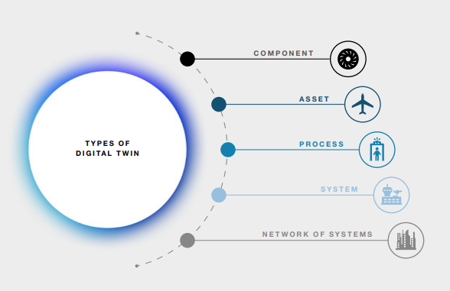
- Component/part/product: Component twins are the basic unit of a digital twin, the smallest example of a functioning component. They represent a physical product or object in a digital environment. It includes detailed 3D models, specifications, and real-time data about the product's condition, performance, and maintenance requirements.
- Asset: When two or more components work together, they form what is known as an asset. A digital asset twin focuses on individual physical assets, such as machinery, buildings, or infrastructure. It provides a digital representation of these assets, including their condition, maintenance history, and real-time performance data, which can support predictive maintenance and asset management.
- Process: This type of digital twin replicates a physical process and includes digital models and data to simulate and optimise real-world processes, such as manufacturing, supply chain logistics, and industrial operations. Process twins can help determine the precise timing schemes that ultimately influence overall effectiveness, enable optimisation, and predict maintenance.
- System: A digital system twin replicates complex systems, often comprising multiple interconnected components or subsystems. This type of digital twin is used in fields like aerospace and automotive engineering to simulate and test the behaviour of entire systems or vehicles. They provide visibility regarding the interaction of assets and may suggest performance enhancements.
- Network of systems/ system of systems (SoS): A number of system-level digital twins are connected together to form SoS-level digital twins, which helps in collaborating different enterprises or different departments with an enterprise such as supply chain, design, service, maintenance, etc.
Additional categories:
- City: digital twin cities create a virtual replica of an entire urban area, incorporating various data sources, such as infrastructure, transportation, utilities, and environmental factors. These twins aid city planners and officials in making informed decisions, optimizing services, and improving urban sustainability.
- Human: Digital twin humans, also known as personal digital twins, represent individuals in a digital context. These twins gather data from various sources, such as wearables and health records, to providing insights into an individual's health, behaviour, and wellbeing. They are valuable in healthcare and wellness applications.
- Each type of digital twin serves a specific purpose, allowing organisations and industries to optimise processes, enhance decision making, and improve the performance of physical assets and systems.
- Digital twins can also be categorised based on the data and level of integration from the physical twin and its environment. Initially, digital twins may give the impression of being precise duplicates, but in reality, they don't always aim for a realistic replication. Instead, they serve as meaningful abstractions of the physical asset. Even in the most advanced smart cities, there's no requirement to digitally recreate every intricate detail, like the precise design of each column or the composition of every brick. In essence, the development of digital twins should align with their intended purpose, and the degree of fidelity will differ according to the primary use cases. Digital twins aren't obliged to replicate every aspect of the original system, and the exchange of data doesn’t need to be in real-time.
Level of integration:
- Digital model: data exchange between the physical and digital entities occurs manually. Consequently, any alterations in the condition of the physical object do not have an immediate impact on the digital counterpart, and vice versa.
- Digital shadow: data from the physical object is automatically transferred to the digital representation, but the reverse process remains manual. Consequently, any alterations in the physical object are reflected in its digital counterpart, but not the other way around.
- Digital twin: data flows automatically in both directions between the physical and digital entities. Consequently, any modifications in either the physical or digital object directly impact changes in the other.
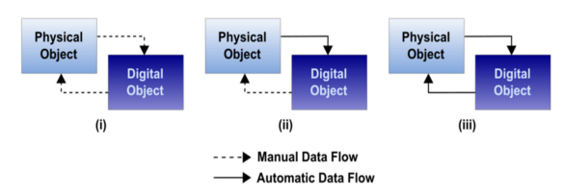

Level of maturity:
- Partial digital twin: Containing a limited set of data points, this form serves to ascertain the connectivity and operational aspects of the digital twin.
- Clone digital twin: Containing all pertinent and significant data from the product or system, this type facilitates prototype creation and phase categorisation in development.
- Augmented digital twin: This variant not only uses current data from the asset but also incorporates historical data. Simultaneously, it extracts and correlates valuable information through the application of algorithms and analytics.

Appendix 3 – Other technologies and their application
In this Appendix, we examine other digital technologies that may also be relevant but do not have such a leading role as those mentioned in the body of the report. These are:
- Distributed ledger technology including blockchain
- High performance computing
- Unmanned Aerial Vehicle (UAV)/Drone
- Open finance, fintech and digital finance
- Nano and advanced technologies (e.g. energy efficiency, water treatment and remediation)
- AR/VR technologies

Distributed ledger technology including blockchain:
Distributed ledger technology has been highlighted as a strong potential enabler for circular supply chains. Blockchain technology, especially in conjunction with other digital technologies like IoT or cloud computing, serves as a secure approach enabling the end-to-end traceability of materials. Blockchain-based materials tracing offers the potential for complete transparency of the origin, quality, and authenticity of materials without compromising any confidential business information.
Blockchain facilitates the process of recording transactions and tracking assets in a business network. As each transaction takes place, it is recorded as a “block” of data – which can contain any information previously chosen. Each block is connected to the ones before and after it, creating a chain of data that is securely linked together to prevent any alteration. Any data modification changes the hash of the block it was in and its subsequent blocks as they are all in a chain. This helps to support inter-business collaboration and build trust between actors along the value chain.,
This technology also has strong synergies with digital material passports. Digital passports carry crucial information about an asset’s lifecycle and materials stock that can be used to support circularity. These include product compositions, usage details, and disassembly instructions which are important to facilitate the appropriate reuse or recovery of the asset’s materials at the end of its first life. Delivering this information via a blockchain rather than a product tag or marker that could be lost, ensures its immutability, further supporting reuse and recovery.
Some examples include:
- Unilever and SAP successfully delivered a pilot project using blockchain technology to enable traceability and transparency of their global palm oil supply chain. This supported Unilever’s goals of going “deforestation free” in its supply chains.
- The battery passport, one of the first digital product passports required by law as a result of the EU battery regulation, is being designed with blockchain sharing in mind to ensure supply chain transparency.

High performance computing:
High performance computing (HPC) is a pivotal technology used to perform complex simulations and data analysis across a wide range of sectors. From drug innovation in medicine to materials science applications in the manufacturing industry, HPC facilitates the processing of vast quantities of data in an accurate and speedy manner – enabling actors to solve complicated issues in minutes that would take days or even weeks with traditional computing. HPC is increasingly being seen as a potential solution for some of the most challenging barriers to the circular economy – such as the need to cost-effectively process big data quickly and accurately.
Quantum computing and memory-driven computing are emerging technologies that are similar to HPC in that they perform computing tasks much faster than conventional computing but have different functional mechanisms. While these technologies are not yet commercially feasible (they are currently in the early stages of research and development or prototype stage), quantum and memory-driven computing appear as potent solutions to accelerate circularity and achieve scale., These technologies boast the same high performance computational capabilities that can process big data while potentially having much lower energy demands – and thus, a smaller environmental footprint.
This area of technology can be applied to various sectors. For example, HPC could be used in urban settings (with IoT) to develop smart cities that could rapidly solve traffic-related pollution issues or manage intricate supply and demand flows. In an industrial setting, HPC technology could enable predictive maintenance of machines that could even repair themselves (with robotics).
An example:
- Amazon partnered with Good Chemistry, a computational chemistry company, to run extensive and computationally demanding simulations by harnessing HPC. The computations simulated bond-breaking energies as part of a wider pathway to eliminate PFAS (polyfluoroalkyl based chemicals) which required notoriously challenging chemical simulations and are long lasting hazard in our environment. The HPC simulations provided very accurate results which could help advance PFAS destruction pathways.

Unmanned Aerial Vehicle (UAV)/Drone:
The use of unmanned aerial vehicles (UAVs) for agricultural purposes has been well established over the past decade as a means to increase efficiency, circumvent human error and reduce costs. The focus of these efforts has largely been on agricultural efficiency and yields but this technology could be applied with a circular and bioeconomy lens.
Drones are already commonly used to survey agricultural and forestry areas – there is an opportunity to extend this functionality for bioeconomy resource mapping, especially if paired with machine vision and AI technologies. Researchers are also investigating the opportunity for UAVs to facilitate circular supply chains in reverse logistics applications. There is also the potential for a very specific application of herbicides or pesticides by UAVs.
An example:
- Mast reforestation (formerly Droneseeds) supplies aerial seeding services via IoT-enabled drones for reforestation. Their drones are able to perform reforestation and seeding activities approximately six times faster than using human labour – greatly increasing the speed and capacity of regenerative efforts.
- Project CAELUS (Care & Equity – Healthcare Logistics UAS Scotland) - East Region Innovation (edinburghbioquarter.com) is a project in Scotland where aerial drones are being trialled for the delivery of medicines and where a digital twin approach is being used to map the systems involved.

Open finance, fintech and digital finance:
The finance sector continues to integrate advancements in digital technologies as a data-driven industry. Concepts like open finance, fintech, and digital finance offer exciting opportunities for business innovation. While the role of the finance sector in scaling up the circular economy has thus far centred around financing alternative business models, and de-risking circular opportunities, digital technologies in the finance sector could play a key role in enabling circular practices and new business models – especially for SMEs.
For example, fintech or open finance could facilitate SME access to mobile payment platforms, and bespoke sell and buy-side payment solutions., The adoption of a more circular economy from our current model may involve lengthy processes including risk assessments, financing, information disclosures, and economic analysis. These technologies could help expedite this shift.
An example:
- Swedish fintech company, Omocom, have developed an innovative micro-insurance product to protect owners who engage in Product as a Service (PaaS) or sharing schemes. Service delivery approaches (sale with pay-per-use) are comparatively disadvantaged compared to goods delivery models (sale with ownership transfer) when it comes to traditional insurance. To combat this, Omocom collects and analyses data on the sharing economy to develop an insurance product tailored for owners in the sharing economy.

Nano and advanced technologies:
Nano and advanced technologies enable the development of materials, devices, and systems with distinctive characteristics and capabilities. The small dimensions of these materials enable them to have different physical and chemical properties compared to the larger ones. Due to their small size, nanomaterials have a large surface area-to-volume ratio, potentially resulting in heightened reactivity, durability, and conductivity.
Additionally, the small size of nanomaterials allows them to be easily incorporated into a wide variety of products and processes, including electronic devices, medical treatments, energy production and environmental remediation. The properties of nanomaterials also render them valuable for creating new products and enhancing current ones, like increasing the effectiveness of solar cells and batteries, fabricating sturdier and longer-lasting construction materials, and crafting more efficient medical treatments.
Nanotechnology is often, and has been from the outset, mentioned as a fast-moving technology. Instead of incremental improvements to existing technologies, nanotechnology offers disruptive, game-changing breakthroughs and innovations that can provide immediate answers and solutions to help our society, environment, and the planet. It is expected to assume pivotal roles in the digital transformation by offering a range of nano-devices, including IoT sensors, self-driving vehicles, intelligent robots, and more. In addition, it can aid in achieving a circular economy by ensuring water purification, reducing carbon emissions, and promoting material circularity. Moreover, it intends to support health and wellbeing through wearable biosensors and biomaterials for regenerative medicine.
There are many potential benefits to nanotechnology, including material improvement, increased energy efficiency, enhanced medical treatments, improved water filtration and purification and improved food safety/agriculture. These can be achieved through different approaches, such as using sustainable and safe-by-design nanomaterials, or ones that are produced using waste as a resource without a high energy and cost demand, and nanoproducts can also be maintained, repaired, reused, remanufactured, refurbished, regenerated and recycled.
An example:
- Drinkwell was established in May 2013 as a technology-driven social enterprise that powers water infrastructure. It uses polymeric ion exchangers doped with zirconium oxide NPs (adsorbents) which can be attached to wells within a filtration column. It targets people who live in affected areas in India, Laos, Cambodia, Bangladesh and Kenya. The NPs are used in small and decentralised treatment systems that don’t require large investments, management structures and costly maintenance. The organisation thus empowers villagers to run their own plant in a sustainable manner and allows them to make small profits.

AR/VR technologies:
With an umbrella term of ‘Extended Reality (XR)’, both VR (Virtual Reality) and AR (Augmented Reality) are computer-generated environments, but while AR merges physical and digital worlds by layering virtual artefacts onto everyday experiences, VR creates an immersive experience for the user by enabling full involvement in the virtual world.
XR is changing the landscape in a number of industries, however, at their core, VR and AR are world-building technologies and, as such, can play a useful role in scoping and shaping a circular future. Since any scenario can be constructed from scratch, these technologies can be used to both paint the problems of a linear economy and explore solutions of a circular one.
These emerging technologies have the potential to enhance efficiency in assembly and design processes, enabling employees to engage with virtual models and decreasing the necessity for physical interfaces. Since it enables access to information, it improves efficiency of fieldwork. When compared to traditional methods of operation and maintenance, AR and VR present a cost-effective and safer alternative, especially for offshore and remote project management.
AR can be used for operation and asset management to allow technicians to view internal components of complex equipment, reduce risk associated with standard operations and optimise maintenance time. It can also reduce expenses by providing stakeholders with real-time access to information, data and remote support. VR is currently being used as a training tool in the workforce, to prioritise skills and safety of employees.
Some examples include:
- Dressx is an international digital fashion retailer that focuses on virtual items and outfits. It carries virtual clothing using AR to build a true-to-life garment that can be visualised and simulated to look like real clothing. DRESSX prevents the production of items that might only be worn once or twice, thus successfully decoupling financial growth from the extraction of raw materials. These applications help reduce material waste by tackling the issue of excessive fast fashion production driven solely for content creation on social media platforms, like Instagram and TikTok.
- X-RAI Park is a virtual environment to facilitate education and training of agricultural biotechnologists and bioentrepreneurs. The park strives to be a hub of biotech innovation, highlighting how XR applications can be resourceful and drivers in this field. VR is used to allow simulation and visualisation of omics data and time-resolved monitoring of biotech crop growth, AR is used to enable team communication and decision-making processes for data-driven biotech discovery, and MR (mixed reality) is used to allow remote operation and management of the X-RAI Park.

Singapore Land Authority. GeospatialSG: Virtual Singapore, 2023. [Online} Available at: https://www.sla.gov.sg/geospatial/gw/virtual-singapore [30 October 2023]
UK Government. National Digital Twins Programme (NDTP) [Online} Available at: https://www.gov.uk/government/collections/the-national-digital-twin-programme-ndtp [30 October 2023]
Victoria State Government. Digital Twin Victoria [Online] Available at: https://www.land.vic.gov.au/maps-and-spatial/digital-twin-victoria [30 October 2023]
NSW Government. [Online] NSW Spatial Digital Twin. Available at: https://www.spatial.nsw.gov.au/digital_twin [30 October 2023]
Buildmedia Wellington Digital Twin. [Online] Available at: https://buildmedia.com/work/wellington-digital-twin [7 November 2023]
Heretaunga Hastings District Council. [Online] Digital twinning of Toitoi takes IPWEA award. Available at: Digital twinning of Toitoi takes IPWEA award [8 December 2023]
BIM in NZ [Online] Ara Institute of Canterbury Kahukura block, 2019. Available at: https://www.biminnz.co.nz/casestudies/2017/ara-institute-of-canterbury-kahukura-block [9 December 2023]
West et al. 2020. Data ethics and data governance from a Maori world view. In Indigenous Research Ethics: Claiming Research Sovereignty Beyond Deficit and the Colonial Legacy Advances in Research Ethics and Integrity, p. 67-81. Riley, N. 2022. Maori Data Sovereignty [Online] Available Māori Data Sovereignty: What is it, and why is it important for ? | It Figures [24 October 2023] Dev Academy – Te Kura Hangarau o . 2021. A Te Ao Maori Lens on Data Sovereignty. [Online] Available A Te Ao Māori Lens on Data Sovereignty – Dev Academy [24 October 2023]
Te Kahui Raraunga. 2022. Iwi data needs. Taiuru, K. 2018. Why data is a taonga: a customary Māori perspective.
Digital Government NZ, 2022. Te Rautaki Matihiko mō Aotearoa – the Digital Strategy for Aotearoa. [Online]. Available: https://www.digital.govt.nz/dmsdocument/237~the-digital-strategy-for-/html [7 December 2023]
MBIE, 2023. Circular Economy and Bioeconomy Strategy. [Online] Available at https://www.mbie.govt.nz/business-and-employment/economic-development/circular-economy-and-bioeconomy-strategy/ [20 February 2024]
Holopainen, M., Saunila, M., Rantala, T. & Ukko, J. 2022. Digital twins’ implications for innovation. Technology Analysis & Strategic Management.
Fortune Business Insights, 2022, Digital Twin Market, 2021-2028, Fortune Business Insights, Maharashtra.
Dassault Systemes, 2021, Designing disruption: The critical role of virtual twins in accelerating sustainability, Accenture Industry.
Schmitt, L & Copps, D. 2023. The business of digital twins, in The Digital Twin, edited by Crespi et al. Switzerland: Springer: 21-63
MBIE. 2022. Building and Construction – Sector Trends. Annual Report 2022. New Zealand Government, Wellington.
Grieves, M. 2003. Digital Twin: Manufacturing excellence through virtual factory replication. [Online]. Available: https://www.3ds.com/fileadmin/PRODUCTS-SERVICES/DELMIA/PDF/Whitepaper/DELMIA-APRISO-Digital-Twin-Whitepaper.pdf [13 October 2023]
Dassault Systemes. 2021. Designing disruption: The critical role of virtual twins in accelerating sustainability, Accenture Industry.
World Economic Forum. 2022. Digital Twin Cities: Framework and Global Practices – Insight Report.
Digital Twin Consortium. 2020. Digital Twin Consortium defines digital twin. [Online]. Available: https://www.digitaltwinconsortium.org/2020/12/digital-twin-consortium-defines-digital-twin/ [13 October 2023]
Glaessgen, E. & Stargel, D. S. 2012. The digital twin paradigm for future NASA and U.S Air Force vehicles. 53rd AIAA/ASME/ASCE/AHS/ASC Structures, Structural Dynamics and Materials Conference, Special Session on the Digital Twin. (accessed October 13, 2023, from NTRS -NASA Technical Reports Server)
Microsoft. 2017. The promise of a digital twin strategy: best practices for designers and manufactures of products and industrial equipment. [Online]. Available: https://info.microsoft.com/rs/157-GQE-382/images/Microsoft%27s%20Digital%20Twin%20%27How-To%27%20Whitepaper.pdf [13 October 2023]
Crespi, N., Drobot, A., & Minerva, R. 2023. The Digital Twin: What and why? in The Digital Twin, edited by Crespi. N., Drobot, A., & Minerva, R. Springer: 3-20.
Buildmedia [Online] Wellington Digital Twin. Available at: https://buildmedia.com/work/wellington-digital-twin [7 November 2023]
New Zealand Government, [Online] 2022, Adapt and thrive: Building a climate-resilient New Zealand. New Zealand’s first national adaptation plan. Available at: https://consult.environment.govt.nz/climate/national-adaptation-plan/ [7 November 2023]
Heretaunga Hastings District Council. [Online] Digital twinning of Toitoi takes IPWEA award. Available at: Digital twinning of Toitoi takes IPWEA award [8 December 2023]
BIM in NZ [Online] Ara Institute of Canterbury Kahukura block, 2019. Available at: https://www.biminnz.co.nz/casestudies/2017/ara-institute-of-canterbury-kahukura-block [9 December 2023] and Jasmax. [Online] Ara Institute 'Kahukura', 2018. Available at https://jasmax.com/projects/featured-projects/ara-institute-kahukura/ [9 December 2023]
Building Innovation Partnership. [Online]. Flood Resilience Digital Twin. Available at: https://bipnz.org.nz/flood-resilience-digital-twin/ [10 December 2023]
Nextspace, 2022. Nextspace + digital twins: an article by Andrew Leal. [Online]. Available: https://www.nextspace.com/news/digital-twins-an-introduction-and-case-study-with-nextspace-dt-solutions [7 December 2023]
Infrastructure NZ Webinar: Connecting our Data: The Value of a Digital Twin. [Online]. Available at: https://www.youtube.com/watch?app=desktop&v=UvQTibMnfAk [7 November 2023]
Digital.govt.nz [Online] Te koke ki tētahi Rautaki Matihiko mō Towards a Digital Strategy for . Available at: https://www.digital.govt.nz/dmsdocument/193~towards-a-digital-strategy-for-/html [7 December 2023]
Unavailable at time of writing.
Beck, A. 2021. Digital twin challenge to grow market opportunities. [Online]. Available: https://www.smartcitiescouncil.com/article/digital-twin-challenge-grow-market-opportunities [7 November 2023].
Infrastructure New Zealand, 2022. Building Nations 2022 [Online]. Available: https://infrastructure.org.nz/local-government/ [7 December 2023]
Infrastructure New Zealand, 2021, ‘Unlocking the value of data: Managing New Zealand’s interconnected infrastructure’.
Charlies, R., Hamilton, J. & Wills, M. 2022. Digital twins: What role do they play for the environment & climate resilience? [Online]. Available: https://issuu.com/nzis/docs/s_s_september_2022_digital/s/16873409 [7 November 2023].
Salm, K. 2022. From strategy to roadmap: tips for digital twin success. [Online]. Available: https://issuu.com/nzis/docs/s_s_september_2022_digital/s/16873402 [7 November 2023]
Niven, K. & Preston, G. 2022. Smart Cities Forum – Infrastructure workshop outcomes. [Online]. Available: https://www.smartcitiescouncil.com/article/smart-cities-forum-infrastructure-workshop-outcomes [7 November 2023].
Infrastructure New Zealand, 2022. Building Nations 2022 [Online]. Available: https://infrastructure.org.nz/local-government/ [7 December 2023]
Digital Government NZ, 2022. Te Rautaki Matihiko – the Digital Strategy for . [Online]. Available: https://www.digital.govt.nz/dmsdocument/237~the-digital-strategy-for-/html [7 December 2023]
MBIE, 2023. ‘Digital Technologies Industry Transformation Plan’. New Zealand Government
The Digital Twin Partnership [Online} Available at: https://www.digitaltwinpartnership.com/ [7 November 2023]
Smart Cities Council [Online} Available at: https://www.smartcitiescouncil.com/article/2023-digital-twin-summit-auckland [7 November 2023]
Unavailable at time of writing.
Preut, A., Kopka, J. & Clausen, U. 2021. Digital Twins for the Circular Economy. Sustainability, 13.
Digital Twin Partnership NZ. [Online] Digital Twin Partnership NZ launches to support sustainable growth across New Zealand. Available at https://www.digitaltwinpartnership.com/post/digital-twin-partnership-nz-launches-to-support-sustainable-growth-across-new-zealand [8 December 2023] and ITP Techblog. [Online]. Digital twin industry effort kicks off, 2023. Available at: https://techblog.nz/3160-Digital-twin-industry-effort-kicks-off [8 December 2023]
Digital Built . [Online]. Data driven solutions to enhance infrastructure resilience. Available at: https://www.digitalbuilt.org.nz/ [10 December 2023]
University of Auckland. [Online] Digital Twin Computer Science Collaboratory (DTCSC), n.d. Available at: https://www.auckland.ac.nz/en/science/about-the-faculty/school-of-computer-science/cs-flagship-projects/digital-twin-computer-science-collaboratory.html [8 December 2023]
Forest Flows. [Online] Forest Flows: technology, 2023. Available at: https://www.forestflows.nz/technology/ [8 December 2023]
University of Auckland Faculty of Science, Te Pūnaha Matatini, Faculty of Engineering, Science and technology. [Online] Halcombe, we have a digital twin, 2023. Available at: https://www.auckland.ac.nz/en/news/2023/08/03/halcombe-we-have-a-digital-twin.html [8 December 2023]
Research Hub. [Online] The Smart Digital Lab: Digital Twinning and Lean Construction 4.0, 2023. Available at: https://research-hub.auckland.ac.nz/article/the-smart-digital-lab [8 December 2023]
Unavailable at time of writing (proposal only)
University of Canterbury. [Online] Geospatial Research Institute, 2023. Available at: https://www.canterbury.ac.nz/research/about-uc-research/research-groups-and-centres/geospatial-research-institute [8 December 2023]
Department of Conservation [Online] Biodiversity in – an overview of state, trends and pressures 2020. Available at: https://www.doc.govt.nz/globalassets/documents/conservation/biodiversity/anzbs-2020-biodiversity-report.pdf 2 November 2023
Te Kahui Raraunga. [Online] 2022. Māori data sovereignty and offshoring Māori data. Available at: https://www.temanararaunga.maori.nz/ [7 November 2023]
Kukutai & Taylor. [Online] 2016. Indigenous data sovereignty. ANU Press: Canberra. Available at: https://press.anu.edu.au/publications/series/caepr/indigenous-data-sovereignty [7 November 2023]
West et al. 2020. Data ethics and data governance from a Māori world view
Te Kahui Raraunga. 2022. Iwi data needs.
Taiuru, K. 2018. Why data is a taonga: a customary Māori perspective.
Te Mana Raraunga. 2018. Principles of Māori Data Sovereignty.
West et al. 2020. Data ethics and data governance from a Māori world view. In Indigenous Research Ethics: Claiming Research Sovereignty Beyond Deficit and the Colonial Legacy Advances in Research Ethics and Integrity, p. 67-81.
Riley, N. 2022. Māori Data Sovereignty [Online] Available Māori Data Sovereignty: What is it, and why is it important for ? | It Figures [24 October 2023]
Dev Academy – Te Kura Hangarau o . 2021. A Te Ao Māori Lens on Data Sovereignty. [Online] Available A Te Ao Māori Lens on Data Sovereignty – Dev Academy [24 October 2023]
Microsoft NZ. [Online] Digital innovation could shape the future of New Zealand, 2022. Available at: https://news.microsoft.com/en-nz/2022/06/30/digital-innovation-could-shape-the-future-of-new-zealand/ [8 December 2023] and Aware Group. [Online] Empowering Climate Action Through Digital Visualisation With NZ’s Ministry for the Environment, 2022. Available at: https://www.awaregroup.com/case-study-empowering-climate-action-through-digital-visualisation-with-nz-ministry-for-environment/[8 December 2023]
Te Matarau. 2023. [Online] Available at: https://www.tematarau.tech/ [7 December 2023]
Te Hapori Maihiko. 2023. [Online]. Available at: https://www.matihiko.nz/ [7 November 2023]
Paua Interface Ltd [Online} Toi Hangarau. A Report on Māori-owned Technology Companies 2023. Available at: https://www.toihangarau.nz/ 2 November 2023
Making Everything Achievable [Online} Mapping the Māori Tech Sector. Available at: https://www.mea.nz/mappingmaoritech
Te Kotahi Research Institute. The University of Waikato. [Online] Tikanga in Technology. Available at: https://www.waikato.ac.nz/rangahau/koi-te-mata-punenga-innovation/TinT 2 November 2023
Te Mana Raraunga. Māori Data Sovereignty Network. [Online] Available at: https://www.temanararaunga.maori.nz/
International Energy Agency 2023 [Online] Available at: https://www.iea.org/energy-system/buildings/data-centres-and-data-transmission-networks, [7 November 2023]
For example, see: Carole L. Jurkiewicz (2018) [Online] Big Data, Big Concerns: Ethics in the Digital Age, Public Integrity. Available at: https://doi.org/10.1080/10999922.2018.1448218 [8 December 2023]
See, for example Forbes [Online] The 15 Biggest Risks Of Artificial Intelligence. Available at: https://www.forbes.com/sites/bernardmarr/2023/06/02/the-15-biggest-risks-of-artificial-intelligence/?sh=775701f27066 [8 December 2023] See also: Robin Mansell [Online] Adjusting to the digital: Societal outcomes and consequences, Research Policy, Volume 50, Issue 9, 2021, 104296, ISSN 0048-7333. Available at https://www.sciencedirect.com/science/article/pii/S0048733321000974 [8 December 2023]
The New York Times [Online] A Traditional Exchange? FTX Was Anything But. Available online at: https://www.nytimes.com/2022/12/16/business/ftx-exchange.html [8 December 2023
USA Whitehouse [Online] Available at: https://www.whitehouse.gov/briefing-room/statements-releases/2023/10/30/fact-sheet-president-biden-issues-executive-order-on-safe-secure-and-trustworthy-artificial-intelligence/ [7 October 2023]
Kumar, N., Kumar, G. and Singh, R.K. 2021, ‘Analysis of barriers intensity for investment in big data analytics for sustainable manufacturing operations in post-COVID-19 pandemic era’, Journal of Enterprise Information Management, 35(1), pp. 179-213. https://doi.org/10.1108/jeim-03-2021-0154.
Trevisan, A.H., Lobo, A., Guzzo, D., Gomes, L.A. de V. and Mascarenhas, J. 2023, ‘Barriers to employing digital technologies for a circular economy: A multi-level perspective’, Journal of Environmental Management, 332, p.117437. https://doi.org/10.1016/j.jenvman.2023.117437.
Ellen MacArthur Foundation 2019 [Online] Artificial intelligence and the circular economy: AI as a tool to accelerate the transition. Available at: https://emf.thirdlight.com/file/24/GgC25OAGBvwdiFGgtzZGVXuZsz/Artificial%20intelligence%20and%20the%20circular%20economy.pdf [7 November 2023]
Ellen MacArthur Foundation 2015, Intelligent Assets: Unlocking the circular economy potential.
Ayati et al. 2022, ‘Toward a circular supply chain: Understanding barriers from the perspective of recovery approaches’, Journal of Cleaner Production, 359, p. 131775. https://doi.org/10.1016/j.jclepro.2022.131775.
Sodergard, C. 2021, ‘Summary of potential and exploitation of big data and AI in bioeconomy’ in Big Data in Bioeconomy. Switzerland: Springer.
Raghu et al. 2022. ETH Zürich [Online] Enabling Component Reuse from Existing Buildings Using Machine Learning – Using Google Street View to Enhance Building Databases. Available at https://www.research-collection.ethz.ch/bitstream/handle/20.500.11850/552226/5/EnablingComponentReuseFromExistingBuildings.pdf 6 November 2023
CattleEye [Online] Available at: https://cattleeye.com/ [7 November 2023]
European Commission [Online] Accelerated Metallurgy - the accelerated discovery of alloy formulations using combinatorial principles. Available at: https://cordis.europa.eu/project/id/263206 6 November 2023
Winnow. [Online] Available at: https://www.winnowsolutions.com/en/case-studies [7 November 2023]
Refed [Online] Available at: https://refed.org/ [7 November 2023]
Reconext [Online] Available at: https://www.reconext.com/ [7 November 2023]
Tomra [Online] Available at: https://solutions.tomra.com/en/gain-deep-learning [7 November 2023]
Guan Wang, Yu Sun, Jianxin Wang, [Online} Automatic Image-Based Plant Disease Severity Estimation Using Deep Learning, Computational Intelligence and Neuroscience, vol. 2017. Available at: https://doi.org/10.1155/2017/2917536 [7 November 2023]
Ecocycle [Online] Available at: https://ecocycle.com.au/ [7 November 2023]
EMO Hannover. [Online] Robot Installations Soar. Available at: https://emo-hannover.com/news/robot-installations-soar [7 November 2023]
AMP Robotics [Online] Available at: https://www.amprobotics.com/robotic-system [7 November 2023]
KUKA [Online] KR QUANTEC. Available at: https://www.kuka.com/en-au/products/robotics-systems/industrial-robots/kr-quantec [7 November 2023]
IEEE Spectrum [Online] Bosch's Giant Robot Can Punch Weeds to Death. Available at: https://spectrum.ieee.org/bosch-deepfield-robotics-weed-control [7 November 2023]
ABB [Online] Bringing robots into the circular economy. Press release. Zurich, Switzerland. 28 March, 2023. Available at: https://new.abb.com/news/detail/101281/prsrl-bringing-robots-into-the-circular-economy [7 November 2023]
Karttunen, E, Pynnönen, M, Treves, L & Hallikas, J 2021, ‘Capabilities for the internet of things enabled product-service system business models’, Technology Analysis & Strategic Management, pp. 1–17. https://doi.org/10.1080/09537325.2021.2012143.
Bressanelli et al. 2018, ‘Exploring how usage-focused business models enable circular economy through digital technologies’, Sustainability, 10(3), p.639. https://doi.org/10.3390/su10030639.
Rane, S.B. and Thakker, S.V. 2019, ‘Green procurement process model based on blockchain-IoT integrated architecture for a sustainable business’, Management of Environmental Quality: An International Journal, 31(3), pp.741-763. https://doi.org/10.1108/meq-06-2019-0136.
MITSloan Management Review [Online] IoT Can Drive Big Savings in the Post-Sales Supply Chain. Available at: https://sloanreview.mit.edu/article/iot-can-drive-big-savings-in-the-post-sales-supply-chain/ [7 November 2023].
The Hong Kong Polytechnic University. Knowledge Transfer and Entrepreneurship Office. [Online] Available at: https://www.polyu.edu.hk/en/kteo/knowledge-transfer/innovations-and-technologies/technology-search/4-smart-cities-and-information-technology/4_ise_17_0916/ [7 November 2023]
Industry Week. [Online] The Industrial Internet of Things: Putting the Hype to Work. Available at: https://www.industryweek.com/technology-and-iiot/iiot/article/22024306/the-industrial-internet-of-things-putting-the-hype-to-work [7 November 2023]
Lacy, P. and Rutqvist, J. 2015, ‘The product as a service business model: performance over ownership’ in Waste to Wealth: The Circular Economy Advantage. London: Palgrave Macmillan UK.
The Circulars Accelerator [Online] Available at: https://thecirculars.org/ [7 November 2023]
SAP. Sustainability Management. [Online] Available at: https://www.sap.com/australia/sustainability/circular-economy.html [7 November 2023]
Lizee. [Online] Available at: https://www.lizee.co/ [7 November 2023]
Van Dijck, J et al. 2018. The Platform Society. Oxford University Press
Evans, P. 2023. Circular Platforms: Unlocking sustainability and material security. Forbes Business Council. Available at: https://www.forbes.com/sites/forbesbusinesscouncil/2023/05/30/circular-platforms-unlocking-sustainability-and-material-security/?sh=1d046d136d01 [7 November 2023]
Berg, H & Wilts, H. 2018. Digital platforms as market places for the circular economy – requirements and challenges. Nachhaltigkeits Management Forum, 27.
Serebryantseva, V. 2023. What is a digital product passport, and why does your business need it? [Online] Available Overview of Digital Product Passport Solution (pixelplex.io) [23 October 2023]
Madaster [Online] Available at: madaster.com [7 November 2023]
Circularise [Online] Available at: https://www.circularise.com/ [7 November 2023]
WBCSD, 2023 [Online] The EU Digital Product Passport: how can companies prepare for it today? Available at: https://www.wbcsd.org/Overview/News-Insights/WBCSD-insights/EU-Digital-Product-Passport [7 November 2023]
SAE International. [Online] Digital Transformation Resources to Support your Business Use. Available at: https://www.sae.org/highlights/digital-standards-system-whitepaper
AMFG Autonomous Manufacturing. [Online] What Advantages do Digital Inventories Offer over Traditional Warehousing in Manufacturing? Available at: https://amfg.ai/2023/02/23/what-advantages-do-digital-inventories-offer-over-traditional-warehousing-in-manufacturing/ [7 November 2023]
3D Natives [Online] Tokyo Olympics Medal Ceremony Podiums 3D Printed Using Recycled Plastic Available at: https://www.3dnatives.com/en/3d-printed-podiums-tokyo-olympics-300720215/ 7 November 2023
AMFG Autonomous Manufacturing. [Online] 3 Unexpected Ways Additive Manufacturing Can Drive a Circular Economy Available at: https://amfg.ai/2023/01/19/3-unexpected-ways-additive-manufacturing-can-drive-a-circular-economy/ [7 November 2023]
Qorox [Online] Available at: https://qorox.co.nz/ [7 November 2023]
BAE Systems. What is Digital Engineering? [Online] Available at https://www.baesystems.com/en-us/definition/digital-engineering 20 October 2023
Shepard, D & Scherb, J. 2020. What is digital engineering and how it is related to DevSecOps? [Online] Available What Is Digital Engineering and How Is It Related to DevSecOps? (cmu.edu) [20 October 2023]
Construction Sector Accord. [Online] Available at: https://www.constructionaccord.nz/ [7 November 2023]
New Zealand Institute of Building [Online] Available at: https://nziob.org.nz/news-2/bim-handbook-consultation/ [7 November 2023]
Waka Kotahi NZ Transport Agency [Online] Available at: https://www.nzta.govt.nz/roads-and-rail/asset-management-data-standard/ [7 November 2023]
Infrastructure New Zealand. [Online] Available at: https://infrastructure.org.nz/wp-content/uploads/2023/08/Infrastructure-NZ-Policy-Postions-Digital.pdf [7 November 2023]
ICG, 2023, Data and Digital principles for project success. Project 13.
Government Technology Agency. [Online] GovTech Singapore: Digital Government Transformation, 2023. Available at: https://www.tech.gov.sg/digital-government-transformation/ [30 October 2023]
Government Technology Agency. [Online] GovTech Singapore: Digital Government Blueprint, 2023. Available at: https://www.tech.gov.sg/digital-government-blueprint/ [30 October 2023]
Government Technology Agency. [Online] Govtech Singapore: GovTech Digital Academy, 2023. Available at: https://www.thedigitalacademy.tech.gov.sg/ [30 October 2023]
Government Technology Agency. [Online] Singapore Government Development Portal: GovTech Digital Academy, 2023. Available at: https://www.developer.tech.gov.sg/communities/events/conferences/ [30 October 2023]
Government Technology Agency. [Online] Govtech Singapore: Digital Standards and Guides, 2023. Available at: https://www.tech.gov.sg/digital-standards-and-guides/ [30 October 2023]
Singapore Land Authority. [Online] GeospatialSG: Virtual Singapore, 2023. Available at: https://www.sla.gov.sg/geospatial/gw/virtual-singapore [30 October 2023]
Luxembourg Institute of Science and Technology. [Online] Digital Twin, 2023. Available at: https://www.list.lu/en/institute/strategic-priorities/digital-twin/ [30 October 2023]
Accenture. [Online] 2023. Case study Tuvalu: Climate change gets real in the metaverse Available at: https://www.accenture.com/au-en/case-studies/technology/tuvalu [30 October 2023]
European Union [Online] 2023. Shaping Europe’s Digital Future. Available at: https://digital-strategy.ec.europa.eu/en/library/destination-earth [30 October 2023]
Government Digital Service, UK [Online] The National Digital Twin Programme (NDTP). Available at: https://www.gov.uk/government/collections/the-national-digital-twin-programme-ndtp
Digital Twin Hub. [Online] What is CReDo? Available at: https://digitaltwinhub.co.uk/credo/credo/ [7 November 2023]
University of Cambridge [Online] 2022. National Digital Twin Programme: Gemini Principles, archive. Available at: https://www.cdbb.cam.ac.uk/DFTG/GeminiPrinciples [30 October 2023]
ANZLIC The Spatial Information Council [Online] 2023 Principles for Spatially Enabled Digital Twins of the Built and Natural Environment in Australia. Available at: https://www.anzlic.gov.au/resources/principles-spatially-enabled-digital-twins-built-and-natural-environment-australia [30 October 2023]
Victoria State Government. [Online]. Digital Twin Victoria. Available at: https://www.land.vic.gov.au/maps-and-spatial/digital-twin-victoria/about-the-program [30 October 2023]
NSW Government. [Online] NSW Spatial Digital Twin. Available at: https://www.spatial.nsw.gov.au/digital_twin [30 October 2023]
Deng et al. 2021. A systematic review of a digital twin city: A new pattern of urban governance toward smart cities. Journal of Management Science and Engineering, 6(2), p. 125-134
World Economic Forum, 2022, Digital Twin Cities: Framework and Global Practices – Insight Report.
Hams, S. 2023. What does living in a ‘smart city’ mean, and what has it got to do with more cameras popping up where you live? [Online] What does living in a 'Smart City' mean, and what has it got to do with more cameras popping up where you live? - ABC News [23 October 2023]
Amsterdam Economic Board. [Online] Amsterdam Smart City. Available at: https://amsterdamsmartcity.com/ [23 October 2023]
Smart Nation Singapore [Online] Transforming Singapore through Technology Available at: https://www.smartnation.gov.sg/about-smart-nation/transforming-singapore/ [23 October 2023]
Lai, O. 2022. How New York Smart City Projects are Leading the Way. https://earth.org/new-york-smart-city/ [23 October 2023]
Digital Boost [Online] Available at https://digitalboost.business.govt.nz/ [7 November 2023]
New Zealand Government, Data Strategy and Roadmap for New Zealand, https://data.govt.nz/assets/Uploads/data-strategy-and-roadmap-dec-18.pdf, Online [November 2023]
Singh et al. 2021. Digital Twin: Origin to future. Applied Systems Innovation, 4(36).
Ibid.
Circularise 2019, The open, distributed and secure communications protocol for the circular economy, Available at: https://www.circularise.com/ [7 November 2023]
Provenance 2015, Blockchain: the solution for transparency in product supply chains, Available at: https://www.provenance.org/whitepaper [7 November 2023]
IBM. (N.a.) What is blockchain technology? [Online] Available at: https://www.ibm.com/topics/blockchain [19 October 2023]
Hayes, A. 2023. Blockchain facts: What is it, how it works, and how it can be used. [Online] Available https://www.investopedia.com/terms/b/blockchain.asp [19 October 2023]
Haro-Olmo et al. 2020. Blockchain from the perspective of privacy and anonymisation: A systematic literature review. Sensors, 20, 7171.
Walden, J., Steinbrecher, A. and Marinkovic, M. 2021, ‘Digital product passports as enabler of the circular economy’, Chemie Ingenieur Technik, 93(11), pp.1717-1727. https://doi.org/10.1002/cite.202100121.
Unliver. SAP, Unilever pilot blockchain technology supporting deforestation-free palm oil. (21 March 2022) [Online] Available at: https://www.unilever.com/news/press-and-media/press-releases/2022/sap-unilever-pilot-blockchain-technology-supporting-deforestationfree-palm-oil/ [15 March 2024]
The Battery Industry Group. Battery passport set for the EU, NZ is sure to follow. (27 July 2023) [Online] Available at: https://big.org.nz/2023/07/eu-adopts-battery-passport/ [15 March 2024]
Bresniker, K.M., Singhal, S. and Williams, R.S. 2015, ‘Adapting to thrive in a new economy of memory abundance.’ Computer, 48(12), pp.44-53. https://doi.org/10.1109/JSTQE.2012.2236080.
De Felice, F. and Petrillo, A. 2021, ‘Green transition: the frontier of the digicircular economy evidenced from a systematic literature review’, Sustainability, 13(19), p.11068. https://doi.org/10.3390/su131911068.
Vargas Tamayo, L., Thron, C., Fendji, J.L.K.E., Thomas, S-K. and Förster, A. 2020, ‘Cost-Minimizing System Design for Surveillance of Large, Inaccessible Agricultural Areas Using Drones of Limited Range’, Sustainability, 12(21), p. 8878. https://doi.org/10.3390/su12218878.
Agnusdei, G.P., Gnoni, M.G., Sgarbossa, F. and Govindann, K. 2022, ‘Challenges and perspectives of the Industry 4.0 technologies within the last-mile and first-mile reverse logistics: A systematic literature review’, Research in Transportation Business & Management, 45, p.100896. https://doi.org/10.1016/j.rtbm.2022.100896.
Rialti, R., Mirza, G., Caputo, A. and Mayah, K.A. 2020, ‘Achieving strategic flexibility in the era of big data: The importance of knowledge management and ambidexterity’ Management Decision, 58(8), pp.1585-1600.
Siddik, A.B., Yong, L. and Rahman, M.N. 2023, ‘The role of Fintech in circular economy practices to improve sustainability performance: A two-staged SEM-ANN approach’, Environmental Science and Pollution Research, pp.1-22.
de Sousa Jabbour, A.B.L., Luiz, J.V.R., Luiz, O.R., Jabbour, C.J.C., Ndubisi, N.O., de Oliveira, J.H.C. and Junior, F.H. 2019, ‘Circular economy business models and operations management’ Journal of cleaner production, 235, pp.1525-1539.
Oppermann, A. 2023. What is Nanotechnology? [Online]. Available at: https://builtin.com/hardware/nanotechnology [16 October 2023].
Pokrajac et al. 2021. Nanotechnology for a sustainable future: Addressing global challenges with the international network for sustainable nanotechnology. ACSNano, 15, p.18608-18623
Pokrajac et al. 2021. Nanotechnology for a sustainable future: Addressing global challenges with the international network for sustainable nanotechnology. ACSNano, 15, p.18608-18623
Hansen et al. 2022. Nanotechnology meets circular economy. Nature Nanotechnology, 17, p.682-685.
Drinkwell. [Online] Available at: https://drinkwellsystems.com/ [15 March 2024]
Scribani, J. What is Extended Reality (XR)? [Online] Available at: https://www.visualcapitalist.com/extended-reality-xr/#:~:text=Extended%20Reality%20%28XR%29%20is%20the%20umbrella%20term%20used,shift%20in%20the%20way%20people%20interact%20with%20media. [19 October 2023]
Ellen MacArthur Foundation. More than just a big idea – how extended reality tech can enable a circular economy. [Online] Available at: https://www.ellenmacarthurfoundation.org/tech-enablers-series/part-1 [19 October 2023]
O’Grady et al. 2021. Circular economy and virtual reality in advanced BIM-based prefabricated construction. Energies, 14, 4065.
Ganjineh, H. 2022. How AR and VR are paving the way for the future of renewable energy. [Online] Available at: https://www.forbes.com/sites/forbestechcouncil/2022/03/31/how-ar-and-vr-are-paving-the-way-for-the-future-of-renewable-energy/?sh=6e7f572a19cd [19 October 2023]
DressX [Online] Available at: https://dressx.com/ [24 March 2024]
Farid Nakhle, Antoine L. Harfouche, Extended reality gives digital agricultural biotechnology a new dimension, Trends in Biotechnology, Volume 41, Issue 1, 2023, Pages 1-5, ISSN 0167-7799, https://doi.org/10.1016/j.tibtech.2022.09.005.

