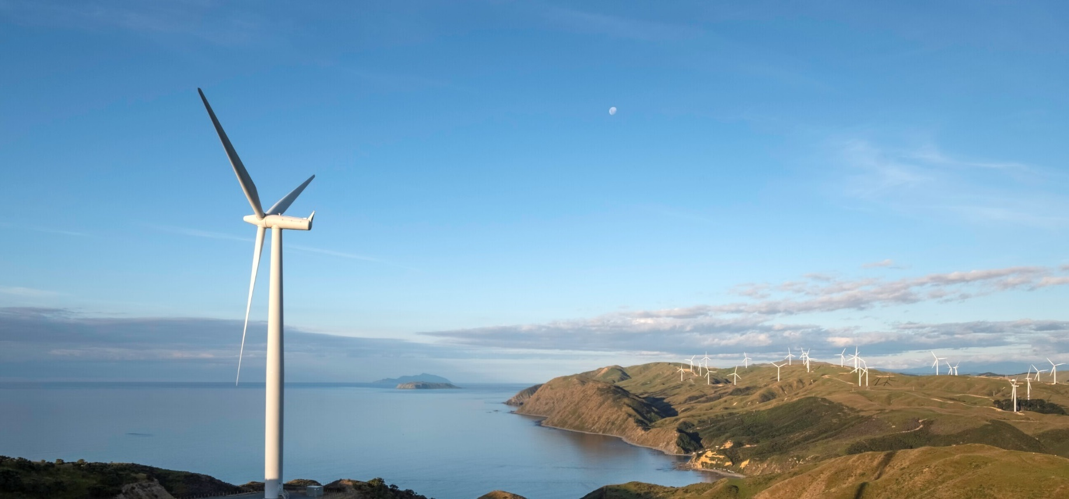**Increased renewable generation sees reduced reliance on fossil fuels**

**New Zealand Energy Quarterly**

**December 2024 Summary**

Lower demand from industrial energy users saw energy use fall across most energy types in the December 2024 quarter compared to the same quarter in 2023. Lower electricity use by New Zealand Aluminium Smelters, following its demand response agreement with Meridian being called on in the September 2024 quarter, contributed to a 9% year-on-year fall in electricity demand from the industrial sector.

With lower electricity demand, total electricity generation fell to its lowest level for a December quarter since 2016. Following historical lows seen in the September 2024 quarter, hydro storage in both islands returned to above historic mean levels. Hydro generation increased 12.45% from the September 2024 quarter, bringing it up to a similar level as the December 2023 quarter. This was bolstered by new geothermal and solar capacity coming online during the December 2024 quarter. Despite outages at several geothermal plants in the December quarter 2024, capacity additions over the 2024 calendar year from new plants coming online saw electricity generation from geothermal increase 6.5 % on the December 2023 quarter.

With lower electricity demand and higher generation from renewables, there was a lesser need for gas- and coal-fired generation. Gas generation fell 29.9% year-on-year, while coal fired generation fell 64.1% this quarter. As a result, the renewable share of generation increased to 94.3% this quarter, the 4th highest quarter on record, with emissions from electricity generation falling accordingly. Emissions were 400 kt CO2-e in the December 2024 quarter, the lowest quarterly level on record.

Unplanned outages at the Kupe field, and lower deliveries from the Pohokura and Maui fields, contributed to a 23% decrease in net gas production from the December 2023 quarter. Net gas production was 26.16 PJ for this quarter, the lowest since the December 1983 quarter. The December 2024 quarter saw a continuation in lower gas use, with Methanex’s temporary idling of its manufacturing operations (from mid-August until the end of the October 2024) contributing to a 32% year-on-year decrease in total gas use.

Coal consumption continued trending down in most sectors, including in major industrial sectors such as dairy product manufacturing. Consumption of oil products was relatively unchanged from the December 2023 quarter, with the only exception being aviation fuel use for international transport which increased 4% year-on-year. Petrol and diesel imports were down slightly, 4% and 9% respectively, but aviation fuel imports were up 19%.

### Quarterly summary charts

|  |  |
| --- | --- |
| Renewable share of electricity generation | Emissions from electricity generation |
| Stacked line chart showing the share of renewables in electricity generation steadily increasing from early 2000's to reach 94.3% in December 2024 quarter. | Line chart showing emissions from electricity generation steadily declining over last decade to reach record low in the latest quarter. |
| Generation from geothermal, solar, and wind | Generation from coal and gas |
| Line chart of electricity generation from geothermal, solar, and wind. All three lines steadily increase sine early 2000s, with sharper increases over last 5 years. | Line chart showing electricity generation from gas and coal steadily decreasing over last two decades, with a sharp drop in the last quarter. |
| Consumption of electricity and gas | Natural gas use |
| Line chart showing electricity and gas consumption. Electricity consumption is relatively steady with seasonal fluctuations, but with an unusual drop in consumption for the last quarter. Gas consumption was steady until 2020, and steadily decreased since. | Stacked line chart showing gas use in various sectors, namely Other, Industrial, Non-Energy Use, and Electricity Generation. Both Industrial and Electricity generation fell sharply in the last quarter. |