Natural gas production continues to decline
New Zealand Energy Quarterly
March 2024 Summary
Natural gas net production for the quarter was 31.89 PJ, a 12 per cent decrease on March 2023 and the lowest quarterly net production since March 1985. A planned outage at Pohokura gas field for maintenance in March added to the steady long-term decrease in gas production. The trend is expected to continue into Quarter 2 with Kapuni gas field going offline for planned maintenance in April.
Reduced natural gas production had a direct impact on consumption with a 33 per cent drop in non-energy use compared with March 2023 quarter, and a 31 per cent decrease in energy use in the chemical sector. Driving this fall was Methanex, one of the largest users of gas in New Zealand reducing its production of methanol in response to less available gas supply.
Although the gas-fired Huntly Unit 5 returned to service earlier than scheduled following an unscheduled outage, the lower gas supply led to the need for coal-fired electricity generation to meet demand. Following a dryer summer and below normal rainfall, generation from gas and coal was needed to meet demand for electricity. Compared to the same quarter last year there was a 99 per cent increase in coal for electricity generation.
As the share of renewable electricity generation decreased, greenhouse gas emissions from electricity generation increased to 861 kt CO2-e, a 21.5 per cent increase compared with the March 2023 quarter. Other key statistics
- New solar and wind electricity generation helped offset a 3.2 per cent drop in hydro generation to keep the renewable share high at 85.7 per cent for the past quarter.
- New capacity from Rangitaiki Solar Farm helped boost solar generation to 145 GWh, a 51.2 per cent increase from March 2023.
- Full commissioning of Turitea Wind Farm helped to increase wind generation with 920 GWh produced, a 43.4 per cent increase.

Read more information on energy use in New Zealand here.

Summary charts

Electricity generation from renewable sources
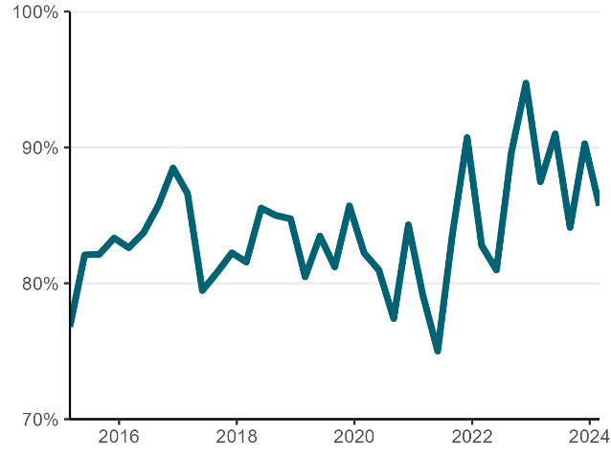

Electricity generation from solar and wind sources
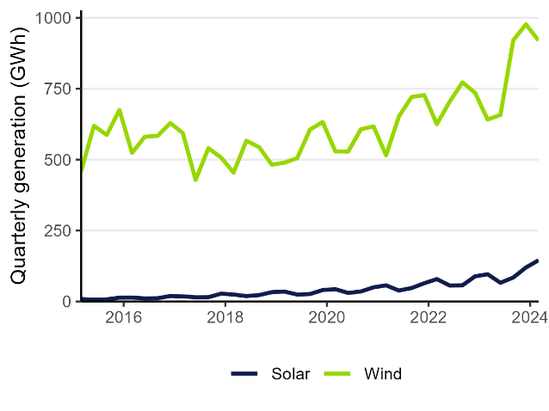

Natural gas production
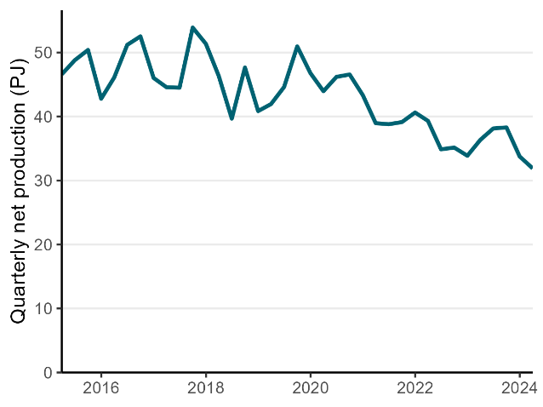

CO₂-e emissions from electricity generation
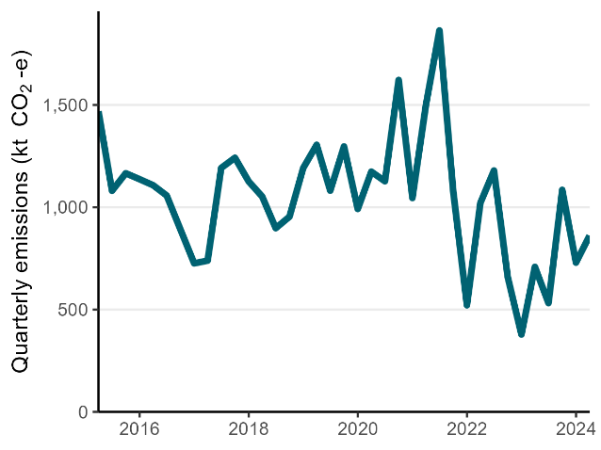

Electricity generation from coal and gas
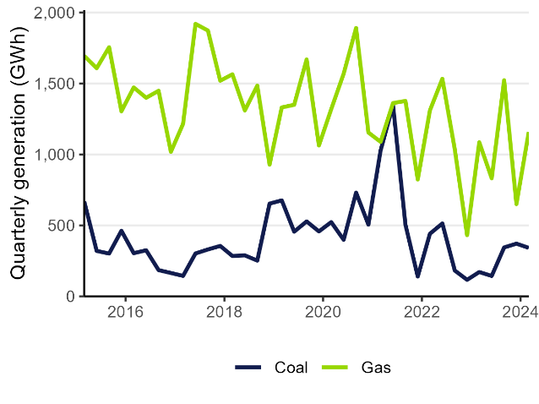

Natural gas demand
