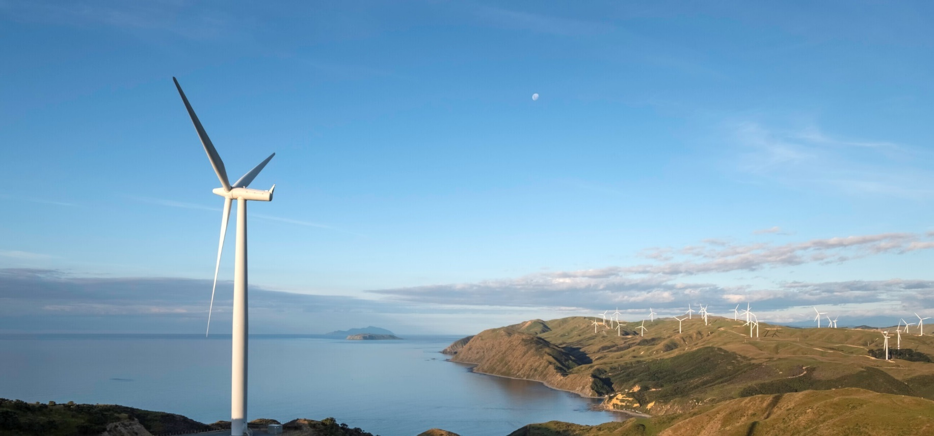**Low hydro lake levels require continued reliance on coal and gas for electricity**

**New Zealand Energy Quarterly**

**September 2024 Summary**

Despite record wind and geothermal power generation in the July to September quarter, below average hydro inflows until mid-August resulted in the third lowest level of hydro generation in a September quarter on record. As result, other sources such as coal were needed to generate enough power for New Zealand homes and businesses until conditions improved.

The combination of low lake levels and a period of reduced wind power generation in early August, meant relying on other forms of generation to keep enough power flowing. Demand side reduction at our largest industrial electricity user, combined with an increased use of coal and a small amount of diesel, were necessary to cover the resulting generation shortfall.

With hydro generation this quarter down 16.6 per cent to 5584 GWh – 48.4 per cent of total generation for the quarter – coal fired generation increased. Electricity generation from coal was 884 GWh; a 156.5 per cent increase on the same quarter last year. Coal fired generation made up 7.7 per cent of the overall generation this quarter. The use of non-renewable energy sources resulted in a 31 per cent increase in emissions from electricity generation compared to last September.

Increasing generation at the new Tauhara geothermal station helped geothermal power hit a record 2,363 GWh this quarter; a 15.2 per cent increase from the September quarter 2023. Similarly, the Harapaki Wind Farm becoming fully operational and windier conditions from mid-August contributed to record wind generation for the quarter with 1,094 GWh produced; a 17.8 per cent increase on the same quarter last year.

In August Meridian asked New Zealand Aluminium Smelters to reduce their electricity consumption as per its demand side response agreement. This contributed to a 10.2 per cent decrease in industrial electricity consumption, contributing to a 2.5 per cent (272 GWh) decrease in overall consumption for the quarter.

Net gas production was 30.05 PJ, a drop of 22 per cent on this quarter last year. Non-energy use of gas was down 3.84 PJ or 57 per cent on September 2023 as Methanex (New Zealand’s largest user of gas) idled all their production facilities to free up gas for the other users in the market. This took effect in mid-August with only one plant being restarted at the end of October.

### Summary charts

|  |  |
| --- | --- |
| Electricity generation from hydro and geothermal | Electricity generation from solar and wind |
| Line chart showing quarterly electricity generation in gigawatt hours for geothermal and hydro over last 10 years. Hydro shows a sharp decline over the last year, while geothermal increased in the last quarter. | Line chart showing quarterly electricity generation in gigawatt hours for solar and wind over last 10 years. Wind sharply increased in the last quarter, while solar continues its steady increase. |
| Electricity generation from coal and gas | CO2-e emissions from electricity generation |
| Line chart showing quarterly electricity generation in gigawatt hours for coal and gas over last 10 years. Both gas and coal had sharp increases in the last couple of quarter. | Line chart show quarterly emissions in CO2 equivalent kilotonnes over last 10 years. Emissions increased sharply over the last two quarters. |
| Electricity consumption by sector | Non-energy gas use |
| Line chart showing quarterly electricity consumption in gigawatt hours for the commercial, industrial, and residential sectors over last 10 years. Residential consumption has high seasonality, but is steadily increasing over time. Industrial consumption sharply declined in the last quarter. Commercial consumption remmains steady. | Line chart showing quarterly non-energy gas use in petajoules. There was a sharp decline in non-energy use in the last quarter. |