Discussion paper

Mandatory unit pricing for grocery products
May 2022

Permission to reproduce
Crown Copyright ©
This work is licensed under the Creative Commons Attribution 4.0 International License. To view a copy of this license, visit http://creativecommons.org/licenses/by/4.0/.

Important notice
The opinions contained in this document are those of the Ministry of Business, Innovation and Employment and do not reflect official Government policy. Readers are advised to seek specific legal advice from a qualified professional person before undertaking any action in reliance on the contents of this publication. The contents of this discussion paper must not be construed as legal advice. The Ministry does not accept any responsibility or liability whatsoever whether in contract, tort, equity or otherwise for any action taken as a result of reading, or reliance placed on the Ministry because of having read, any part, or all, of the information in this discussion paper or for any error, inadequacy, deficiency, flaw in or omission from the discussion paper.

How to have your say

Submission process
The Ministry of Business, Innovation and Employment (MBIE) seeks written submissions on the issues raised in this document by 5pm on 11 July 2022.
Your submission may respond to any or all the questions. Where possible, please include evidence to support your views, for example references to independent research, facts and figures, or relevant examples. Please include your contact details in the cover letter or e-mail accompanying your submission.
You can make your submission by:
- sending your submission as a Microsoft Word document to consumer@mbie.govt.nz.
- mailing your submission to:
Competition and Consumer Policy
Building, Resources and Markets
Ministry of Business, Innovation & Employment
PO Box 1473
Wellington 6140
New Zealand
Please direct any questions that you have in relation to the submissions process to consumer@mbie.govt.nz.
Use of information
The information provided in submissions will be used to inform MBIE’s policy development process and will inform advice to Ministers on mandatory unit pricing for grocery products. We may contact submitters directly if we require clarification of any matters in submissions.

Release of information
MBIE intends to upload PDF copies of submissions received to MBIE’s website at www.mbie.govt.nz. MBIE will consider you to have consented to uploading by making a submission, unless you clearly specify otherwise in your submission.
If your submission contains any information that is confidential or you otherwise wish us not to publish, please:
- indicate this on the front of the submission, with any confidential information clearly marked within the text
- provide a separate version excluding the relevant information for publication on our website.
Submissions remain subject to request under the Official Information Act 1982. Please set out clearly in the cover letter or e-mail accompanying your submission if you have any objection to the release of any information in the submission, and in particular, which parts you consider should be withheld, together with the reasons for withholding the information. MBIE will take such objections into account and will consult with submitters when responding to requests under the Official Information Act 1982.

Private information
The Privacy Act 2020 establishes certain principles with respect to the collection, use and disclosure of information about individuals by various agencies, including MBIE. Any personal information you supply to MBIE in the course of making a submission will only be used for the purpose of assisting in the development of policy advice in relation to this review. Please clearly indicate in the cover letter or e-mail accompanying your submission if you do not wish your name, or any other personal information, to be included in any summary of submissions that MBIE may publish.
Contents
How to have your say 3
1 Introduction 7
Purpose of this discussion paper 7
What does this discussion paper seek feedback on? 7
What outcomes are sought? 7
What are the policy options? 8
What criteria will be used to evaluate the merits of policy options? 8
Key for qualitative judgments in tables 8
Process and timeline 8
Structure of this discussion paper 8
2 Background 9
What is unit pricing? 9
What were the Commerce Commission’s recommendations for unit pricing in New Zealand? 11
Why has the Commission recommended, and why is the Government introducing, mandatory unit pricing? 11
3 What are the potential benefits and compliance costs associated with a mandatory unit pricing regime? 12
Potential benefits 12
Potential compliance costs 13
4 Which retailers should mandatory unit pricing apply to? 14
Background 14
Floor space threshold 14
Product range threshold 15
Annual revenue threshold 15
Options analysis 17
5 Where should retailers display unit pricing? 18
Background 18
Displaying unit price point of purchase 18
Requiring grocery retailers to have a “sort and/ or filter by unit price” option on their website 18
Displaying unit price in specific advertising formats 19
Displaying unit price in all forms of advertising, including video and audio advertising 19
Options analysis 21
6 What should be the standard and non-standard unit measurements for unit pricing? 22
Background 22
Australian approach to standard unit measurements 22
Australian approach to non-standard unit measurements 22
Providing more guidance around standard and non-standard measurements for unit pricing 23
Options analysis 24
7 What products should be exempt from a compulsory unit pricing standard? 25
Background 25
Australian approach to product exemptions for unit pricing 25
Rationale for product exemptions 26
Unit pricing for tobacco and/ or alcohol products 26
Options analysis 27
8 How should unit pricing be displayed? 28
Background 28
An Australian, principle-based approach 28
Options analysis 30
9 What sort of legislative instrument could be used to implement mandatory unit pricing? 31
10 Recap of questions 32

Introduction

Purpose of this discussion paper
- In November 2020, the Minister of Commerce and Consumer Affairs instructed the Commerce Commission (the Commission) to conduct a market study into the retail grocery sector to investigate whether competition is working well in the sector.
- The Commission published its final report on 8 March 2022 and found that competition in the retail grocery sector is not working well for consumers in New Zealand. The final report made several recommendations for improving competition, including mandating the consistent display of unit pricing for grocery retail products.
- It is likely that the Government will accept the Commission’s recommendation and agree that mandatory unit pricing be implemented for New Zealand. The discussion paper therefore seeks feedback on how mandatory unit pricing should be designed and implemented.

What does this discussion paper seek feedback on?
- This discussion paper seeks feedback on:
  - the potential benefits and compliance costs of mandatory unit pricing
  - who mandatory unit pricing should apply to
  - where mandatory unit pricing should apply
  - what units of measurement should be used
  - what, if any, products should be exempt
  - how unit pricing should be displayed.

What outcomes are sought?
- Mandatory unit pricing for grocery products is aimed at ensuring that grocery retailers display unit pricing in a manner that is clear and consistent, and that consumers are empowered to make informed purchasing decisions. Particularly, any decision to mandate the display of unit pricing will aim to achieve the following outcomes:
  - Legibility and clarity: The required information should be prominently displayed in a manner that can be easily seen and read, including by consumers who have impaired vision or reduced mobility.
  - Consistency of units of measure: The unit pricing for a particular product category should be uniformly and consistently expressed in the same unit of measure.
  - Accuracy: The required information should be accurate and should be displayed accurately.

What are the policy options?
- This discussion paper functions as interim RIA by weighing up the policy options set out in sections 3 – 7 against the stated criteria in the context of the desired outcomes.

What criteria will be used to evaluate the merits of policy options?
- The following criteria will be used (and given equal weight) to assess the merits of policy options in the context of the desired outcomes set out above:
  - Effectiveness: The potential for each policy option to drive the outcomes of legibility and clarity, consistency, and accuracy.
  - Practicality: The cost and feasibility of implementing each policy option.
  - Certainty: Certainty for retailers regarding their obligations, and certainty for consumers regarding the prominence, legibility and accuracy of unit prices.

Key for qualitative judgments in tables
+ 2 | Considerably better than doing nothing / the status quo
+ 1 | Better than doing nothing / the status quo
0 | About the same as doing nothing / the status quo
- 1 | Worse than doing nothing / the status quo
- 2 | Considerably worse than doing nothing / the status quo

Process and timeline
- Consultation is open from 30 May 2022 until 11 July 2022. During this process, we welcome any submissions, comments, and questions that you may have on this issue. Following submissions, further analysis will be undertaken to inform policy decisions by Cabinet. Following policy decisions, drafting will commence.

Structure of this discussion paper
- This discussion paper sets out background information on unit pricing, works through the primary issues, highlights certain questions for discussion, and then assesses the options against the stated criteria.

Background

What is unit pricing?
- Unit pricing is the price per unit of measure for a product, such as the cost per kilogram or litre. Unit pricing is usually displayed as a price per standard unit of measurement, together with the retail price of the product. For example, where a 1.5kg bag of flour is sold for $3.00, the unit price displayed would be $2.00 per kg. This unit price would be included near the total price for the product.
- Grocery retailers already display unit pricing for groceries sold by unit, weight or measure, and some grocery retailers in New Zealand voluntarily display unit pricing for certain pre-packaged grocery products.
- However, unit pricing for pre-packaged products is not mandatory in New Zealand and is not standardised or consistent across grocery retailers or grocery products. The images below illustrate the varied nature of current unit pricing practices in New Zealand:
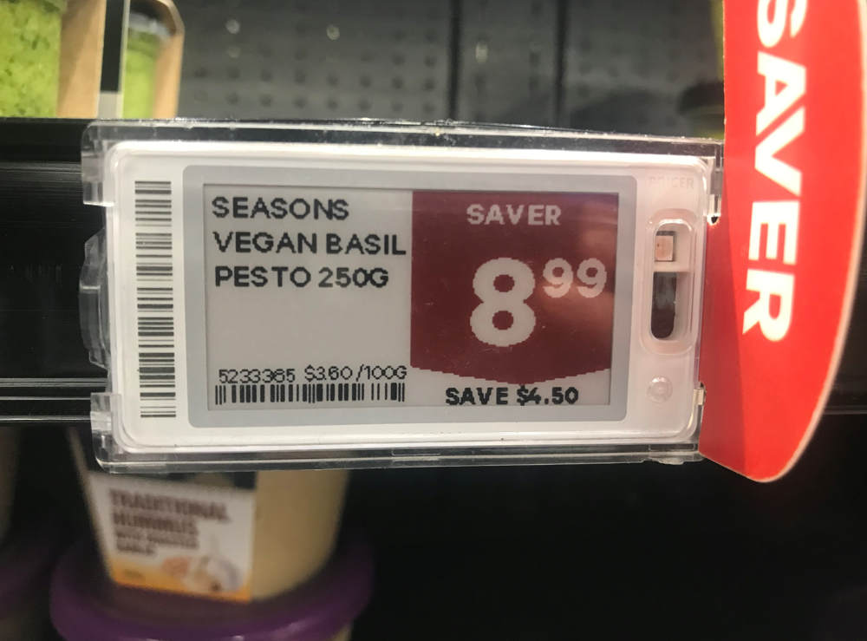 | The unit price in this example is included but it is significantly smaller than the sale price, not prominent, and therefore may not be useful for consumers.
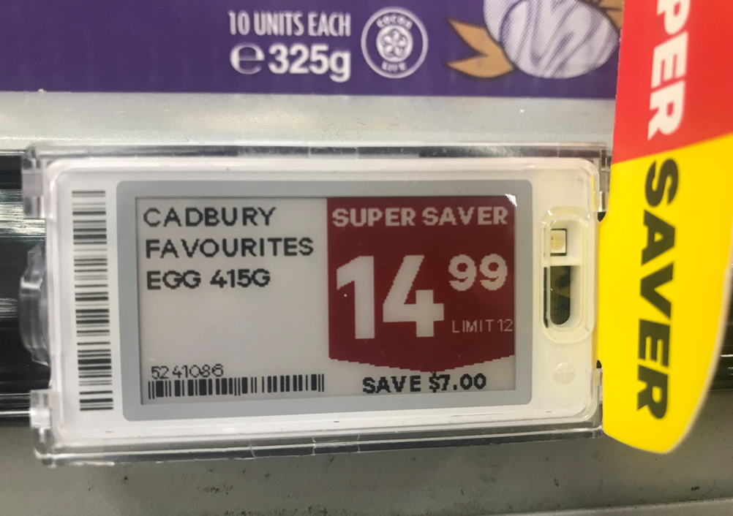 | No unit price is displayed for this product.
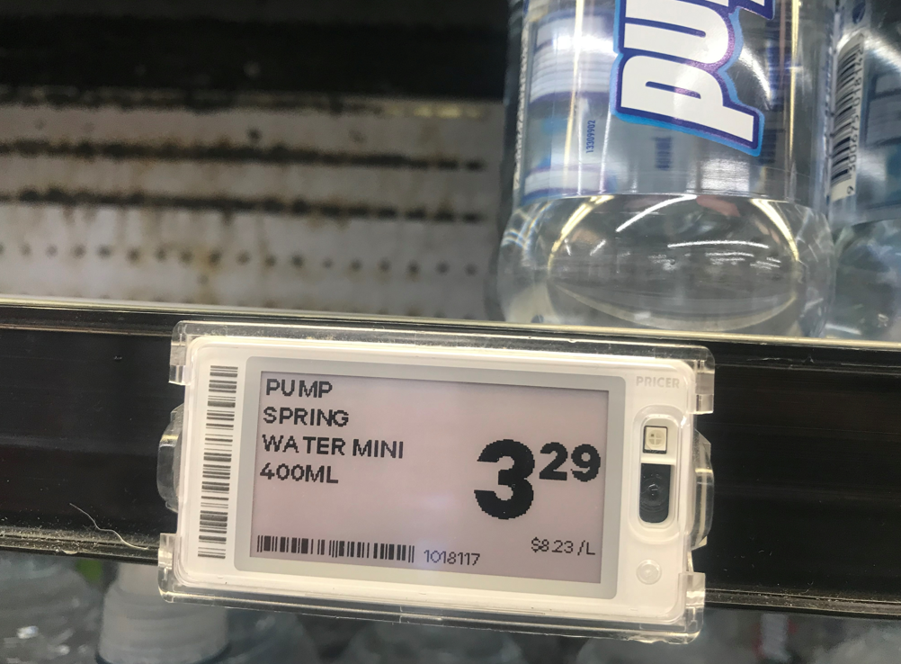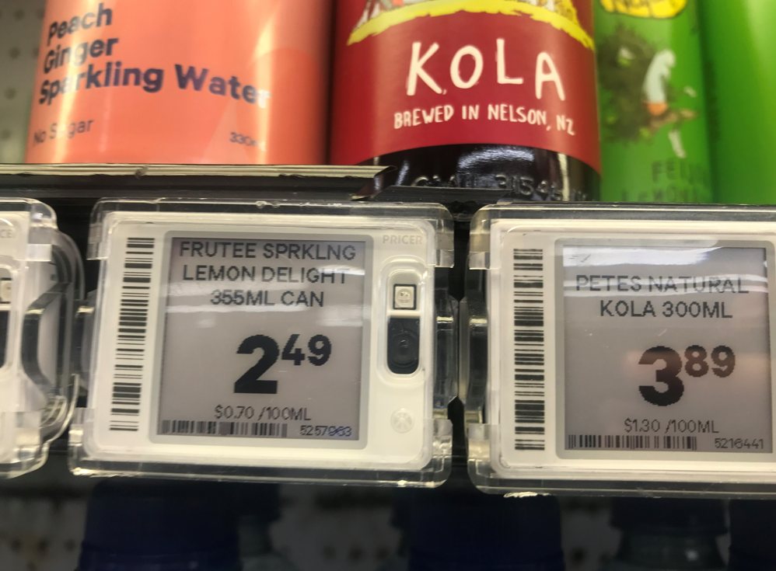 | These products are in the same product category, in the same store, but the unit prices are displayed in different units of measurement. This makes it harder for consumers to rely on the unit price to compare these products.
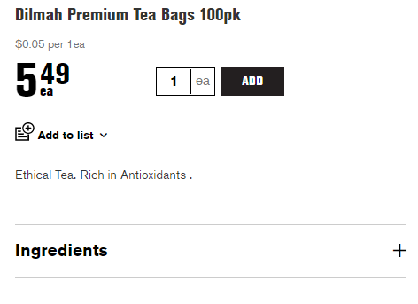 | This grocery retailer’s website displays the unit price for this product per tea bag.
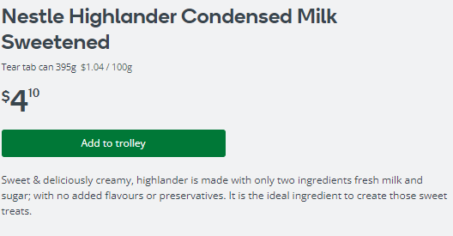 | This grocery retailer’s website displays the unit price for this product per 100 grams.

What were the Commerce Commission’s recommendations for unit pricing in New Zealand?
- In its final report, the Commerce Commission recommended that unit pricing be mandated for grocery products in New Zealand, and specifically recommended that:
  - minimum standards regarding display be specified
  - standardised units of measurements be specified for each category of products to be covered by the requirements
  - certain product categories be exempted from unit pricing requirements where unit pricing would not provide useful information
  - unit pricing requirements apply to in-store display, and advertising in print media and online where the retail price is displayed, but not television, radio, or other video or audio content
  - an appropriate transitional period be provided before compliance is mandatory, to ensure necessary retailer systems can be implemented
  - there be an appropriate monitoring and enforcement regime, including penalties for non-compliance
  - both online and physical grocery retailers above an annual grocery revenue threshold should be subject to unit pricing requirements.

Why has the Commission recommended, and why is the Government introducing, mandatory unit pricing?
- Unit pricing can help consumers more easily compare between the prices of different products, especially where products are sold in different sized packaging and by different brands.
- Even when not directly comparing products and retailers, clear and accurate unit pricing information can help consumers develop perceptions of value over time which in turn can help them decide where to shop to best meet their needs.
- Where unit pricing information is not consistently available or cannot easily be accessed and acted upon by consumers, they may be less able to make informed decisions and may be less likely to shop around. This can lessen competition between grocery retailers.
- The section below explores more of the potential benefits associated with unit pricing, together with the potential compliance costs of a mandatory unit pricing regime.

What are the potential benefits and compliance costs associated with a mandatory unit pricing regime?

Potential benefits
- In 2021, New Zealanders spent more than $22 billion at grocery stores. Groceries are an essential purchase for all New Zealanders and continue to be one of the most significant expenditure items for households. In 2019, the average New Zealand household spent more than $234 a week on groceries.
- In this environment, the clear and consistent display of unit pricing can:
  - help consumers spend less money at the supermarket and find better deals
  - empower consumers to make better informed purchasing decisions, and thereby participate more meaningfully in the marketplace
  - make it easier for consumers to navigate the widely varying range of products, prices, and package sizes in grocery stores
  - help mitigate the incidence and effects of “shrinkflation”, where products are shrunk in size, quantity, or quality, while prices remain the same or increase. As shrinkflation often goes unnoticed by consumers, unit pricing can provide some transparency around this practice and can signal which grocery products provide better value.
- In October 2018, CHOICE (a leading Australian consumer advocacy group), conducted a national survey to test Australian consumers’ experience with unit pricing. The survey found that:
  - 96% of people found unit pricing helpful
  - 76% of people used unit prices all or most of the time
  - 69% of people said unit prices made it easier to compare products and prices.
- In the short- to medium-term, consumers are unlikely to change where they shop based on improved unit pricing information. However, accurate and consistent display of unit pricing is likely to promote inter-brand competition in the short-term and may motivate retailers to compete more directly on price over time.
- Supporting consumers to make deliberate and informed purchasing decisions can also improve inter-store competition in the medium- to long-term by putting pressure on grocery retailers to compete on metrics such as value and pricing transparency.
- For the full benefits of unit pricing to be realised, consumers will need to be made aware of unit pricing and will need to be educated and empowered to use unit pricing when making purchases.
- For this reason, there may be benefits in requiring grocery retailers to educate consumers about unit pricing and the ways in which unit pricing can be used to make in-store purchasing decisions. This could be done by requiring grocery retailers to provide in-store and online pamphlets, posters and/or other guidance on unit pricing and how it can be used. However, this could complicate compliance and enforcement responsibilities for the regulator.

Potential compliance costs
- Although unit pricing has many potential benefits for consumers and competition, mandating the display of unit pricing will involve implementation costs for grocery retailers.
- Mandating the display of unit pricing could also impact on conditions of entry and expansion for smaller retailers who often rely on old software or hand-labelling practices. These retailers may have to invest in newer software systems to implement unit pricing, at possibly significant cost.
Are there any other benefits or costs associated with mandatory unit pricing that are not mentioned above?
Should grocery retailers be required to educate consumers about unit pricing by providing in-store and online pamphlets, posters and/or other guidance?
How much do you estimate it will cost to implement unit pricing in grocery stores? Please explain how you have arrived at this estimate.

Which retailers should mandatory unit pricing apply to?

Background
- The Commerce Commission has recommended that unit pricing be mandated for grocery products in New Zealand. The Commerce Commission defines grocery products as “a range of food and drinks, including meat, fruit and vegetables, canned goods, dairy products, and a range of other household products, like toilet paper, cleaning products, pet food, alcohol and tobacco”. Therefore, the scope of this discussion paper is limited to grocery products (defined above) and grocery retailers, defined as “businesses which sell grocery products directly to final consumers in New Zealand”.
- Although unit pricing can assist consumers to make informed decisions and help promote inter-brand competition, it will involve compliance costs for retailers. It is therefore important to consider which retailers should be required to display unit pricing and to ensure that unit pricing requirements are applied proportionally. This involves weighing up the likely benefits to consumers against the cost implications for retailers.
- One way to balance these competing interests is to set threshold requirements for the application of mandatory unit pricing. These threshold requirements are intended to exclude those retailers for whom the cost implications of implementing unit pricing will be significant, and where the benefits to consumers may be limited.
- The following paragraphs explore three potential threshold requirements that may be appropriate for New Zealand, namely store floor space, product range, and annual revenue.

Floor space threshold
- The Australian unit pricing code is limited to grocery retailers with more than 1000 square metres of floor space and who sell the minimum range of food-based grocery items. The floor space threshold does not apply to online grocery retailers without a physical store.
- The rationale for a floor space threshold is that most household spend on groceries occurs in large grocery stores. These stores maintain an extensive product range and require consumers to make rapid value judgements about many goods packaged in different sizes.
- The value of unit pricing in small grocery stores, with smaller product selections, may be more limited. Smaller retailers are also more likely to rely on manual systems, which could make the accurate display of unit pricing difficult, costly, and time consuming.
- Although a floor space threshold is a practical way of ensuring that mandatory unit pricing requirements are applied proportionately, there are potential issues with this approach, namely:
  - a floor space threshold alone may not be appropriate for online grocery retailers without a physical presence, as unit pricing would then either apply to all online retailers or no online retailers, regardless of size
  - determining the appropriate floor threshold will require careful consideration, as many grocery retailers in New Zealand have a floor space smaller than 1000 square metres (including Four Square, many New World and Countdown Metro stores, convenience stores, and specialist grocery retailers).

Product range threshold
- In addition to the floor space threshold, the Australian unit pricing code is limited to grocery retailers who sell the minimum range of food-based grocery items, namely bread, breakfast cereal, butter, eggs, flour, fresh fruit and vegetables, fresh milk, meat, rice, sugar, and packaged food. The rationale for this threshold is that stores with a smaller product range are unlikely to sell many products in the same category, providing less need for price comparison.
- However, a potential issue with a product range threshold is that there may be specialty grocery retailers who sell a wide range of groceries, but not the full range of grocery items set out in the Australian code. Consumers may expect these retailers to display unit pricing, even though these retailers do not necessarily sell products from each product category.

Annual revenue threshold
- Instead of a floor space or product range threshold, the Commerce Commission has recommended that mandatory unit pricing apply to both physical and online grocery retailers if they meet a minimum threshold in terms of annual grocery revenue, either at group level or store level.
- An annual revenue threshold is intended to limit application of mandatory unit pricing to grocery retailers where the costs and benefits of unit pricing are proportionate. However, this threshold may be difficult to monitor and enforce as it will require accurate and comprehensive information regarding the annual revenue of grocery retailers, which may be difficult to collect and assess.
- If an annual revenue threshold is introduced, it will be necessary to determine whether the threshold should be set at group level or store level. Setting an annual revenue threshold at group level may be appropriate if:
  - the group can support individual stores with systems that enable the implementation of unit pricing
  - individual stores that receive group support will not be subject to significant fixed costs that outweigh the benefits of unit pricing in that store
  - setting the threshold at group level could help prevent significant benefits being lost by some stores in a group not implementing unit pricing.
- Setting an annual revenue threshold at store level may be more appropriate if:
  - individual stores incur significant fixed costs that cannot be supported by the group, and these costs would outweigh the benefits of unit pricing
  - no significant benefit will be lost if some stores in a group do not implement unit pricing.
Which grocery retailers should a mandatory unit pricing standard apply to?
Which of the approaches to threshold requirements (store size, product range, annual revenue) should be used to set the threshold for mandatory unit pricing in New Zealand?
If New Zealand adopts:
- a floor size threshold, what should be the appropriate floor size (in square metres) for this threshold?
- a product range threshold, what products should be included?
- an annual revenue threshold, what is the appropriate dollar amount for this threshold, and should the threshold be set at group level or store level?

Options analysis
Criteria | Options for threshold requirements
 | Floor space threshold | Product range threshold | Annual revenue threshold
Effectiveness  The potential for this policy option to drive the outcomes | Effectiveness score: + 1 (more effective than the status quo)  A floor space threshold will likely be effective in ensuring most customers benefit from unit pricing by applying it to the largest retailers. | Effectiveness score: + 1 (more effective than the status quo)  A product range threshold will likely be effective in ensuring that larger retail stores with a broad product range display unit pricing. | Effectiveness score: + 1 (more effective than the status quo)  An annual revenue threshold will likely be effective in ensuring that larger grocery retailers with sufficient resources display unit pricing.
Practicality  The cost and feasibility of this policy option | Practicality score: - 1 (less practical / more costly than the status quo)  A floor space threshold will likely be a practical way of determining which stores will have to display unit pricing. This should reduce the risk of smaller retailers being caught, but it may not be practical for smaller online-only retailers. | Practicality score: - 1 (less practical / more costly than the status quo)  A product range threshold will likely be a practical way of determining which stores will have to display unit pricing. This should reduce the risk of stores with only a small product range being caught, but it may not be practical for specialist retailers. | Practicality score: - 2 (considerably less practical / more costly than the status quo)  An annual revenue threshold will likely help ensure that only grocery retailers with sufficient resources are required to display unit pricing, but the threshold may be more difficult and expensive to monitor and enforce than a floor space or product range threshold.
Certainty  Certainty for retailers regarding their obligations and for consumers regarding unit prices | Certainty score: + 1 (more certain than the status quo)  A floor space threshold will likely provide certainty to retailers regarding whether their store is large enough to be caught by the regime. | Certainty score: + 1 (more certain than the status quo)  A product range threshold will likely provide certainty to retailers. However, this is less certain than a floor space threshold, given that product ranges may change over time while store size is likely to remain more static. | Certainty score: + 1 (more certain than the status quo)  An annual revenue threshold will likely provide certainty to retailers regarding whether they earn sufficient revenue, either at store or group level, to be caught by the regime.
Overall score | + 1 | + 1 | 0

Where should retailers display unit pricing?

Background
- Requirements for mandatory unit pricing could apply at one or more of the following locations:
  - At the point of purchase, in close proximity with the product – both for physical stores and online
  - only in specific advertising formats, such as print media
  - all forms of advertising where a retail price is displayed or shared, including print, radio, television, and online print, audio and video.
- In Australia, grocery retailers must display unit pricing at point of sale in store, as well as in advertising in print media or on the internet (excluding video and audio files). Retailers in Australia are not required to display unit pricing on television or radio, or video or audio files on the internet. This is consistent with the approach in the European Union and the United Kingdom.
- A rationale for this approach is that audio and video advertisements on the radio and television are impermanent and do not offer an opportunity for price comparison, which is the main function of unit pricing.

Displaying unit price point of purchase
- At a minimum, mandatory unit pricing will likely require retailers to display unit pricing at the point of purchase, in close proximity with the product. This will be necessary to ensure consumers can compare product prices at the time of purchase.
- What qualifies as “close proximity” is not set out in the Australian unit pricing code but is generally understood as requiring the unit price to be near enough to the retail price to enable both prices to be seen at the same time.
- In recent years, there has been a trend for certain pre-packaged products to display the retail price on the product itself. It may therefore be appropriate to require product manufacturers to also display the unit price on such products, in line with the requirement that the unit price be in “close proximity” to the retail price.

Requiring grocery retailers to have a “sort and/ or filter by unit price” option on their website
- To further support and empower consumers to use unit pricing effectively, it may be appropriate to require grocery retailers with an online offering to have a “sort and/ or filter by unit price” option on their website. Consumers would then be able to search for a specific product and then sort and/ or filter the results by unit price to find the product with the lowest unit price.
- Allowing consumers to sort and/ or filter products by unit price could increase use and understanding of unit pricing and allow the benefits of unit pricing to be realised as increasingly more grocery purchases are made online.

Displaying unit price in specific advertising formats
- The Commerce Commission has recommended that retailers be required to display unit pricing at point of sale in store, as well as in advertising in print media or on the internet (excluding video and audio files). As mentioned, the rationale for this approach is that audio and video advertisements on the radio and television are impermanent and do not offer an opportunity for price comparison, which is the main function of unit pricing.

Displaying unit price in all forms of advertising, including video and audio advertising
- Although not all forms of advertising provide an opportunity for price comparison, it may be appropriate to require grocery retailers to display unit prices in all forms of advertising where the retail price is displayed (including video and audio advertising), because:
  - retailers provide the retail price in advertisements to inform and influence consumers even when there is no opportunity for price comparison
  - this could increase consumer awareness of unit pricing and use of unit pricing in store
  - unlike television and radio, audio and video files on the internet are often displayed for an extended period, and may therefore provide an opportunity for price comparison
  - even when not directly comparing products, clear and accurate pricing information can help consumers to develop perceptions of value over time.
- Therefore, a possible approach is to require retailers to provide the unit price of a product in any advertisement where the retail price is displayed or shared (including print, radio, television, audio and video).
Where should retailers be required to display unit pricing, and why?
Where the retail price is displayed on a product itself, should the unit price also be displayed on the product?
Should grocery retailers be required to have a “sort and/ or filter by unit price” option on their website?
In which forms of advertising should retailers be required to display unit pricing?
What are the potential costs and benefits of including unit pricing in audio and video advertising formats?

Options analysis
Criteria | Options for the display of unit pricing
 | Unit pricing displayed at point of sale, as well as in print media advertising | Unit pricing displayed at point of sale, as well as in all forms of advertising
Effectiveness  The potential for this policy option to drive the outcomes | Effectiveness score: + 1 (more effective than the status quo)  Requiring unit price to be displayed at point of sale, as well as in certain forms of advertising, is likely to be reasonably effective in driving the outcomes of legibility and clarity, consistency of units of measure, and accuracy. | Effectiveness score: + 2 (considerably more effective than the status quo)  Requiring unit pricing to be displayed at appoint of sale, as well as in all forms of advertising, will mean that unit prices are displayed in a broad range of settings, making this option highly effective in driving the policy outcomes.
Practicality  The cost and feasibility of this policy option | Practicality score: - 1 (less practical/ more costly than the status quo)  Requiring grocery retailers to display unit prices at point of sale, as well as in certain forms of advertising, will be a relatively practical way of implementing mandatory unit pricing, but will incur some compliance costs. | Practicality score: - 2 (considerably less practical/ more costly than the status quo)  Requiring grocery retailers to display unit pricing at point of sale and in all forms of advertising will likely increase compliance costs more than if unit pricing is only required for certain forms of advertising. Including unit prices in audio and visual advertising is also likely to be less practical for enabling price comparison.
Certainty  Certainty for retailers regarding their obligations and for consumers regarding unit prices | Certainty score: + 1 (more certain than the status quo)  Requiring grocery retailers to display unit prices at point of sale, as well as in certain forms of advertising, should provide a reasonable amount of certainty to consumers regarding legibility and accuracy of unit prices, and to retailers regarding their obligations. | Certainty score: + 2 (considerably more certain than the status quo)  Requiring grocery retailers to display unit pricing at point of sale and in all forms of advertising should provide considerable certainty to consumers, and to retailers regarding their obligations by setting an expectation to all consumers that this information is to be included in any advertisement.
Overall score | + 1 | + 2

What should be the standard and non-standard unit measurements for unit pricing?

Background
- Unit pricing is intended to make it easier for consumers to compare prices and make informed purchasing decisions. For this reason, it is important that the unit price for a particular product category is expressed in uniform and consistent measurements to enable direct comparisons between comparable products.
- Inconsistencies in unit pricing across products within the same category (for example, some pre-packaged salads displaying unit price per 100 grams while others are priced per kilogram) can make it difficult for consumers to compare prices and undermines the benefits of unit pricing.
- Therefore, any mandatory unit pricing code, standard or regulation, will need to specify standard unit measurements. It may also be necessary to clarify that unit prices for products within the same product category should use the same unit measurements, preferably using the unit that is most dominantly or prevalently displayed on packages within that category.

Australian approach to standard unit measurements
- In Australia, the following standard measurements are used:
  - Supplied by volume: Per 100 millilitres
  - Supplied by weight: Per 100 grams
  - Supplied by length: Per metre
  - Supplied by area: Per square metre
  - Supplied by number: Per item.

Australian approach to non-standard unit measurements
- In Australia, the following non-standard measurements are used:
  - Herbs and spices: Per 10 grams
  - Flavouring essences and food colouring: Per 10 millilitres
  - Makeup: Either per item included, or if supplied by weight per 10 grams, or if supplied by volume per 10 millilitres
  - Meat, powdered sauce and stock: Per 10 grams
  - Fruit and vegetables: Per item or per kilogram if supplied by weight
  - Beverages: Per litre
  - Air fresheners: Per item or per millilitres if supplied by volume
  - Products supplied on a roll (including toilet paper): Per metre if supplied by continuous length, or per item if there if there are 40 or fewer items, or per 100 items if there are more than 40 items
  - Products supplied by number in packages of 41 or more items: Per 100 items
  - Packaged eggs: Per 100 grams
  - Cheese, ice and flour: Per kilogram
  - Laundry supplies (including washing powders and liquids, fabric softeners and fabric bleach) and pet products (other than pet food): Per item included, or per kilogram if supplied by weight, or per litre if supplied by volume.

Providing more guidance around standard and non-standard measurements for unit pricing
- The Australian unit pricing code does not state explicitly that unit prices for products within the same product category should use the same unit of measurement. Therefore, there may be value in requiring the same unit of measurement to be used for products within the same product category, and that this should be the unit that is most dominantly or prevalently displayed on packages within that category.
- There may also be value in using one litre as the standard measurement for volume (instead of 100 millilitres) and one kilogram as the standard measurement for weight (instead of 100 grams). The rationale for using kilograms and litres is that:
  - larger standards of measurement can make it easier to compare unit prices, especially where unit prices are displayed in small font sizes that are difficult to read (for example, where a 300ml chocolate milk sells for $3.30, its unit price will be $11 per litre or $1.1 per 100ml)
  - Using kilograms and litres as the standard units of measurement for weight and volume would align with the Weights and Measures Act.
- What should be the standard and non-standard measurements for unit pricing in New Zealand?
- Should one litre or 100 millilitres be used as the standard measurement for volume?
- Should one kilogram or 100 grams be used as the standard measurement for weight?
Should the same unit of measurement be used for all products within the same product category?

Options analysis
Criteria | Options for standard and non-standard units of measurement
 | Use the standard and non-standard measurements as set out in the Australian unit pricing code | Take the Australian unit pricing code as a starting point, but use litres and kilograms, and require the same unit to be used for all products within the same product category
Effectiveness  The potential for this policy option to drive the outcomes | Effectiveness score: + 1 (more effective than the status quo)  Using the same standard and non-standard units of measurement as required in Australia is likely to be effective in driving the outcomes of legibility and clarity, consistency of units of measure, and accuracy. | Effectiveness score: + 2 (considerably more effective than the status quo)  Taking the Australian unit pricing code as a starting point, but using litres and kilograms as standard units, and requiring the same unit to be used for all products within the same product category, is likely to be highly effective in driving the outcomes of legibility and clarity, consistency of units of measure, and accuracy.
Practicality  The cost and feasibility of this policy option | Practicality score: - 1 (less practical/ more costly than the status quo)  Using the same standard and non-standard units of measurement as required in Australia is likely to be a practical way of clarifying unit pricing requirements, but it will incur some compliance costs. | Practicality score: - 1 (less practical/ more costly than the status quo)  This option is likely to be more costly than the status quo, but it should not be more costly than adopting the Australian approach to standard and non-standard units of measurement without any changes.
Certainty  Certainty for retailers regarding their obligations and for consumers regarding unit prices | Certainty score: + 1 (more certain than the status quo)  Using the same standard and non-standard units of measurement as required in Australia is likely to provide certainty to consumers regarding legibility and accuracy of unit prices, and to retailers regarding which units of measurement to use. | Certainty score: + 2 (considerably more certain than the status quo)  Using litres and kilograms as standard units and requiring the same unit to be used for all products within the same product category is likely to provide considerable certainty to consumers regarding legibility and accuracy of unit prices, and to retailers regarding their obligations.
Overall score | + 1 | + 3

What products should be exempt from a compulsory unit pricing standard?

Background
- Many grocery retailers sell a range of non-grocery products in respect of which the benefits of unit pricing may be limited. These include products that are sold as single items (such as books or magazines), are not sold in large quantities (such as furniture) or are sold in quantities that are difficult to measure (such as flowers). It is therefore important to determine which products, if any, should be excluded from mandatory unit pricing requirements.

Australian approach to product exemptions for unit pricing
- In Australia, the following items are exempt from the application of the unit pricing code:
  - books, magazines and stationery
  - optical discs and magnetic storage devices used for computing, sound reproduction or video, whether or not they are pre-loaded with content
  - photography items and equipment
  - electrical items (other than batteries and light bulbs)
  - garden tools and items for garden or pool maintenance or decoration
  - flowers, including fresh, dried and imitation flowers
  - furniture
  - hardware items
  - computer equipment
  - audio-visual equipment
  - telecommunication items or equipment
  - items for motor vehicle maintenance or repair
  - sports and camping equipment
  - toys
  - household appliances and kitchen and bathroom utensils
  - clothing, jewellery and other fashion items (other than make-up)
  - services, and goods supplied as part of providing a service, including mobile phone recharges
  - goods for hire
  - cigarettes and other tobacco products, including nicotine replacement products
  - alcoholic beverages
  - haberdashery
  - items sold from vending machines
  - meals prepared at the retail premises for immediate consumption.
- In Australia, items are also exempt if:
  - different items are bundled together and sold for a single price (for example, if a retailer offers a mouthwash, toothpaste and dental floss together for a single price)
  - different items are offered at the same price (for example, a retailer offers a range of lipsticks of different kinds, weights and sizes for $5.50)
  - some perishables, damaged goods and discontinued items.

Rationale for product exemptions
- The rationale for the above exemptions is that:
  - it would not be practical to require unit pricing for these products
  - these products are not sold by unit of measurement
  - unit pricing is not likely to provide significant additional information to consumers in respect of these products.
- Furthermore, many grocery retailers now sell a range of non-grocery products in competition with non-grocery retailers. It may be inconsistent to require grocery retailers to comply with unit pricing requirements for these products when their competitors do not have to.

Unit pricing for tobacco and/ or alcohol products
- In most countries, including Australia, tobacco and alcohol products are excluded from mandatory unit pricing requirements on the basis that consumers should not be encouraged to purchase these products based on considerations of volume. Tobacco products are also typically hidden from view, meaning there is no real opportunity for price comparison.
- However, as tobacco and alcohol sales are high-cost products and a significant expense for many households, there may be reasons to consider including either or both of these products in a mandatory unit pricing standard or code for New Zealand.
Is the Australian approach to product exemptions appropriate for New Zealand?
Should mandatory unit pricing apply to tobacco products in New Zealand?
Should mandatory unit pricing apply to alcohol products in New Zealand?
Are there any other products for which unit pricing may not be workable or appropriate? What are these products?

Options analysis
Criteria | Options for product exemptions
 | Use the product exemptions as set out in the Australian unit pricing code | Adopt the Australian approach, but do not exempt tobacco and/ or alcohol products
Effectiveness  The potential for this policy option to drive the outcomes | Effectiveness score: + 1 (more effective than the status quo)  Adopting the Australian approach to product exemptions is likely to be effective in driving the outcomes of legibility and clarity, consistency of units of measure, and accuracy. | Effectiveness score: + 1 (more effective than the status quo)  Adopting the Australian approach to product exemptions, but not exempting tobacco and/ or alcohol products, is likely to be effective in driving the outcomes of legibility and clarity, consistency of units of measure, and accuracy.
Practicality  The cost and feasibility of this policy option | Practicality score: - 1 (less practical / more costly than the status quo)  The Australian approach is likely to be practical and feasible for the New Zealand context, but it will involve some compliance costs for retailers to implement. | Practicality score: - 1 (less practical / more costly than the status quo)  Requiring grocery retailers to display unit pricing for alcohol and/ or tobacco should not significantly increase compliance costs for grocery retailers more than if these products were exempted. However, as tobacco products are stored out of sight, there may be practical difficulties with applying unit pricing for tobacco products.
Certainty  Certainty for retailers regarding their obligations and for consumers regarding unit prices | Certainty score: + 1 (more certain than the status quo)  Adopting the Australian approach to product exemptions is likely to provide certainty to consumers, and to retailers regarding their obligations. | Certainty score: + 1 (considerably more certain than the status quo)  Requiring grocery retailers to display unit pricing for alcohol and/ or tobacco is likely to provide certainty to consumers, and to retailers regarding their obligations.
Overall score | + 1 | 0

How should unit pricing be displayed?

Background
- Unit pricing is only beneficial if consumers can clearly and quickly view and interpret unit prices and make meaningful comparisons between products based on this information. If unit prices are illegible or are not plainly visible, consumers may find it difficult to rely on this information and the benefits of unit pricing are unlikely to be fully realised.
- Issues around legibility and visibility are important for all consumers but are particularly relevant for people with visual impairments and for those with reduced mobility (who may find it difficult to bend or stretch to read small print labels on upper and lower shelves).
- In light of the above, there are two main options for specifying how unit pricing should be displayed in New Zealand, namely:
  - a principle-based approach
  - a prescriptive approach that specifies requirements around factors such as font size, font type, and contrast.

An Australian, principle-based approach
- In Australia, the unit price for a grocery item must be:
  - prominent – it must stand out so that it is easily seen
  - legible – it must not be difficult to read
  - unambiguous – the information must be accurate and its meaning clear
  - in close proximity to the selling price for the grocery item.
- The rationale for this principle-based approach is that more prescriptive requirements can increase the costs of compliance and may stifle pricing innovations, such as electronic shelf labels. Some may argue that principle-based requirements provide sufficient direction to retailers and sufficient protection to consumers, and are appropriate where the information might be displayed in a wide range of circumstances.
- Although there are benefits to adopting a principle-based approach to the display of unit pricing, there are also potential drawbacks, namely:
  - requiring unit prices to be “prominent” and “legible” without defining these terms or providing further guidance does not provide clarity to retailers regarding their obligations
  - a principle-based approach can be more difficult to enforce as requirements around prominence and legibility can be interpreted differently
  - general requirements around prominence and legibility do not always consider the needs of people with visual impairments or reduced mobility
  - according to a 2018 CHOICE survey, 25% of Australians find unit pricing for groceries to be too small and difficult to read, and 24% had experienced issues with unit pricing being obstructed or covered.
- Below are some examples of unit prices with legibility and prominence issues:
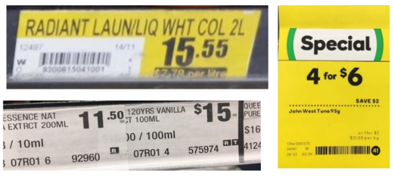
- Considering the above, instead of adopting a principle-based approach to the display of unit pricing, it may be more appropriate to clearly set out to retailers how unit pricing should be displayed. This can be achieved by setting prescriptive requirements regarding font size, font, contrast and location of unit pricing.
- The following are prescriptive requirements for unit pricing that could help ensure that unit pricing is accessible for all New Zealanders:
  - the font size for the unit price should not be smaller than 6mm and should not be less than 50% of the size of the selling price
  - text should use both upper and lower case
  - unit price and selling price should be in bold font
  - retailer specific information (such as store name) should be less prominent in type size than the selling price and unit price.
Should New Zealand adopt a principle-based approach to the display of unit pricing, or should there be more prescriptive requirements around font size, font, contrast, and location?
In your view, what are the most important principles or requirements for the display of unit pricing?
What should officials keep in mind when considering a more prescriptive option that specifies minimum requirements for the display of unit pricing?

Options analysis
Criteria | Options for the display of unit pricing
 | Adopt a principle-based approach to the display of unit pricing | Adopt prescriptive requirements around font size, font, contrast and location
Effectiveness  The potential for this policy option to drive the outcomes | Effectiveness score: + 1 (more effective than the status quo)  Adopting a principle-based approach to the display of unit pricing is likely to be effective in driving the outcomes of legibility and clarity, consistency of units of measure, and accuracy. | Effectiveness score: + 2 (considerably more effective than the status quo)  Adopting prescriptive requirements around font size, font, contrast and location is likely to be highly effective in driving the outcomes of legibility and clarity, consistency of units of measure, and accuracy.
Practicality  The cost and feasibility of this policy option | Practicality score: - 1 (less practical/ more costly than the status quo)  Adopting a principle-based approach to the display of unit pricing is likely to be a practical way of ensuring unit prices are prominent, legible and unambiguous. However, this option will incur more compliance costs than the status quo option. | Practicality score: - 2 (considerably less practical/ more costly than the status quo)  Adopting prescriptive requirements for the display of unit pricing will likely increase the cost of compliance for grocery retailers more than under a principle-based approach and is likely to be less practical. This is partly due to the need to adjust pricing practices to meet the specific requirements set for unit pricing.
Certainty  Certainty for retailers regarding their obligations and for consumers regarding unit prices | Certainty score: + 1 (more certain than the status quo)  Adopting a principle-based approach to the display of unit pricing will likely provide a reasonable amount of certainty to consumers regarding legibility and accuracy of unit prices, and to retailers regarding their obligations. | Certainty score: + 2 (considerably more certain than the status quo)  Adopting a prescriptive approach to the display of unit pricing will likely provide considerable certainty to consumers regarding legibility and accuracy of unit prices, and to retailers regarding their obligations.
Overall score | + 1 | + 2

What sort of legislative instrument could be used to implement mandatory unit pricing?

- Mandatory unit pricing could be implemented through a consumer information standard under the Fair Trading Act 1986, or through amendment of the Weights and Measures Act 1987.
- Consumer information standards are set by regulation under the Fair Trading Act and are aimed at helping consumers make informed decisions about the products they buy. In New Zealand, consumer information standards are used for care labelling, clothing and footwear country of origin labelling, country of origin food labelling, fibre content labelling, water efficiency labelling, and for used motor vehicles. Consumer information standards provide for a high degree of flexibility, enabling prescriptive and principle-based approaches.
- Another option to implement unit pricing is to amend the Weights and Measures Act. This may also be a viable option, as the Weights and Measures Act already sets out certain requirements around accuracy for goods sold by weight, number or measure, and grants broad enforcement powers to ensure compliance with the Act.
Do you have any views on whether mandatory unit pricing should be implemented through a consumer information standard under the Fair Trading Act 1986, or through amendment of the Weights and Measures Act 1987?

Recap of questions

1 | Are there any other benefits or costs associated with mandatory unit pricing that are not mentioned above?
2 | Should grocery retailers be required to educate consumers about unit pricing by providing in-store and online pamphlets, posters and/ or other guidance?
3 | How much do you estimate it will cost to implement unit pricing in grocery stores? Please explain how you have arrived at this estimate.
4 | Which grocery retailers should a mandatory unit pricing standard apply to?
5 | Which of the approaches to threshold requirements (store size, product range, annual revenue) should be used to set the threshold for mandatory unit pricing in New Zealand?
6 | If New Zealand adopts:  - a floor size threshold, what should be the appropriate floor size (in square metres) for this threshold?  - a product range threshold, what products should be included?  - an annual revenue threshold, what is the appropriate dollar amount for this threshold, and should the threshold be set at group level or store level?
7 | Where should retailers be required to display unit pricing, and why?
8 | Where the selling price is displayed on a product itself, should the unit price also be displayed on the product?
9 | Should grocery retailers be required to have a “sort and/ or filter by unit price” option on their website?
10 | In which forms of advertising should retailers be required to display unit pricing?
11 | What are the potential costs and benefits of including unit pricing in audio and video advertising formats?
12 | - What should be the standard and non-standard measurements for unit pricing in New Zealand?  - Should one litre or 100 millilitres be used as the standard measurement for volume?  - Should one kilogram or 100 grams be used as the standard measurement for weight?
13 | Should the same unit of measurement be used for all products within the same product category?
14 | Is the Australian approach to product exemptions appropriate for New Zealand?
15 | Should mandatory unit pricing apply to tobacco products in New Zealand?
16 | Should mandatory unit pricing apply to alcohol products in New Zealand?
17 | Are there any other products for which unit pricing may not be workable or appropriate? What are these products?
18 | Should New Zealand adopt a principle-based approach to the display of unit pricing, or should there be more prescriptive requirements around font size, font, contrast, and location?
19 | In your view, what are the most important principles or requirements for the display of unit pricing?
20 | What should officials keep in mind when considering a more prescriptive option that specifies minimum requirements for the display of unit pricing?
21 | Do you have any views on whether mandatory unit pricing should be implemented through a consumer information standard under the Fair Trading Act 1986, or through amendment of the Weights and Measures Act 1987?

2019-02-28 CHOICE submission - Unit Pricing Code review.pdf.

