Submission template

Future of the Skilled Migrant Category – submission instructions
This is the submission template for the consultation document Future of the Skilled Migrant Category: commentary and request for submissions
The Ministry of Business, Innovation and Employment (MBIE) seeks written submissions on the questions set out in the consultation document by 5pm on Friday 18 November 2022.
Please make your submission as follows:
- Fill out your responses to the consultation document questions in the table below.
Your submission may respond to any or all of the questions in the consultation paper. Where possible and relevant, please include evidence to support your views, for example references to independent research, facts and figures, or relevant examples.
- Please only check one box for each question (with the exception of question one which requires one answer per line).
- When preparing to send your submission:
  - Delete the submission instructions page (pages 1 and 2).
  - Include your e-mail address or alternative contact details in the e-mail or cover letter accompanying your submission – we may contact submitters directly if we require clarification of any matters in submissions.
  - If your submission contains any confidential information: MBIE may upload copies of submissions received to MBIE’s website at www.mbie.govt.nz. MBIE may also refer to submissions or parts of submissions in any summary of submissions. If your submission contains any information that is confidential or that you otherwise do not wish to be published, please clearly indicate which parts you would like us to withhold.
  - If you do not wish for your submission to be published:
    - please clearly indicate this in the cover letter or e-mail accompanying your submission. However, please note that submissions remain subject to requests made under the Official Information Act 1982.
- Send your submission:
- as a Microsoft Word document or searchable PDF to SkilledMigrantReview@mbie.govt.nz (preferred), or
- by mailing your submission to:
Skilled Migrant Review
Immigration Policy (Skills and Residence) team
Employment, Skills and Immigration Policy
Ministry of Business, Innovation and Employment
PO Box 1473
Wellington 6140
New Zealand

Use of information
Release of information
MBIE may upload PDF copies of submissions received to MBIE’s website at www.mbie.govt.nz. MBIE may also refer to submissions or parts of submissions in any summary of submissions. By making a submission, MBIE will consider you to have consented to the release of your submission in full, unless you clearly specify otherwise.

If you do not wish for certain information in your submission to be released, please tick the relevant boxes on the next page and provide further detail about the parts you consider should be withheld, and reasons for withholding.

MBIE will take such objections into account and will consult with submitters when responding to requests under the Official Information Act 1982.
Private information
The Privacy Act 2020 establishes certain principles with respect to the collection, use and disclosure of information about individuals by various agencies, including MBIE.

Any personal information you supply to MBIE in the course of making a submission will only be used for the purpose of assisting in the development of policy advice in relation to this review. Your personal information or any other identifiable information will only be published where we have sought and received your consent to do so.

Please direct any questions that you have in relation to the submissions process to SkilledMigrantReview@mbie.govt.nz.

Thank you for taking the time to share your thoughts on the future of the Skilled Migrant Category.

Submission on Consultation document – Future of the Skilled Migrant Category

Supporting information and responses to consultation document questions
Rationale for making changes to the Skilled Migrant Category
We are proposing changes to attract and retain migrants with the medium- to long term skills New Zealand needs. The changes are designed to align with the Immigration Rebalance and give more certainty to migrant workers and their families.
Please refer to pages 10-12 of the consultation document for a detailed explanation of the rationale for making changes to the Skilled Migrant Category.
 | Do you agree with what the proposed changes to the Skilled Migrant Category are seeking to achieve?
 | Strongly agree | Agree | Neither agree nor disagree | Disagree | Strongly disagree
To align with the Immigration Rebalance
To give more certainty to migrants and employers
To improve processing times
To reduce immigration and labour market risks

 | Why/Why not?
2 | Are there any other issues or opportunities that we should consider?
Simplified points system
The key proposal is to introduce a new, simplified points system. It focuses on granting residence to people who can fill medium- to long-term skill needs that would be hard, or take time, to fill from the domestic labour market, even under the right conditions.
Please refer to pages 13-15 of the consultation document for a detailed explanation of the proposed changes to the Skilled Migrant Category points system.
3 | Do you agree with the proposed skill threshold, i.e. equivalent to six years of formal training and/or skilled experience?
Strongly agree
Agree
Neither agree nor disagree
Disagree
Strongly disagree

 | Why/Why not?
4 | Do you agree that a points system using a range of skills proxies is a clear, fair way to assess Skilled Migrant Category applications?
Strongly agree
Agree
Neither agree nor disagree
Disagree
Strongly disagree

 | Why/why not?
5 | Do you have any other comments on this section?
Managing the flow of migrants into New Zealand
Under the proposed new settings, there will be no cap and all eligible applications can be processed annually. This relies on setting an appropriate skill level to help manage demand. The settings will be monitored and adjustments may be made if the number of approvals is higher (or lower) than expected.
Please refer to pages 15-17 of the consultation document for a detailed explanation of the proposals for managing migrant flows.
6 | Do you agree with the proposed approach to managing migrant numbers?
Strongly agree
Agree
Neither agree nor disagree
Disagree
Strongly disagree

 | Why/why not?
7 | Do you have any other comments on this section?
People who are not eligible for residence
We are proposing to apply the stand-down period requirement to all migrants who do not meet the eligibility criteria for residence. The stand-down would mean that after a maximum period of three years on an Accredited Employer Work Visa, people must spend at least 12 months outside New Zealand. This is to avoid the risks to migrants of becoming well-settled in New Zealand without the rights and protections that come with residence.
Please refer to pages 17 and 18 of the consultation document for a detailed explanation of the proposal for stand-down requirements.
8 | Do you agree with the proposal to apply the stand-down period, to reduce the risks associated with migrants becoming well-settled without a realistic pathway to residence?
Yes
No

 | Why/why not?
9 | Do you have any other comments on this section?
Special conditions for people in specified occupations
We are proposing to introduce special requirements for people in specified occupations, including some roles in retail and hospitality, to manage immigration and labour market risks while granting residence to highly skilled people in these occupations.
Please refer to pages 20 and 21 of the consultation document for a detailed explanation of the proposal to introduce special conditions for people in specified occupations.
10 | Do you agree with having a higher wage threshold for people in specified higher-risk occupations?
Strongly agree
Agree
Neither agree nor disagree
Disagree
Strongly disagree

 | Why/why not?
11 | Do you have any other comments on this section?
Simplified points system in depth
We are proposing to introduce a simplified points system that sets a clear, fair, and transparent eligibility threshold for skilled residence.
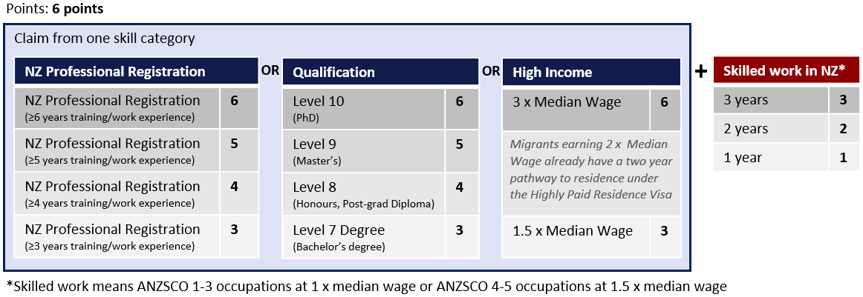
Please refer to pages 22-25 of the consultation document for a detailed explanation of the structure of the simplified points system.
12 | Is the simplified points system easy to understand?
Yes
No

13 | Do you think that the number of points allocated for professional registrations is fair?
Yes
No

 | Why/why not?
14 | Do you think that the number of points allocated for qualifications is fair?
Yes
No

 | Why/why not?
15 | Do you think that the number of point points allocated for income is fair?
Yes
No

 | Why/why not?
16 | Do you think that the points are balanced between the three different skill categories?
Yes
No

 | Why/why not?
17 | How could we improve the simplified points system?
18 | Do you have any other comments on this section?
Final thoughts
19 | Do you have any other comments in relation to the proposed changes to the Skilled Migrant Category that are not covered above?
Submitter information
20 | Personal information
Name
Email address
Phone number

21 | What is your immigration status?
NZ citizen
Resident/Permanent Resident visa holder
Temporary visa holder
Offshore

 | Other (please specify)
22 | Are you making a submission on behalf of a business or organisation?
No
Yes (please tell us your business/organisation)

23 | What type of business or organisation are you representing?
Private business
Industry organisation
Union
NGO (e.g. migrant community representative/group)

 | Other (please specify)
24 | What sector/division best describes your place of work or the work of the business/organisation you are representing?
25 | Are you a Licensed Immigration Adviser or immigration lawyer?
Yes
No

26 | In which region are you or the business/organisation you are representing based?
27 | Are you happy for MBIE to contact you if we have questions about your submission?
Yes
No

28 | Privacy
 | Please tick this box if you do not wish your name or contact details above to be included in any information about submissions that MBIE may publish.
29 | Do you have any objection to the release of any information provided in this survey
Yes
No

 | If yes, please indicate which parts you consider should be withheld, together with the reasons for withholding the information.

