March 2024
The potential for digital twin technology to accelerate the transition to a circular economy:
Demonstration workshop

Report

PREPARED BY:

Background
As part of project work for MBIE - “Enabling digital technologies for New Zealand’s circular and bioeconomy, including the role of digital twins”, a demonstration through a use-case was undertaken. This was designed to enable interaction by a (non-technical) government audience and other stakeholders, such as industry and business. It took the form of a presentation followed by a workshop session.

Summary
A hypothetical demonstration use-case was developed for a built environment scenario due to its relatability to a wide audience. The use-case, along with selected digital twin (DT) examples from across New Zealand, was presented at a workshop on Tuesday 28 November, 2023 to an in person and online audience.
The workshop was well received, with a high level of interaction from the audience.
The use case highlighted how digital twin technology could unlock more circular outcomes via the use of the technology to achieve cost and resource savings and utilising the DT ability to undertake virtual trials of design changes, material/equipment choices and infrastructure upgrades.
Key questions raised by the audience following the use case presentation focussed on ownership, connectivity, scenario modelling, accuracy, application in regulated industries and the role of government.
The audience was split into groups to reflect on the use case presentation and then focus on a particular scenario self-selected by the group members.
Reflections on the use case reinforced circular and general process opportunities as well as highlighting further questions such as: ‘Who owns the data?’
The different scenarios explored for digital twin technology included beer brewing, packaging and enabling wellbeing through Ministry of Education assets.
In conclusion, the audience, via a Slido poll, overwhelmingly indicated a high level of potential for digital twin technology to enable the transition to a circular economy in Aotearoa New Zealand.

Workshop details
When: Tuesday, 28 November 2023, 9:30am – 11:30am
Online and in-person at Aurecon Auckland offices – Level 3, 110 Carlton Gore Road, Newmarket, Auckland

Attendees
In total, 66 registered for the workshop, with an approximate 1/3-2/3 split between attending in person and online. (In some cases attendees originally registering for in person attendance opted to join online).

Attendees were asked to illustrate their current level of understanding of digital twin technology:
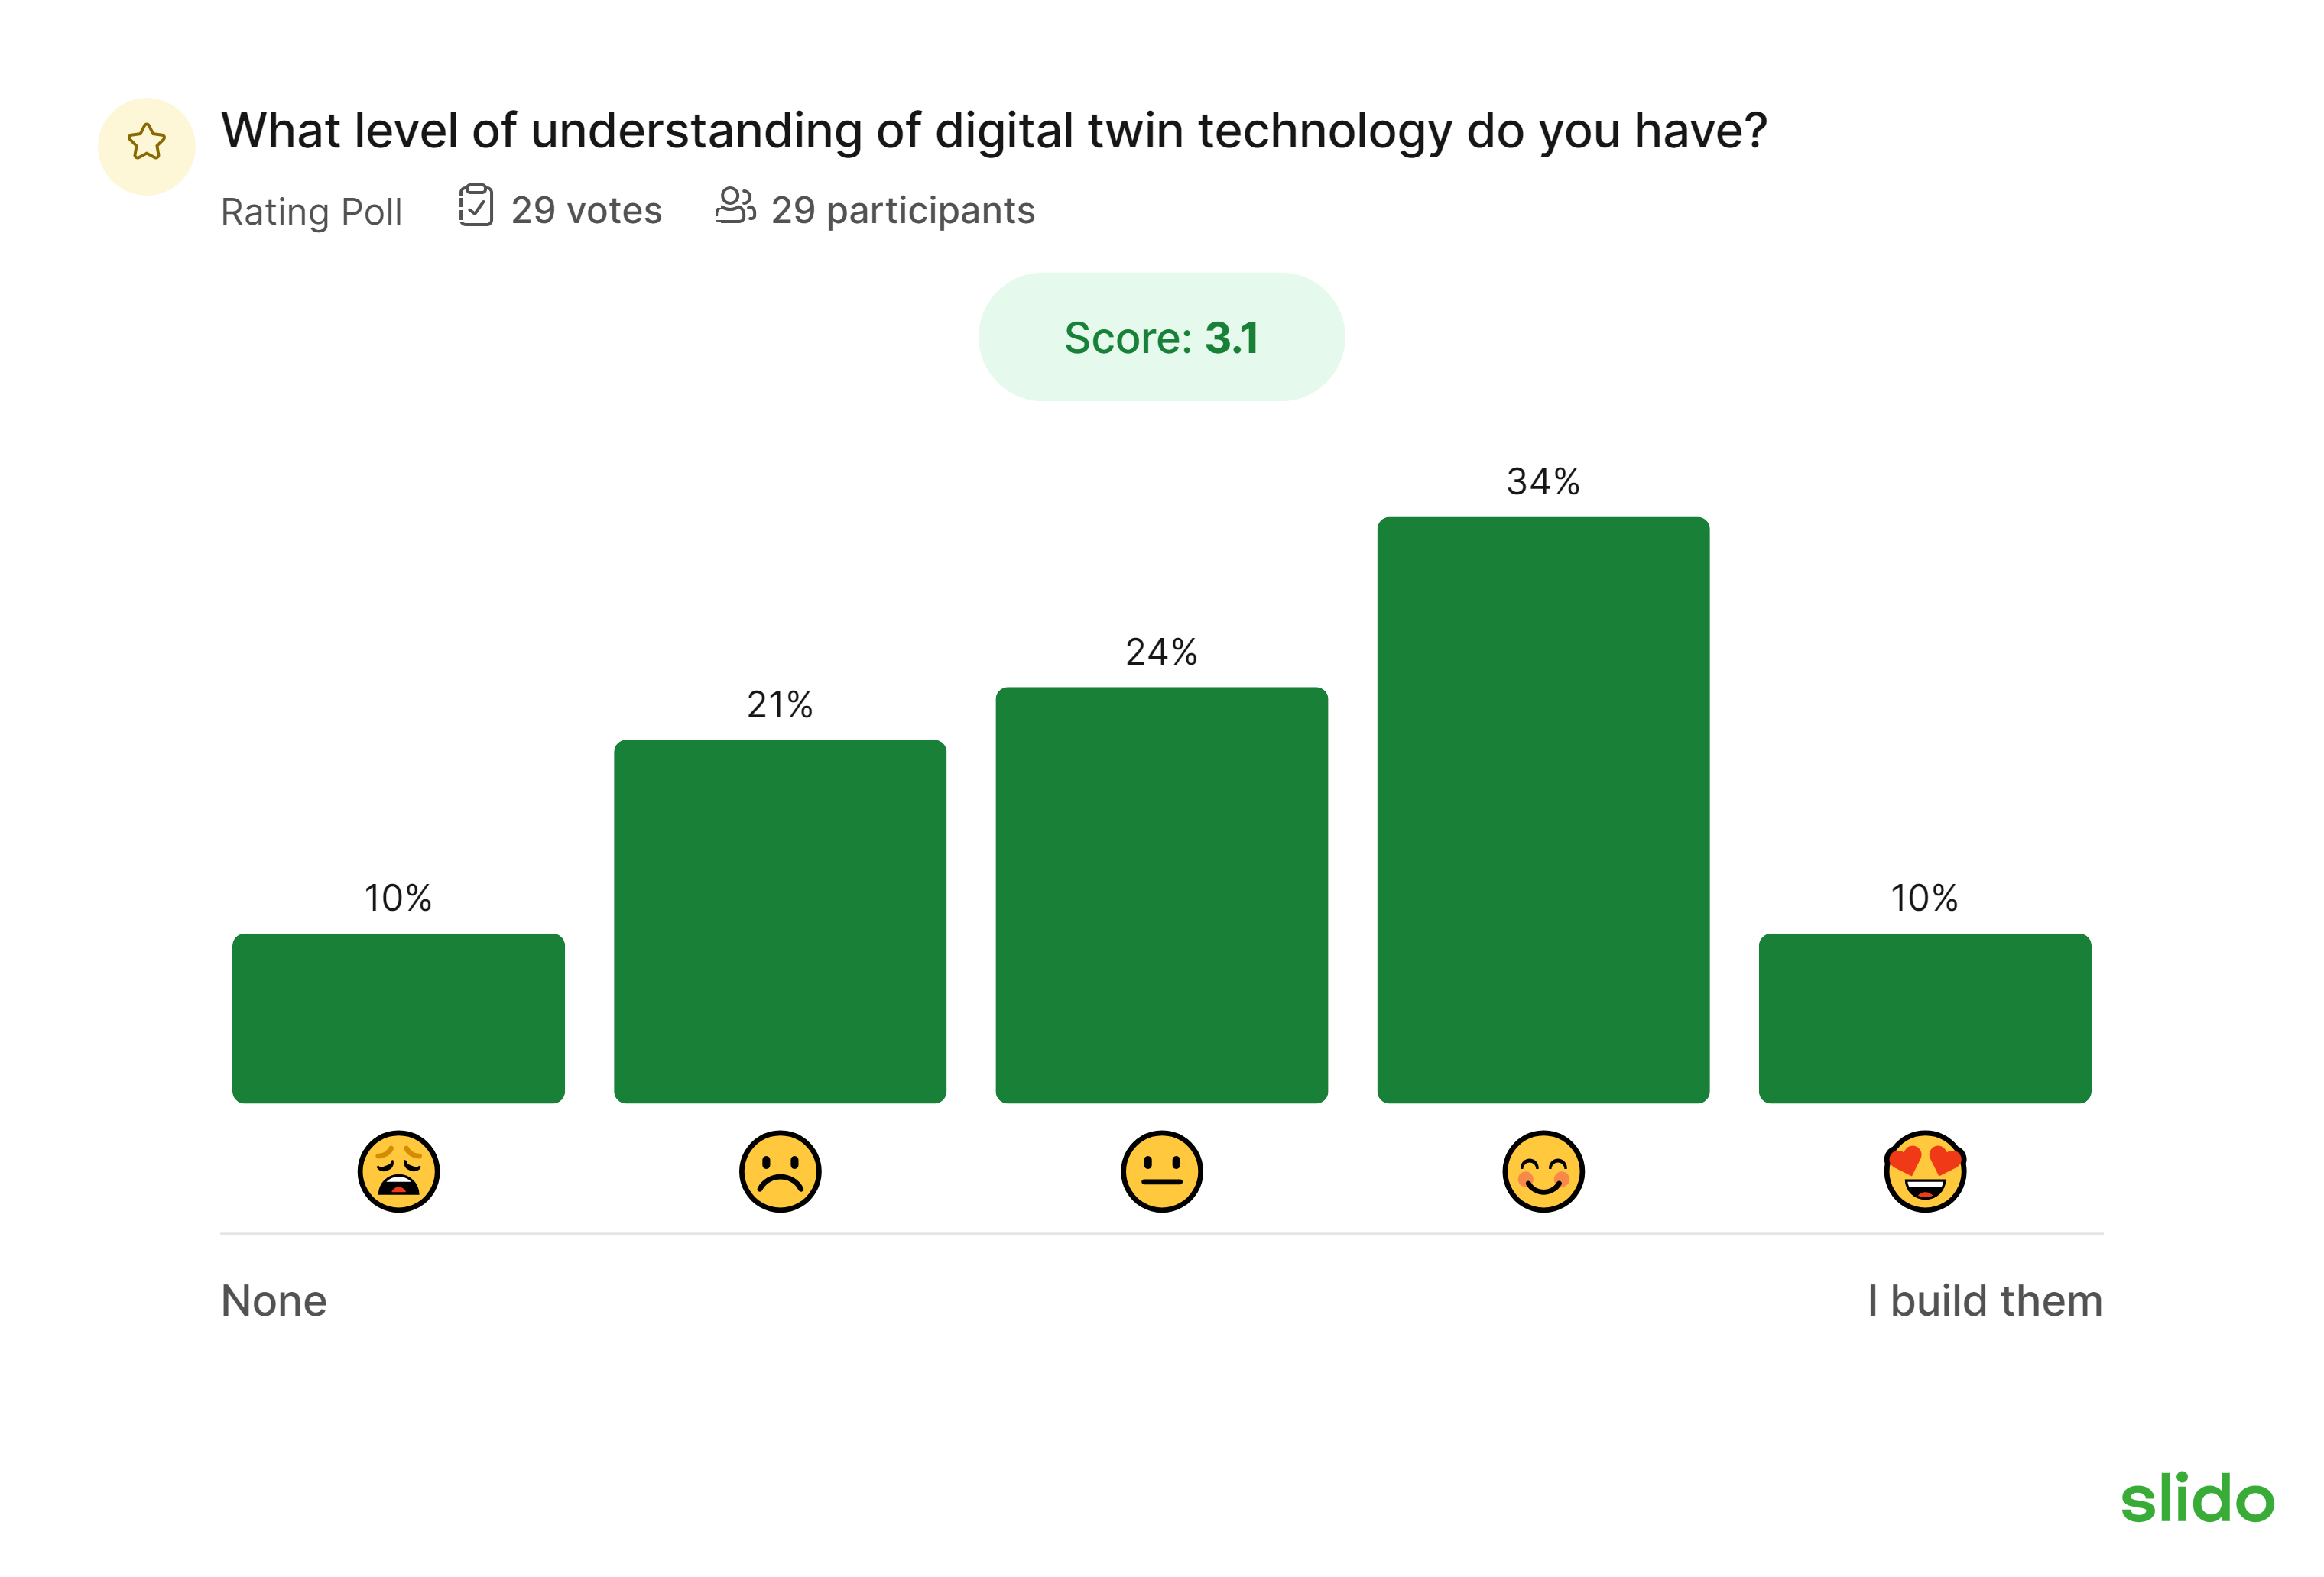

Workshop agenda
- Introduction and context
- Digital twin use case
- Q&A session
- Group work
- Sharing insights
- Wrap up
A recording of the workshop including the demonstration use case can be accessed here.

Introduction
A digital twin is typically considered a digital replica mapped onto a living or non-living entity.
It is a dynamic and interconnected digital representation of a physical asset or system, enabling comprehensive insights and informed decision making.
The essence of a digital twin lies in its ability to synchronise data between physical and digital realms. This fosters a two-way data flow. It facilitates feedback mechanisms for effective interventions in the physical system.
Through a stakeholder engagement exercise a further definition was obtained:
“A dynamic and interconnected digital representation of a physical asset or system, enabling comprehensive insights and informed decision making.”
The circular economy is based on three principles, driven by design:
- Eliminate waste and pollution
- Circulate products and materials (at their highest value)
- Regenerate nature

Digital twin use case: Optimising building asset design and management
The hypothetical use case created is a complex comprising multiple buildings, including residential units, shared community spaces, and commercial areas as well as public assets such as a medical centre situated in Lyall Bay, Wellington.
A timeframe of 75 years was taken to demonstrate how digital twin technology can unlock circular outcomes throughout the life cycle of the complex. The following pages summarise the PowerPoint presentation used and any key speaker notes that accompanied it.
The design stage:
Time frame: present day
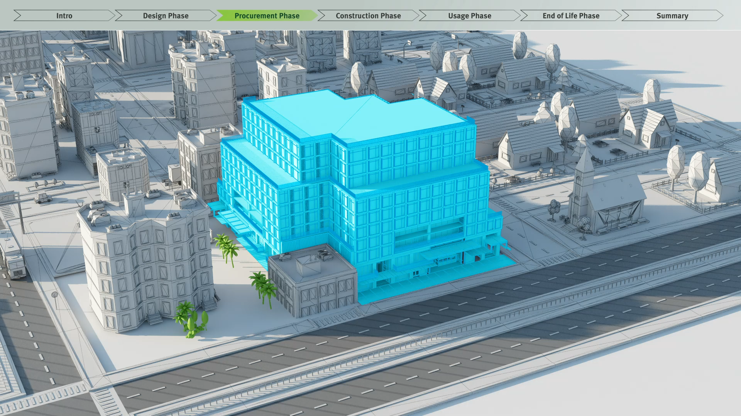
From the outset DT was used to enhance the overall design of the complex.
It enables the simulation and analysis of various architectural and operational scenarios in a virtual environment, enabling architects and engineers in the development team to optimize the building's layout, energy efficiency and overall sustainability, including the carbon footprint, before actual construction begins.
We recognise that the complex will need to be adaptable, so we are able to plan for various different needs the users of the building may have over the years. For example, an ageing population would mean rest home requirements or greater adaption of the buildings for those with access requirements.
One of the unexpected cost savings we are currently enjoying is in the consent process. There are, however, many useful opportunities to test different construction materials in the design, offering significant cost saving opportunities.

The procurement stage:
Timeframe: 2024
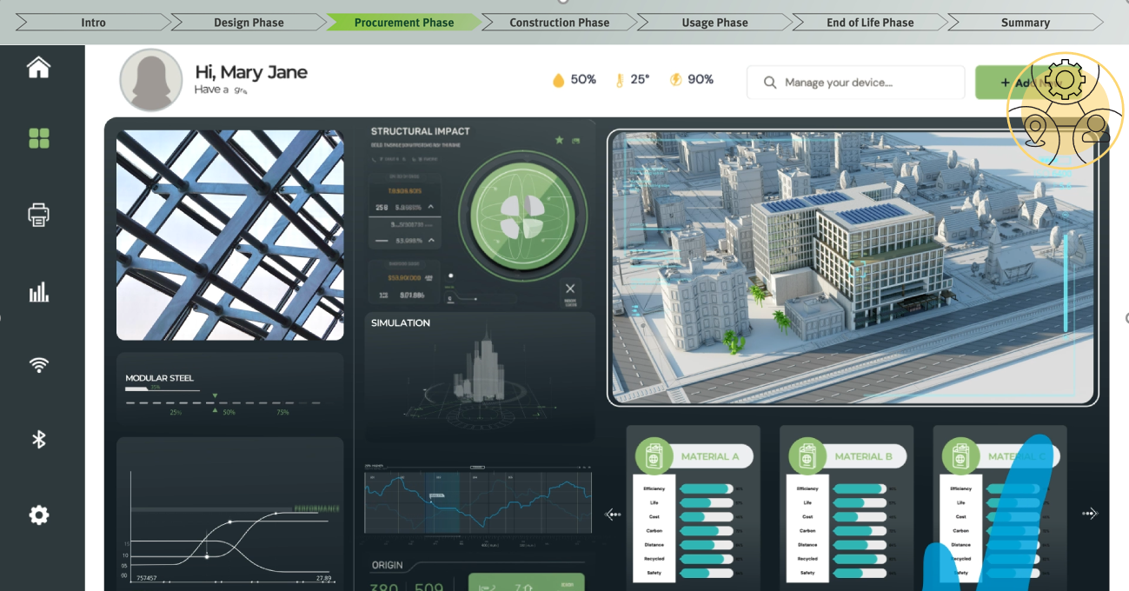
The DT integrates with supply chain networks, ensuring that materials used are sustainably sourced wherever possible and have end of life solutions. These end-of-life pathways to achieve maximum value are based on current circumstances in Aotearoa New Zealand and reverse supply chain infrastructure. Over time these will change as the economy becomes more circular and the DT will update them, maintaining a building deconstruction value as well as end of life pathway for the main elements of the complex. Modularity and repairability of materials are of interest to the developers, with maintenance estimated for consideration.

The construction stage
Timeframe 2024/5
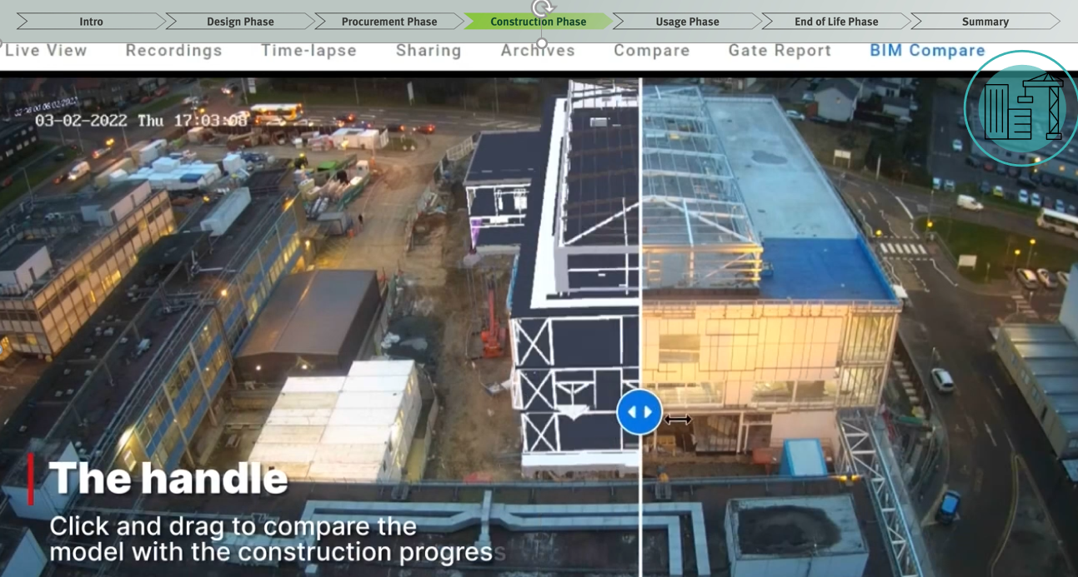
It enables an optimised timeline for construction, combining data from the digital twin and using predictive analytic tools with AI and supports off-site construction specification development, where construction waste can be closely monitored and avoided. All timelines and interdependencies are considered, meaning the tradies arrive ‘just in time’ to do the job and the necessary pre-work has been completed. And, inevitably, when some things don’t go to plan, the plan can be updated quickly with any necessary changes.
Where a material has to be changed in the construction phase, for example, due to a spike in inflation, extensive delays in obtainability, or an unexpected design change requested by users, then the DT can quickly show the necessary adjustments and stakeholders can see the impact visually and in key reference data for any necessary authorisations.

The use phase
Timeframe: 2025-2075+
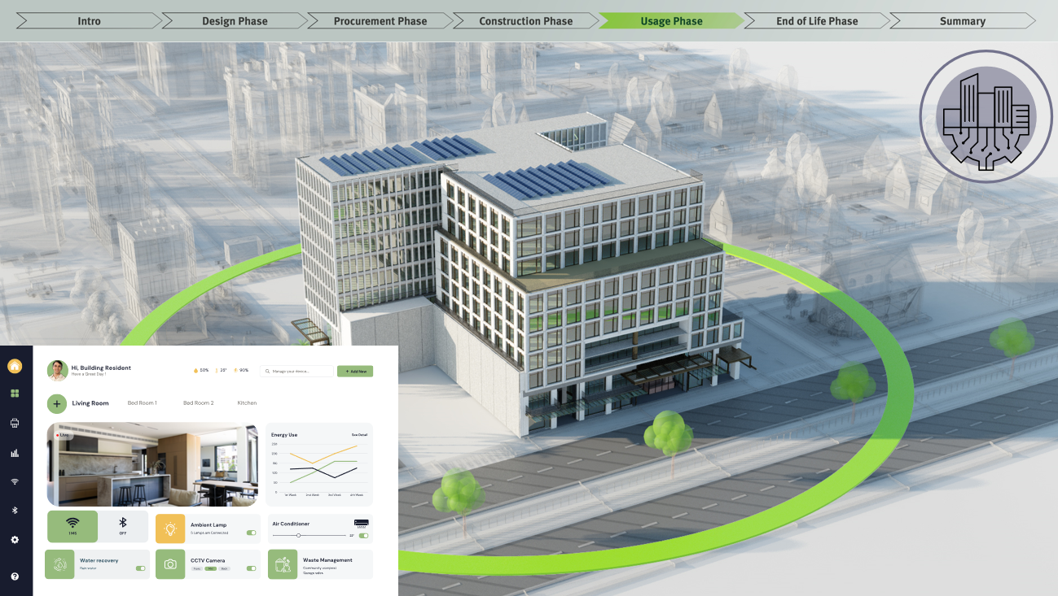
The DT tracks the condition of building materials and infrastructure. It predicts maintenance needs and schedules repairs, extending the lifespan of materials and reducing waste. Replacement equipment and materials can be tested virtually prior to use in the DT to optimise stakeholder buy in, recognising wider impacts and resources/costs. Engagement costs are notably reduced, because users of the complex can see the proposed changes easily prior to any agreement and implementation.
The DT continuously monitors and manages resources like energy, water, and waste. It uses real-time data to optimize renewable energy usage, water recycling and waste recycling. This enables a range of reporting to be undertaken to various interests including business and public sector users of the complex.
Building users interact with the digital twin through an app. The app provides feedback on their consumption patterns, suggesting ways to reduce waste and conserve resources. It also allows residents to participate in community-wide sustainability initiatives, such as recycling.
The predicted change to residents’ needs considered at the design phase can relatively easily be implemented, due to pre-planning and an extensive amount of captured data sets on the building structure. Elderly care apartments can be added to existing structures for the elderly parents of residents and existing residences can be altered to one storey living to ensure that the older residents with mobility constraints can stay longer in their homes.

Integration with city infrastructure
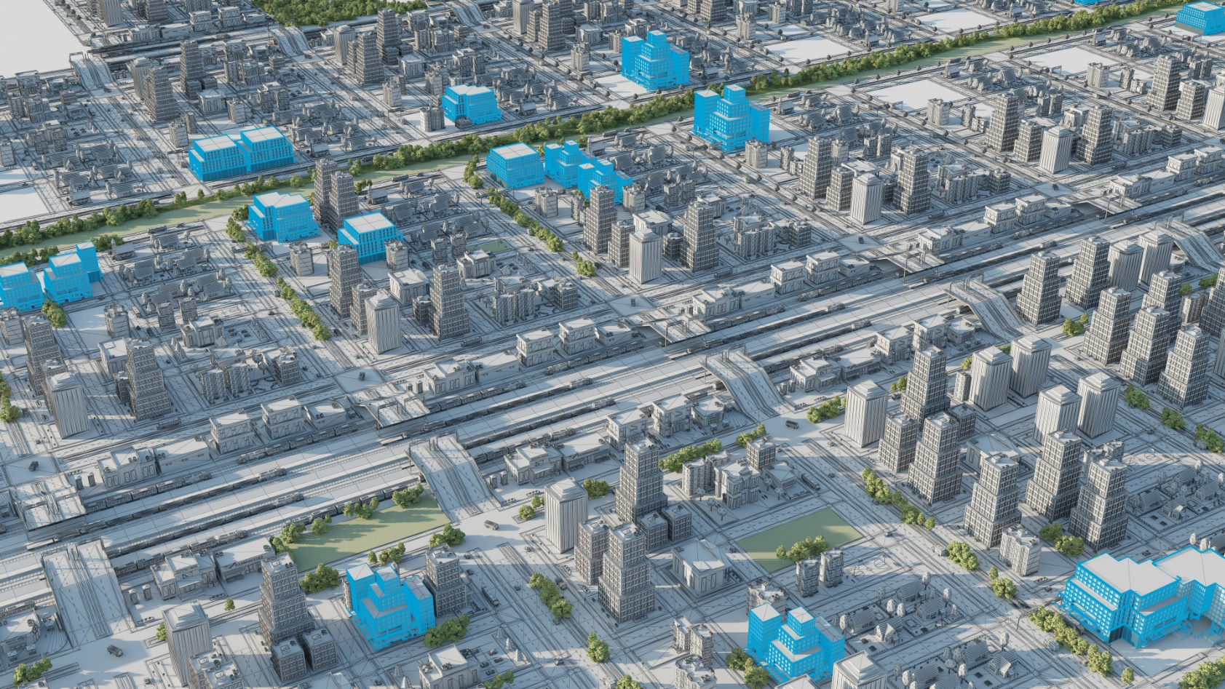
Over time the digital twin for the complex becomes connected to Wellington’s wider infrastructure systems. This integration allows for more optimized water and traffic management, energy distribution and public service delivery, benefiting the complex users and the wider urban environment.

End of life
Time frame: 2100
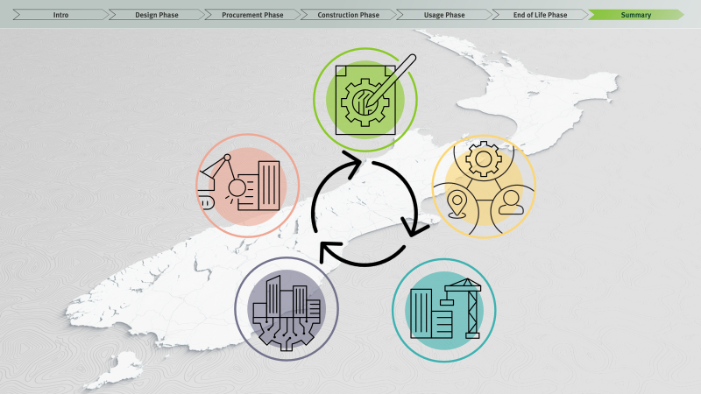
Following several more adaptations to the complex it has now been deemed that some buildings have reached the end of their life, for example the existing medical centre is unable to accommodate the new technology required to deliver modern healthcare and some buildings have inadequate space to store their robotic staff. These buildings will be replaced and as they have been acting as a ‘material bank’– at the end of use of the building the provenance and status of individual parts and materials can be identified, enabling reuse or recycling into the construction of the new buildings. Alternatively, some elements are returned to their original manufacturer for reprocessing or sent to an appropriate recycler. There is a thriving market for these materials due to supply constraints.
Enabling technology and data
Digital Twin technology interoperability and its ability to utilise and manage data is at the heart of what is possible. Access to digitised data is the backbone of the DT. However, other technology is key to making it work effectively. This includes Material Passports, BIM, IoT tech, cloud computing and AI to help assist with the management of various types of data, of varying quality. DT as a service may be important to ensure small and medium sized businesses can access it cost effectively.

Examples illustrating the current state of digital twin technology in NZ
Safeswim
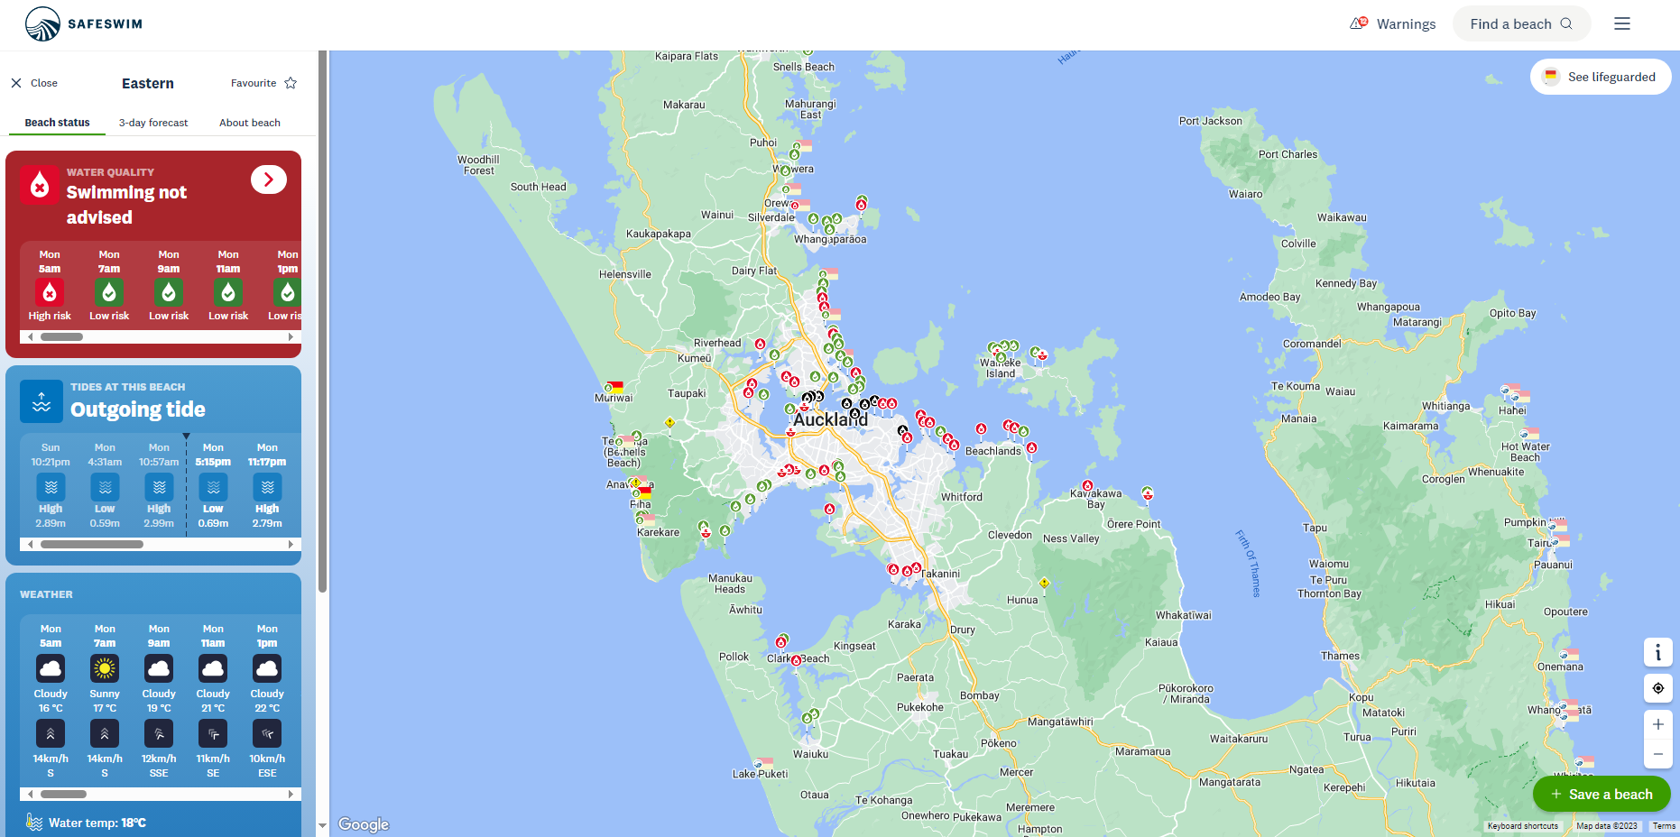
Safeswim is a collaborative programme providing real-time advice on the level of risk associated with swimming at specific locations, allowing beach users to make informed decisions on when and where to swim.
Safeswim is a partnership between the Auckland Council and other regional councils, Surf Life Saving New Zealand, Surf Life Saving Northern Region and the Auckland Regional Public Health Service.
Wellington Digital Twin
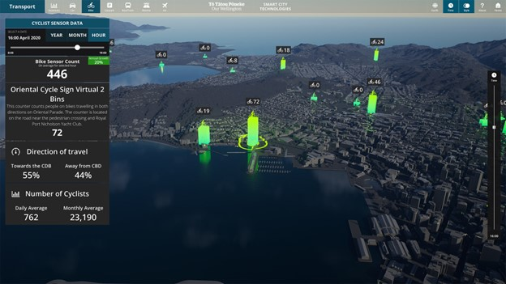
The Wellington City twin has the purpose of showcasing the multitude of real-time activity, and to create a platform where decision making could be enhanced.
It uses smart city technologies, with real-time data to provide transportation statistics; air traffic visualisations; cycle sensor data; and car park availability.
Urban flood Digital Twin (Christchurch City Council)
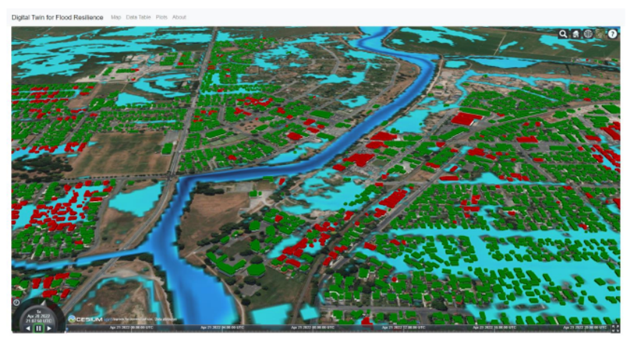
The MBIE-funded Building Innovation Partnership undertook an exploration of a common reference framework to bring together all the disparate information sources needed for flood modelling to test the resilience of infrastructure to flood events.
This pilot is being leveraged into a Christchurch digital twin and in work by the NZ Geospatial Research Institute to democratise access to flood assessment modelling.
Nextspace
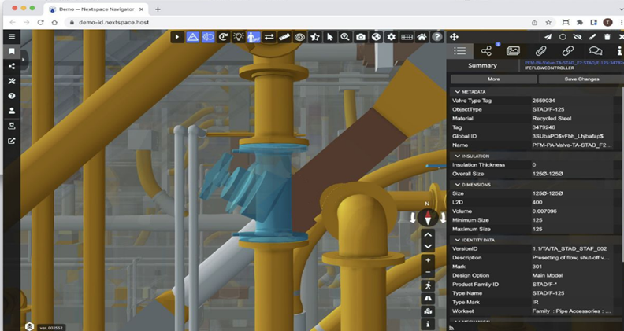
Nextspace is a cloud-based platform for building, maintaining and visualising digital twins. The platform allows for different data formats and sources and can easily transition between teams as the assets moves across life stages.

The whole process is governed by a ‘GUID-based ontology’, in which every component has its own unique ID, allowing proper data storage and connection with other digital twins without the need for data harmonisation.
Forest Flows
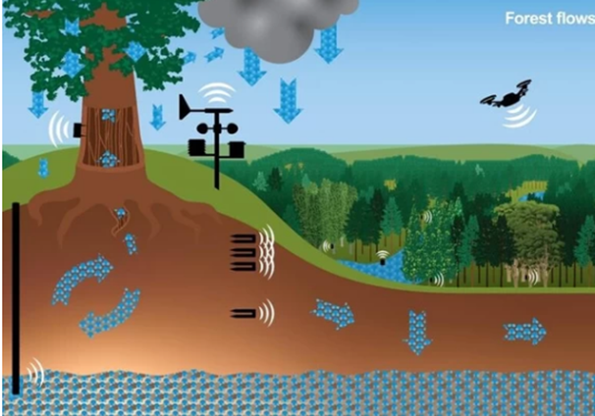
The bold goal of this programme is to create a new biophysical forest hydrology model combining cutting edge remote sensing techniques with terrestrial based measurements, integrating data and enabling scale, as a digital model applicable to planted forests all over New Zealand.
These extrapolations will be made possible through detailed analysis and simulation capability, and coupled with powerful tools including visualisation and enabling access to insights, achieving this Forest Digital Twin will be a major breakthrough for hydrology research internationally.

Question & Answer session
Q: Who owns or operates the technology over the lifespan of the building?
A: It could be owned by a company, partnership or a city. That entity would need to interact with multiple other stakeholders throughout. One of the challenges is the ownership and sharing of commercially sensitive data. There is a lot of work going on to try and establish how best to overcome this challenge.
Q: Can you expand on linking the DT to the supply chain?
A: Essentially the DT is a capability. It doesn’t necessarily hold data and it doesn’t necessarily ingest data. The power of a DT is the way it connects. For example, not only is it connecting, in this case, to architectural models but it can also connect to material databases. Going forward to the end of life stage for the materials, the DT doesn’t have to ingest or save databases for reuse or recycling options, it just needs to connect to the relevant data source or platform. A powerful capability of the technology is that it is not necessary to have one DT scaled across the country, you can have individual DT all connected.

Q: Could you look at the impact of increasing bike parking to raise active mode uptake by a x% and the impact that would have on car parking space and associated greenhouse gas emissions?
A: Absolutely, if you had the data. The DT would be able to look at different options and what the implications of that are.
Q: Could DT be used in the manufacturing setting to monitor things like pumps and labelling machinery to optimise run times and throughputs. Also could it monitor flow of ingredients and materials as well?
A: Simple answer is yes! DTs are being used to understand the flow of components through additive manufacturing processes, for example, through the flow of information between additional representations and simulations of manufactured components and the actual manufacturing enables the dynamic adjustment of the manufacturing process on the basis of simulated data.
Q: Are their particular technology platforms or providers that are really critical to DT technology behind the scenes and how are they fitting together?
A: A key technology that was behind the use case was a BIM (Building Information Modelling) which has been around for some time. GIS (Geographic Information System) is another one. A digital twin is able to connect to these existing systems and data sources. So, for example, a user can still log into their existing system rather than the DT. This is important as an enabler of collaboration, to encourage the breaking down of silos as well as data sharing for even greater insights and efficiency.
Q: Things are never perfect with AI so what are some of the accuracy issues that can be encountered and how might they be mitigated?
A: The first thing for the mitigation is: keep the human in the loop. Secondly, be really aware that even if it works in one scenario on one set of data, the algorithm may or may not work in another instance.
The important thing there is to make sure that you're discussing with your IT team or other internal resources and you're building capability and or liaising with some professionals and experts outside the organisation.
It’s also important to correlate outputs. For example, there are DTs in New Zealand that are still correlating with the manual ways of recording the data and what the sensors are picking up because they just want to make absolutely sure that the sensors are picking up what they should be picking up.
Q: How are DTs being considered in some highly regulated industries, for example, medical devices? Are the different regulatory agencies across the world considering DTs as a key part of present or future product development? And if they could be used on the regulatory processes when you are submitting for product approved?
A: DTs are increasingly being utilized across various sectors, notably in medical devices and aerospace. In aerospace, digital twins are becoming a crucial part of the certification process. The sector is witnessing an influx of additive manufactured (AM) parts, initially in less critical applications. However, as AM progresses to more critical components, the ability to verify the unique manufacturing of each part becomes essential. Unlike standardised stamped or machined parts, every AM part is distinct. This trend is likely to extend to medical devices, especially when adapting geometries to fit individual patients.
The verification of the entire manufacturing process is vital, allowing for traceability from a potentially faulty part back to the specific material batches used. This level of scrutiny is already being implemented in aerospace, enabling identification of other components that may be in service using the same batch of materials. The medical device sector is expected to adopt similar practices, particularly for implants and components that have experienced failures. The ability to trace these failures back to their material batches and then forward to their application points is crucial to mitigate risks.
This shift towards greater traceability and verification in manufacturing processes is the result of direct collaboration between manufacturers and regulators. It represents a significant development in ensuring the safety and reliability of critical components in both the aerospace and medical device industries.
Q: What is the government's role in the use of DTs for enabling the circular economy?
A: There are two prevailing models. One involves the industry collectively taking initiative, potentially with government support. The other model is where the government actively drives the process, believing in the technology's efficiency and utility. By taking the lead and integrating the technology into their own processes, especially in procurement, the government sets a precedent that others may tend to follow. This approach has been confirmed as one that would be welcomed in New Zealand by the feedback we've received from our engagements as part of this project.
Regarding the specifics, the circular economy presents a unique challenge. Although it's not the primary driver for digital twins, its relation to resource efficiency and cost savings is undeniable. It's crucial to make stakeholders, particularly small businesses, aware of the circular benefits. Providing case studies on how digital twins can address various issues, including those related to the circular economy and emissions, can be highly informative. As these aspects become increasingly vital for reporting, the advantages of using this technology in these contexts should be emphasized. A final point is about the importance of shared learning, as exemplified by the Construction Sector Accord.
An additional answer to the question was put forward in the online chat:
- Open data: One of the things government has done and can continue to do is to provide open datasets that will be used as the basis for the innovations in the space.
- Data standards and minimum requirements: government can enable the adoption of standards and the development of a 'common language' that can allow integration of information.
- Active development as a client of this technology: Setting the tone of what and how digital twin can be achieved throughout their services by being an early adopter of the technology.
- Regulation.
Breakout group work
Reflections on use case presentation
- Improving tracking and maintenance in buildings – predictive work
- Highlights bottlenecks and stress points
- Logistical dynamics
- Cost and efficiency savings likely to drive adoption
- Unsure how competition will pan out between vendors
- Less about technology and more about access to data
- Interoperability is critically important – federation of digital twins the end point
- Focus on co-management, stewardship, value creation
- Potential connector of resources and end use all in an optimised digital system
- Who owns the data?
- Bring together the disconnected siloes
- Supporting effective decision making and feedback loops
- Visualising information in a useful way for the client or other stakeholders
Exercise: Agree sector/product/scenario or an aspect of national relevance that you will explore the potential of digital twins for and the most impactful ways digital twin technology may help enable adoption of more circular approaches
- Scenario: Digital Twin of supply chain for carbon impact assessment – brewery
  - Packaging – design and disposal options
- Scenario: Plastics manufacturing and recycling to boost circularity
  - Acceleration of time to market for new materials
  - Enhancing visibility of materials to designers and engineers
  - Connecting EoL realities to product design and specification
- Design and manufacturing of fibreglass with the goal of more circular practices and networks
  - Enable more modularity and adaptability
  - Understanding universal processes at a macro scale
  - Providing transparent and easily digestible data EPD
  - Real-time decisions in the design space
- Built Environment
  - Role of government – the commons, culture to support etc
  - Standards and rules for engagement
  - Resilience of the network
  - Linking the built environment and ecosystems
  - Change thinking to pan-interest as opposed to pan-industry
- Resilient communities - urban planning with a social and ecosystems lens
  - Digital simulation for risk minimisation and ecosystem preservation e.g. floods, wetlands, bird flight paths
  - Adaptive urban planning
- Enabling greater wellbeing through the Ministry of Education school assets
  - Incorporate other data related to community wellbeing and environmental information e.g. illness trends, air quality etc.
  - Connect the data to create a two-way flow e.g. trigger an adjustment in temperature based on real-time occupancy
- Energy systems
  - Electricity distribution by demand – advanced metres
  - Simulation of regional networks
  - Model network build and maintenance
  - Resilience for communication of assets
  - Backup / local grids
  - Emergency response – power diverting to need
Selected summaries of breakout sessions
Scenario: Brewery
Our group discussed the use of a digital twin in a brewery to assess the impact of the supply chain, particularly in relation to COVID-19 disruptions. This example highlighted the broader implications of digital twin technology in complex operational settings.
Additionally, we delved into the aspects of circular economy impacts, particularly in procurement processes. This included considerations like choosing manufacturing locations based on distance, managing end-of-life product phases, and optimizing the use of waste materials, such as using surplus materials for animal feed. The logistics and demand prediction for these processes were also discussed, emphasizing the need to streamline sales and distribution to minimize waste.
One of the most impactful topics was the design of packaging. We explored how to improve packaging design for better disposal options and its subsequent environmental impact. Our discussions underlined the importance of clearly defining the questions we need to answer to effectively gather and utilize relevant data.
Scenario: Energy supply and demand in buildings
We focused on the development of a digital twin for buildings, equipped with sensors to accurately monitor various aspects. A significant application of this technology is in the management of energy supply and demand. By leveraging data from these sensors, it becomes possible to distribute energy efficiently, directing it to areas of need.
We also deliberated on the strategic use of these digital twins in the context of aging assets. As equipment and infrastructure age, there is an opportunity to consider replacing them with renewable energy assets. This approach not only modernizes the infrastructure but also contributes to community-wide benefits. By integrating renewable energy sources, we can distribute electricity more effectively within the community, enhancing sustainability and resource efficiency.
Scenario: Plastic Manufacturing
Our session focused on plastic manufacturing aiming to enhance circularity. However, our discussion was only able to cover aspects up to the production phase. We explored the trade-offs between developing new polymers to improve circularity and reducing the material palette to enhance recyclability. We also considered the procurement process, particularly the type of information necessary to ensure product assurance. This includes overcoming the familiarity barrier that designers and engineers face with existing materials and ensuring product performance.
Additionally, we discussed how to integrate information about downstream recycling infrastructure, which significantly impacts the viability of materials. There was a mention of challenges in viewing the shared screen, which briefly interrupted our flow.
In the production phase, we observed a trend towards minimizing trial and error in manufacturing by employing digital simulations. These simulations test various materials and manufacturing parameters, allowing for more precise data gathering on a select group of materials. This approach aims to verify the initial simulations and continues to gather data on the performance of these materials throughout the manufacturing process, ensuring consistency and reliability.
Workshop conclusion
At the end of the workshop the audience were asked a question via Slido about the potential they felt DT technology has to enable the transition to a circular economy in Aotearoa New Zealand.