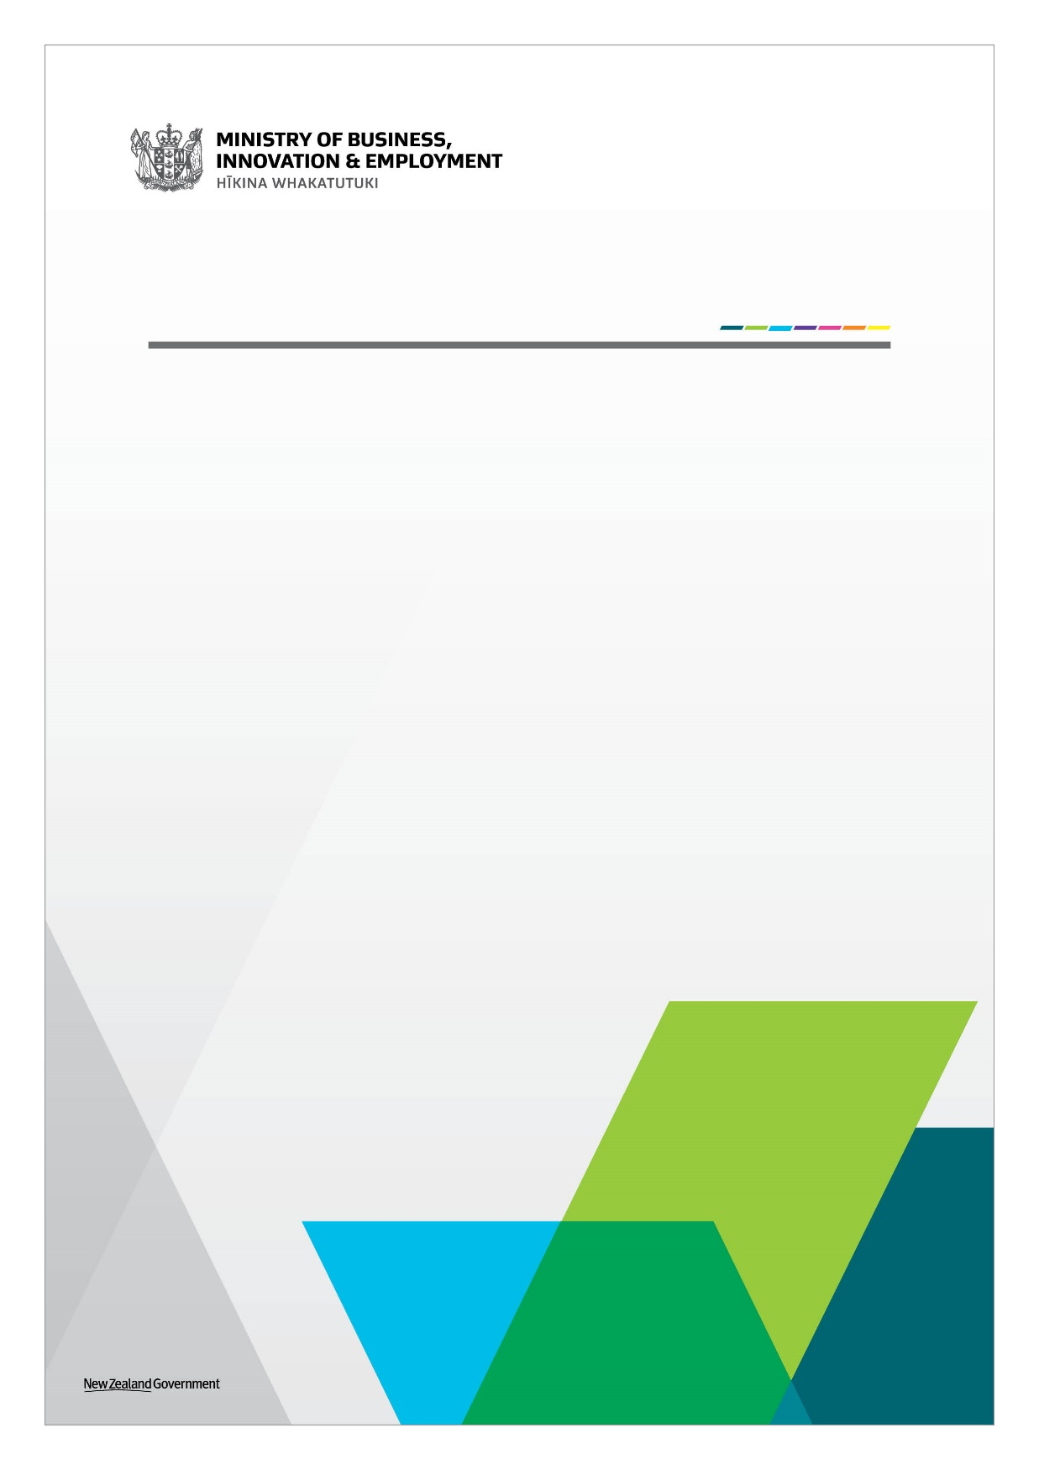

Ngā Haerenga, the New Zealand Cycle Trail

Electrifying the Great Rides Fund

Application Form   
August 2024

Electrifying the Great Rides Fund

Application Form

**Completing this form**

Please complete the form in full and submit it electronically to [NZCT@mbie.govt.nz](mailto:NZCT@mbie.govt.nz). If you need any assistance with completing this form, please contact the MBIE Cycle Trail team on [NZCT@mbie.govt.nz](mailto:NZCT@mbie.govt.nz).

MBIE will assess proposals against the eligibility and/or the assessment criteria, we will consider whether the evidence provided supports the claims, as well the quality of that evidence. Where questions ask for evidence to support claims, it is highly recommended that you provide reference sources that attest the accuracy and quality of the evidence.

MBIE will assess the application using the information provided by the applicant.

**Intention of the Funding**

The purpose of the Electrifying the Great Rides Fund (EGR) is to improve access to the New Zealand cycle trail network by investing in e-bike charging stations on cycle trails around the country. This initiative is part of the Government’s 100-point Economic Plan to rebuild the economy.

The funding is only for e-bike charging equipment and installation (e.g., connecting directly into the existing power network, but not for extending the network or upgrading transformers)). Solar power charging equipment for off-the-grid locations is within scope of this fund. The funding is not intended to be used for additional facilities associated with the charging station (e.g., installing a potable water source, toilets, interpretation panels). Great Rides are expected to fund additional facilities by themselves. Ongoing maintenance of the e-bike charging equipment is out of scope of this fund.

The maximum amount of funding available to each e-bike charging station is $60,000 (excl. GST). Applicants can apply for one or more e-bike charging stations, but only one application per Great Ride. For the purposes of the EGR, the locations of e-bike charging stations should be within five kilometres of a Great Ride and provide evidence that they will service Great Ride users.

Any approved funding from the EGR should be used within 18 months of contracting.

**Co-funding Requirements**

Applicants must co-fund at least 50 per cent of each e-bike charging station (with some flexibility for financially constrained Great Rides).

In-kind contributions may be allowed, but will be considered on a case by case bases. Please contact MBIE for any questions regarding in-kind contributions.

**Eligibility Checklist**

You must meet all the eligibility criteria below before you apply for this funding:

☐ Is your trail a Great Ride?

☐ Is the Great Ride a financial member of NZCT Inc.?

☐ Are you able to co-fund the required amount of the estimated total cost of the e-bike charging station/s for your Great Ride?

☐ If your Great Ride is managed or associated with several stakeholders, have you provided evidence that they have been consulted and are supportive of this application?

☐ Has ownership and maintenance of the e-bike charging equipment been confirmed?

|  |  |
| --- | --- |
| *Name of Great Ride* |  |
| *Trading name of applicant* |  |
| *Legal status of applicant* | For example, ‘a unitary local authority’ or a ‘Charitable Trust’. |
| *Role of applicant in the governance of the Great Ride* (i.e. trail owner, trail management) |  |
| *Estimated total cost of project (excl. GST)* | $ |
| *Amount of funding sought (excl. GST)*  (For e-bike charging equipment and installation only) | $ |
| *Project time frame* |  |
| *Summary of project*  (Provide a brief summary of the proposed project, includes location/s of the proposed project, type of e-bike charging station being used, estimated usage of e-bikes at this location, and a breakdown of how this funding will be spent.) |  |
| *Demonstrate the rational and importance of your proposed project*  (Please include the benefit that you expect will flow from your proposed project.) |  |
| *Procurement:*  (Please describe your procurement process, and why you have selected your preferred e-bike charging station.) |  |
| *What are the ownership and maintenance arrangements for the proposed e-bike charging station/s?*  (Please clarify who will own the proposed e-bike charging station/s; and who will provide funding for the ongoingmaintenance of the proposed e-bike charging station/s.) |  |
| *Have all necessary land access and resource consents been obtained for this project?*  (If not please provide an overview of what will be required and expected timeframes.) |  |
| *Please identify any other risks associated with this project and how they will be managed.* |  |

|  |  |  |
| --- | --- | --- |
| *Applicant information* | | |
| Contact person |  | |
| Great Ride name |  | |
| Title |  | |
| Phone |  | |
| Contact email |  | |
| Postal address | Organisation or Building  (if required) |  |
| Street, Bag, or Box |  |
| Suburb |  |
| Town, Postcode |  |
| *Legal name of organisation funding contract will be with, if application is successful* | | |
| Name |  | |

**Declaration by applicant**

I declare on behalf of the applicant(s), that:

* this declaration outlines the basis on which this application is made;
* I confirm that I have read the information relating to funding for the Electrifying the Great Rides Fund on the MBIE website;
* the statements in this application are true and the information provided is complete and correct and there have been no misleading statements, omission of any relevant facts nor any misrepresentation made;
* I understand MBIE and its advisers may disclose to or obtain from any government department or agency, private person or organisation, any information about the applicant or project for the purposes of gaining or providing information related to the processing and assessment of this application;
* the applicant will, if requested by MBIE or its advisers in connection with this funding process, provide any additional information sought and provide access to its records and suitable personnel;
* I understand MBIE may undertake due diligence checks as needed to meet government requirements, and I consent to checks required being carried for those purposes;
* I consent to the public release, including publishing on the Internet, of the name of the applicant, the amount of grant sought, contact details of the applicant and a general statement of the nature of the activity/project, and undertake to cooperate with MBIE on communications relating to this application;
* I understand MBIE’s obligations under the Official Information Act 1982 and that, notwithstanding any relationship of confidence created as a result of this application, the provisions of this Act apply to all of the information provided in this application;
* the application involves an activity/project that is a lawful activity that will be carried out lawfully;
* the applicant is not in receivership or liquidation nor will the project be managed by an undischarged bankrupt or someone prohibited from managing a business;
* where external providers are being employed as part of the project/activity, the relevant providers are not employees or directors of the applicant, and nor do they have any other direct or indirect interest in the applicant, whether financial or personal unless specifically stated in the application; and
* I am authorised to make this application on behalf of the applicant/s and I have consulted with all relevant entities associated with management of the Great Rides.

|  |  |  |  |
| --- | --- | --- | --- |
| ***The Applicant to sign and complete details below***  (This acknowledgment must be signed by a person with the legal authority to commit your organisation to a transaction.) | | | |
| Name of Authorised Signatory: |  | Signature: |  |
| Title:  Organisation: |  | Date: |  |
| Co-signatory (if applicable)  Name:  Title:  Organisation: |  | Signature:  Date: |  |