**Consultation submission form**

**A Draft Critical Minerals List for New Zealand  
September 2024**

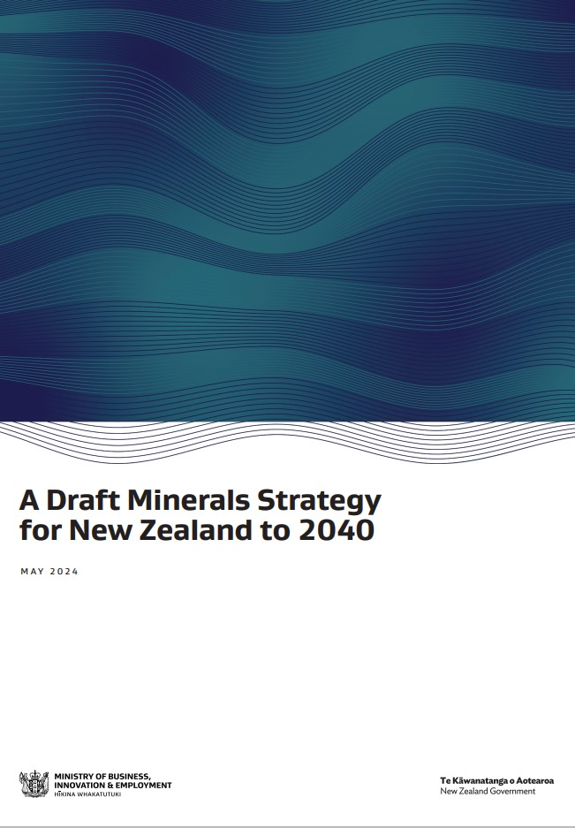

# How to submit using this form

## This form is used to provide feedback on the Draft Critical Minerals List for New Zealand.

When completing this submission form, please provide comments and reasons explaining your choices. Your feedback provides valuable information and informs decisions about the development of the list.

You can submit this form by 5pm, Thursday, 10 October 2024 by:

* Emailing to [resourcesfeedback@mbie.govt.nz](mailto:resourcesfeedback@mbie.govt.nz) with subject line ‘Critical Minerals List 2024’

Your feedback will contribute to further development of a Critical Minerals List for New Zealand. It will also become official information, which means it may be requested under the Official Information Act 1982 (OIA).

The OIA specifies that information is to be made available upon request unless there are sufficient grounds for withholding it. If we receive a request, we cannot guarantee that feedback you provide us will not be made public. Any decision to withhold information requested under the OIA is reviewable by the Ombudsman.

# Submitter information

The Ministry of Business, Innovation and Employment (MBIE) would appreciate if you would provide some information about yourself. If you choose to provide information in the “About you” section below it will be used to help MBIE understand the impact of our proposals on different occupational groups. Any information you provide will be stored securely.

1. About you

|  |  |
| --- | --- |
| Name: |  |

|  |  |
| --- | --- |
| Email address: |  |

1. Are you happy for MBIE to contact you if we have questions about your submission?

Yes  No

1. Are you making this submission on behalf of a business or organisation?

☐ Yes ☐ No

If yes, please tell us the title of your company/organisation:

|  |
| --- |
|  |

1. The best way to describe your role is:

Academic/researcher/research institute  Independent expert (please specify below)

Community group (please specify below)  Business owner (please specify below)

Consultant (please specify below)  Environmental NGO (please specify below)

Tradesperson (please specify below)  Student (please specify below)

Industry group (please specify below)  Other (please specify below)

Industry participant (please specify below)  Prefer not to say

Please specify here:

|  |
| --- |
|  |

1. Privacy information

The Privacy Act 2020 applies to submissions. Please check the box if you do not wish your name or other personal information to be included in any information about submissions that MBIE may publish.

MBIE may upload submissions, or a summary of submissions, received to MBIE’s website at [www.mbie.govt.nz](http://www.mbie.govt.nz). If you do not want your submission or a summary of your submission to be placed on our website, please check the box and type an explanation below:

|  |
| --- |
| *I do not want my submission placed on MBIE’s website because… [insert reasoning here]* |

1. Confidential information

I would like my submission (or identifiable parts of my submission) to be kept confidential and have stated my reasons and ground under section 9 of the Official Information Act that I believe apply, for consideration by MBIE.

If you have checked this box, please tell us what parts of your submission are to be kept confidential.

|  |
| --- |
|  |

# A Draft Critical Minerals List for New Zealand

|  |
| --- |
| MBIE is developing a critical minerals list for New Zealand to identify the minerals that are:   * essential to New Zealand’s economy, national security, and technology needs, including renewable energy technologies and components to support our transition to a low emissions future; and/or * in demand by New Zealand’s international partners to enable us to benefit from international economic opportunities, contribute to the diversification of global mineral supply chains and improve the pipeline of the end-use products for which these minerals are essential; and * susceptible to supply disruptions domestically and internationally. In some instances, we rely on domestic sources of minerals, but the supply of these minerals can be constrained, for example by regulatory factors and social licence. Internationally, supply chain disruptions could arise due to geopolitical risks and external market forces.   Minerals play an essential role in New Zealand’s economic growth through high-paying jobs, Crown royalties, direct positive impact in the regions where mining takes place, and through export revenues. Minerals are also critical inputs into products that are necessary for other sectors to thrive, including the use of aggregates in construction and infrastructure.  Minerals are also essential to modern economies as they are needed to manufacture advanced technologies such as semi-conductors, defence applications and medical equipment. Minerals are also critical for a clean energy transition as low emission technologies requires more mineral inputs than those fuelled by fossil fuels.  The extraction and processing of the minerals essential to New Zealand and our international partners are concentrated in a few countries. Any disruption that interrupts operations at a large facility or group of facilities can have a major impact on supply availability, and therefore on prices. The greater the concentration of production the larger the affect a disruption can have.  In addition, New Zealand does not manufacture a wide range of technologies, we are generally an end consumer of many products produced internationally and rely on the functioning of international supply chains and their access to resilient supplies of minerals.  The development of a critical minerals list is one of the key actions identified in the draft Minerals Strategy that was publicly consulted on from 23 May – 31 July 2024. Due to the technical nature of the list, MBIE engaged a consultancy with specialist expertise, Wood Mackenzie, to support the development of the list.  We are seeking feedback on the content of the draft list that has been developed by Wood Mackenzie for New Zealand. It identifies the minerals that are critical to New Zealand and summarises the reason for their inclusion in the list. Once the list is finalised, actions could be identified to help us reduce the ‘criticality’ of those minerals, i.e., secure better access to them.  Please see the draft Critical Minerals List attached below for more information. |

## **Questions for the consultation**

1. Have we missed the inclusion of any mineral(s) on the draft Critical Minerals List?

Yes, (please provide more details below)  No, the list is okay.  Not sure/no preference

Is there anything you would like to tell us about the reason(s) for your choice?

|  |
| --- |
|  |

1. Have we included any mineral(s) that you think should not be on the list?

Yes, (please provide more details below)  No, the list is okay.  Not sure/no preference

Is there anything you would like to tell us about the reason(s) for your choice?

|  |
| --- |
|  |

1. Do you have any further feedback on the list, or the methodology under which it was developed?

Yes, (please provide more details below)  No, the list is okay.  Not sure/no preference

Is there anything you would like to tell us about the reason(s) for your choice?

|  |
| --- |
|  |

# Thank you

Thanks for your feedback, we really appreciate your insight on the development of New Zealand’s Critical Minerals List.